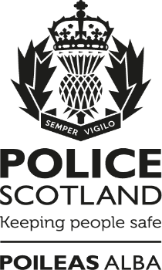

Your Police 2020-2021
Keeping Scotland Safe

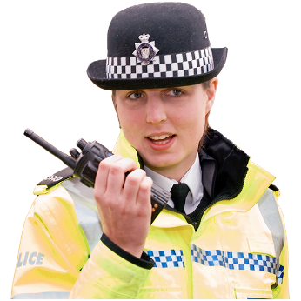

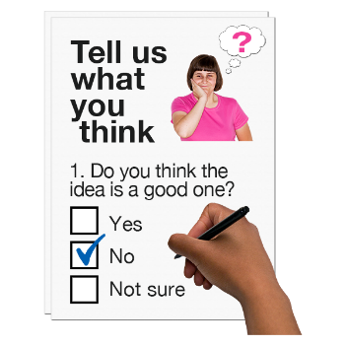

Copyright images © Photosymbols. Prepared by Disability Equality Scotland

What is this survey for?
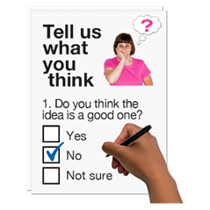 | We want to know what you think about the work of Police Scotland.  It is more important now because of coronavirus.
This survey is not about reporting crime.
There are ways to contact Police Scotland.
Find out more online at:
https://www.scotland.police.uk/contact-us/

How will we use your personal information?
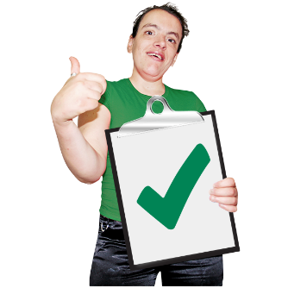  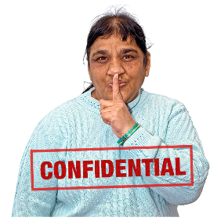 | Your replies are confidential.  This means your information will be kept private.  If you fill out the survey you agree to Police Scotland using your data for their reports.  No-one will know it is your information.
How do I take part in the survey?
You can fill out this survey on your computer, then save it and email it to:
consultations@scotland.pnn.police.uk
 | or print a copy, write in your answers then scan it and email it to: consultations@scotland.pnn.police.uk
 | Send us your survey before 31 March 2021.
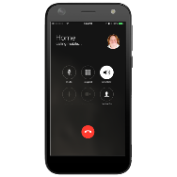 | If you have questions call Lucy Fraser on: 07717 150 296  or email: consultations@scotland.pnn.police.uk
There are 6 parts in the survey.

Click on the box of the answer you agree with and a tick will appear. ☐

If you change your mind you can click on it again to untick it.

If you are filling out a paper copy, tick the box of the answer you agree with, and if you have more to say write your answer in the ‘Write your answer here’ spaces.

If you don’t know the answer to a question, miss it out.

Part 1: The area you live in.

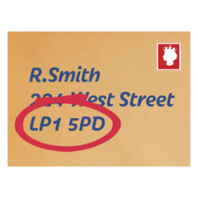 | - What is your postcode? Write it here:  We use postcodes for our reports.  We do not use them to find out who you are or where you live.  Your information is kept private.
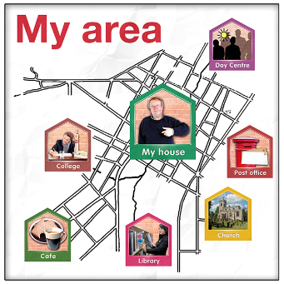 | - How safe do you feel in your local area?
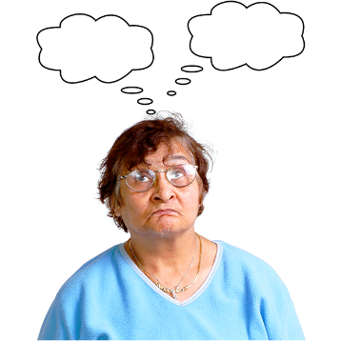 | Very safe | ☐
 | Quite safe | ☐
 | Not safe | ☐
 | I’m not sure | ☐
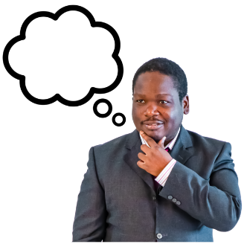 | - What worries you most about your local area that the police can help with?  Write your answer here:
Part 2: Coronavirus pandemic
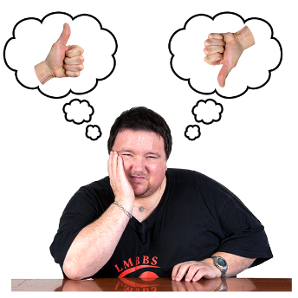 | - Have your worries about crime changed during the coronavirus outbreak?
 | I am more worried | ☐
 | My worries are the same | ☐
 | I am less worried | ☐
 | I am not sure | ☐
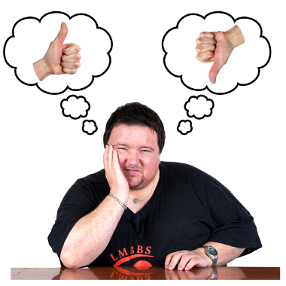  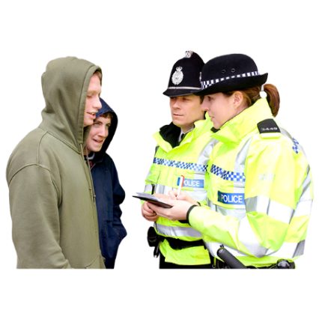 | - How have the police handled the coronavirus lockdown?  Tick the box next to the sentence that is nearest to what you think.
 | I support how the Police have handled it. | ☐
 | I support how the Police have handled it but in some cases they are going too far. | ☐
 | The Police should take stronger action to make sure people follow the lockdown advice to stay at home. | ☐
 | The Police have been too tough. | ☐
 | The Police should do nothing to make sure people follow the lockdown advice. It should be up to each person. | ☐
 | None of the above. | ☐
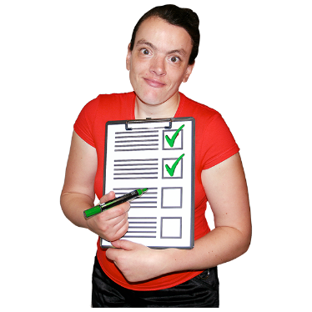 | - What are the Police doing well in your area during the coronavirus outbreak? Write your answer here:
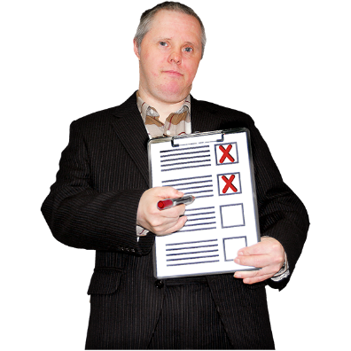 | - What could the Police do better in your area during the coronavirus outbreak?  Write your answer here:
Part 3:
Policing in the coronavirus outbreak.

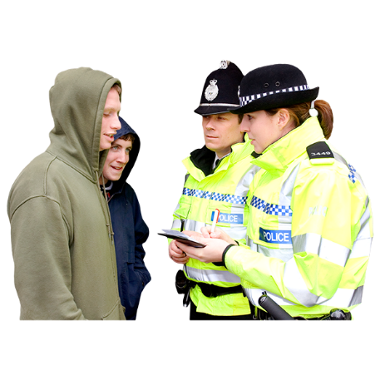 | 8.1 The police are right to speak to people who are out during the coronavirus lockdown, to find out why they are out and how quickly they can go home and stay safe.  What do you think about this?
 | I agree | ☐
 | I’m not sure | ☐
 | I don’t agree | ☐
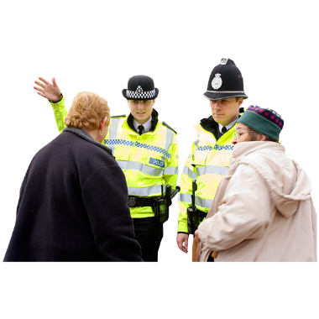 | 8.2 The police should explain the risks to health and the National Health Service to people who are in public.  What do you think about this?
 | I agree | ☐
 | I’m not sure | ☐
 | I do not agree | ☐
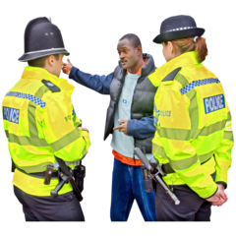 | 8.3 The police are right to encourage people who are out of their homes to go back home.  What do you think about this?
 | I agree | ☐
 | I am not sure | ☐
 | I do not agree | ☐
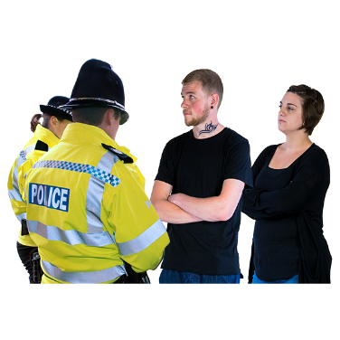 | 8.4 The police should make people follow the advice to go home and stay safe when people do not want to follow the advice.  What do you think about this?
 | I agree | ☐
 | I am not sure | ☐
 | I do not agree | ☐
Part 4: The Police in your area.

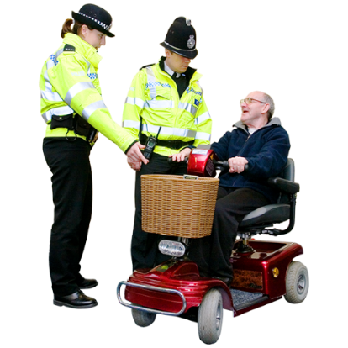 | The police listen to what local people are worried about.  What do you think about this?
 | I agree | ☐
 | I am not sure | ☐
 | I do not agree | ☐
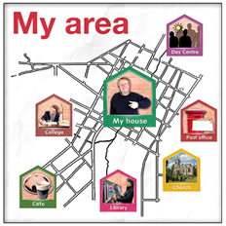 | The police are dealing with the problems in my local area.  What do you think about this?
 | I agree | ☐
 | I am not sure | ☐
 | I do not agree | ☐
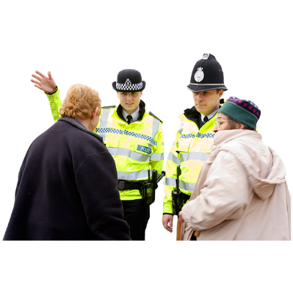 | The police are friendly, easy to talk to and I can ask them questions.  What do you think about this?
 | I agree | ☐
 | I am not sure | ☐
 | I do not agree | ☐
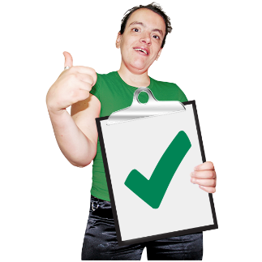 | I have confidence in the police in my area.  What do you think about this?
 | I agree | ☐
 | I am not sure | ☐
 | I do not agree | ☐
Part 5: Getting in touch with Police Scotland.

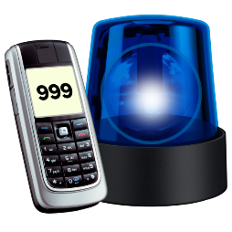 | 10. Have you been in touch with Police Scotland recently?
 | Yes, to report an incident or crime.  (go to question 11) | ☐
 | Yes, to report an incident or crime about Coronavirus. (go to question 11) | ☐
 | Yes, to get information.  (go to question 11) | ☐
 | No  (go to question 15) | ☐
 | I can’t remember. | ☐
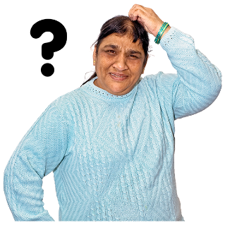 | 11. How did you get in touch with Police Scotland?
 | Phoned 111 | ☐
 | Phoned 999 | ☐
 | Text | ☐
 | Used the online form on the Police Scotland website | ☐
 | Email | ☐
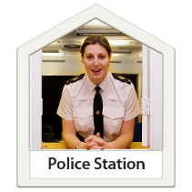 | Went to a police station | ☐
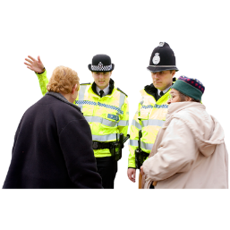 | Spoke to an officer on the street | ☐
 | Through another organisation | ☐
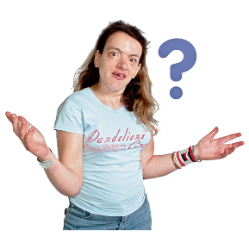 | Another way | ☐
 | I can’t remember | ☐
 | 12. How easy was it to get in touch with Police Scotland?
 | Very easy | ☐
 | Easy | ☐
 | Not easy or hard | ☐
 | Hard | ☐
 | Very hard | ☐
 | I can’t remember | ☐
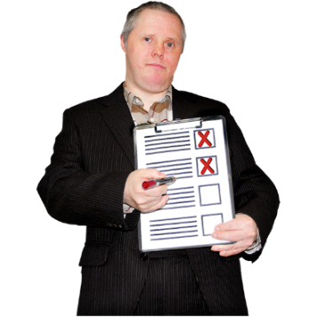 | 13. What could we have done better?  Write it here:
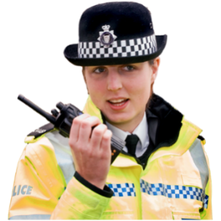 | 14. Think about all the times you have been in touch with Police Scotland. How do you feel about your experiences?
 | Very happy | ☐
 | Happy | ☐
 | Not happy or unhappy | ☐
 | Unhappy | ☐
 | Very unhappy | ☐
Part 6: About you.

We ask these questions to make sure we get lots of different types of people answering the survey.

You can miss out any question that makes you feel uncomfortable.
You do not have to answer any of these questions if you don’t want to.

 | 15. Are you answering this survey:
 | as an individual | ☐
 | or as an organisation.  Tell us the name of the organisation. | ☐
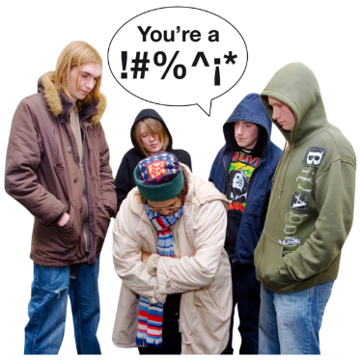 | 16. In the last 12 months have any of these things happened to you?
 | I have been a victim of crime | ☐
 | I have seen a crime | ☐
 | I have been a victim of crime and I have seen a crime | ☐
 | I have not been a victim and have not seen a crime | ☐
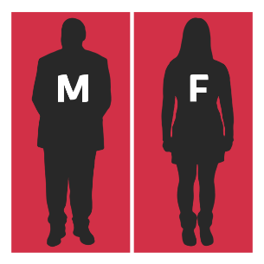 | 17. Do you think of yourself as:
 | Female | ☐
 | Male | ☐
 | Non-binary (I don’t see myself as only male or only female) | ☐
 | In another way | ☐
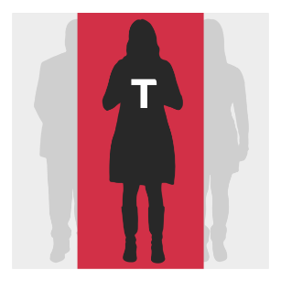 | 18. Do you think of yourself as transgender or that you have a transgender history?  Transgender means you see yourself differently from your birth sex (male or female).
 | Yes | ☐
 | No | ☐
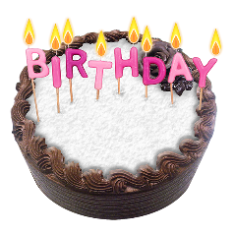  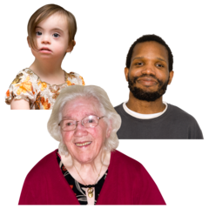 | 19. How old are you? Write it here:
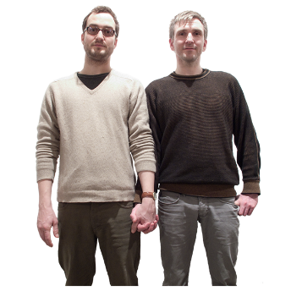 | 20. Sexual orientation means what kinds of people you love or have sexual or romantic feelings about.  Do you think of yourself as:
 | Heterosexual or straight | ☐
 | Bisexual | ☐
 | Gay | ☐
 | Lesbian | ☐
 | Any other sexual orientation | ☐
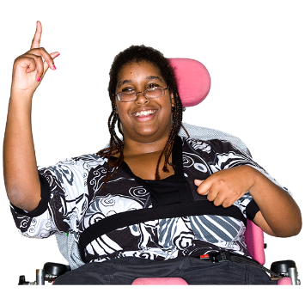 | 21. Do you consider yourself to have a disability, long-term illness or health condition?  Yes ☐ No ☐
21. What is your ethnicity?
Ethnicity is the word we use to describe our background.
People from an ethnic group might have the same language, culture or religion.
What best describes you?
If you tick ‘other’ please tell us what your ethnicity is.
 | White
 | Scottish | ☐
 | Other British | ☐
 | Irish | ☐
 | Gypsy or Traveller | ☐
 | Polish | ☐
 | Any other white ethnic group | ☐
 | Mixed or multiple ethnic group
 | Any mixed or multiple ethnic group | ☐
 | Asian, Asian Scottish or Asian British
 | Bangladeshi, Bangladeshi Scottish, Bangladeshi British
 | Chinese, Chinese Scottish, Chinese British | ☐
 | Indian, Indian Scottish, Indian British | ☐
 | Pakistani, Pakistani Scottish, Pakistani British | ☐
 | Any other Asian | ☐
 | African
 | African, African Scottish, African British | ☐
 | Any other African | ☐
 | Caribbean or Black
 | Black, Black Scottish, Black British | ☐
 | Caribbean, Caribbean Scottish, Caribbean British | ☐
 | Any other Caribbean or Black | ☐
 | Other ethnic group
 | Arab, Arab Scottish, Arab British | ☐
 | Any other ethnic group. Write your answer here: | ☐
 | 7. What religion do you belong to?
 | No religion | ☐
 | Church of Scotland | ☐
 | Roman Catholic | ☐
 | Other Christian | ☐
 | Buddhist | ☐
 | Hindu | ☐
 | Jewish | ☐
 | Muslim | ☐
 | Sikh | ☐
 | Any other religion. Write your answer here:
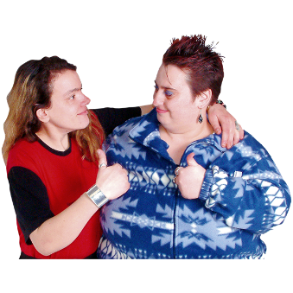 | Thank you for telling us what you think.  What you tell us is important.

Copyright images © Photosymbols. Prepared by Disability Equality Scotland

