Victim Care Card Survey

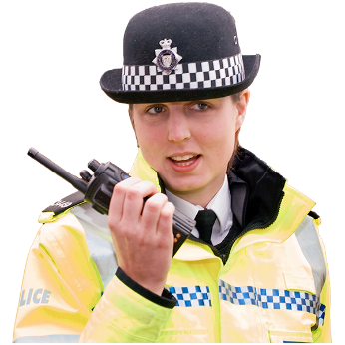

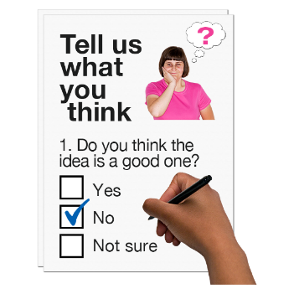

Copyright images © Photosymbols. Prepared by Disability Equality Scotland

What is this survey for?
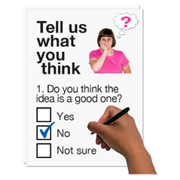 | This survey is from Police Scotland and Victim Support Scotland.  We want to know what you think about how you get information about support services.
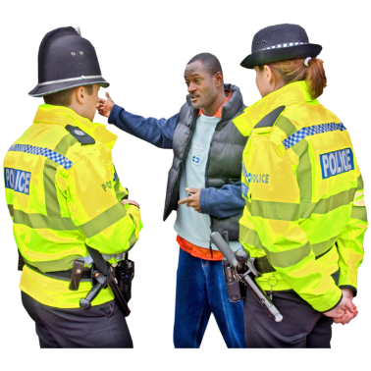 | This survey asks for your views about the best way to support people who have been victims of crime or saw a crime happen.  What you think will help us make our services better.
 | This survey is not about feedback on other things, or about complaints.
To tell Victim Support Scotland what you think of their services, please see details on their website.
To tell Police Scotland what you think of their services, please see our public information on their website.
How will we use your personal information?
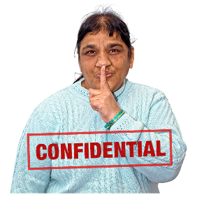 | Your replies are confidential.  This means your information will be kept private.  If you fill out the survey you agree to Police Scotland and Victim Support Scotland using your data for their reports.  They will use it to make services better.  No-one will know it is your information.
How do I take part in the survey?
You can fill out this survey on your computer, then save it and email it to:
consultations@scotland.pnn.police.uk
 | or print a copy, write in your answers then scan it and email it to: consultations@scotland.pnn.police.uk
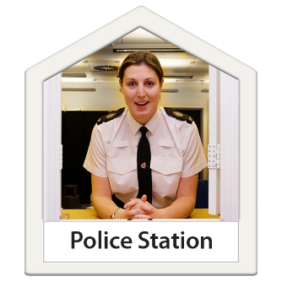 | If you the internet cannot use the internet to send an email, please go to the public counter of your local police station.  Take this survey with you if you can.
Ask the staff to send an email with your phone number to: consultations@scotland.pnn.police.uk
Our team will call you before 10 days have passed.

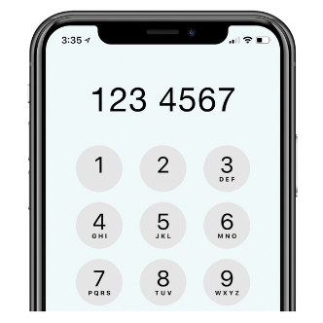  101 | If you do not live close to a police station, please phone 101 and choose Option 4.  Tell them you are phoning about the Your Police survey.
 | Ask them to email: consultations@scotland.pnn.police.uk with a phone number our team can reach you on.
 | Send us your survey before 31 August 2021.
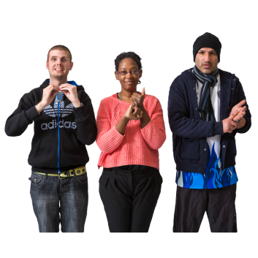 | A British Sign Language version of the survey is available online at: https://consult.scotland.police.uk
If you have questions or if you want to do the survey over the phone please phone the Insight Team on: 07717 188 184

or email: consultations@scotland.pnn.police.uk

There are 8 parts in the survey.

Click on the box of the answer you agree with and a tick will appear. ☐

If you change your mind you can click on it again to untick it.

If you are filling out a paper copy, tick the box of the answer you agree with, and if you have more to say write your answer in the ‘Write your answer here’ spaces.

If you do not know the answer to a question, miss it out.

Part 1: Tell us what happened to you.
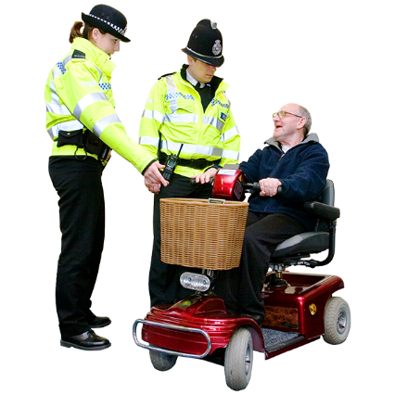 | - Have you experienced a crime in the last two years?  You can tick more than one box.
 | I have been a victim of crime |  |  | ☐
 | I have seen a crime |  |  | ☐
 | I have not been a victim or a witness of crime.  If you tick this answer, move to Question 11. |  |  | ☐
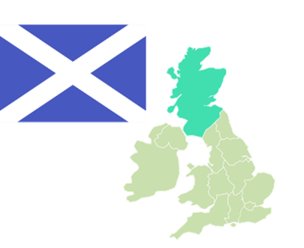 | - Did the crime happen to you in Scotland?
 | Yes  If you tick this answer go to Question 3. |  |  | ☐
 | No  If you tick this answer, move to Question 11. |  |  | ☐
- Thank you for telling us that you are:
- someone who survived a crime

- or someone who saw a crime.

Using your own words, can you tell us more about what happened?

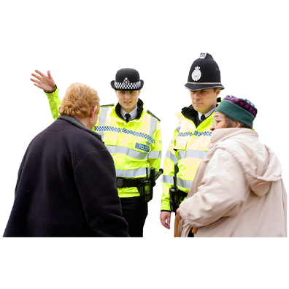 | Did you have contact with the Police?
 | Yes, go to question 4 |  | ☐
 | No, go to question 11 |  | ☐
Part 3: How you communicated with Police Scotland.
This part asks about your communication with Police Scotland after the crime and what information they gave you.
A Victim Care card is given to people after they have reported a crime to the police.
It looks like this:
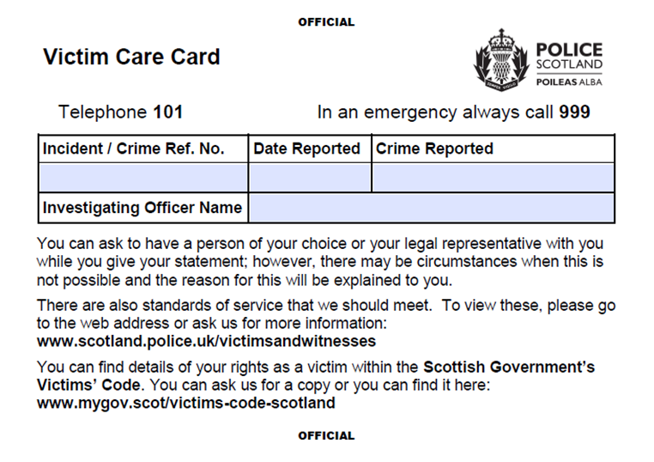

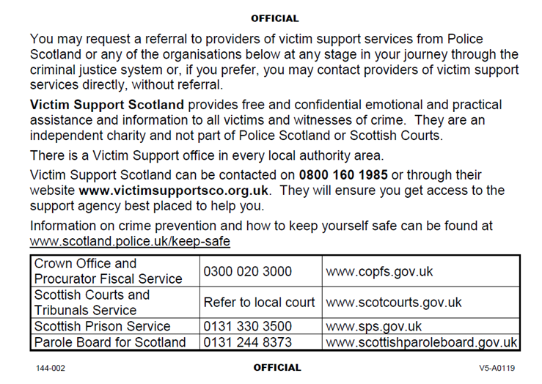
 | - In your communication with Police Scotland, were you given with a Victim Care Card?
 | Yes |  |  | ☐
 | No |  |  | ☐
 | I do not know |  |  | ☐
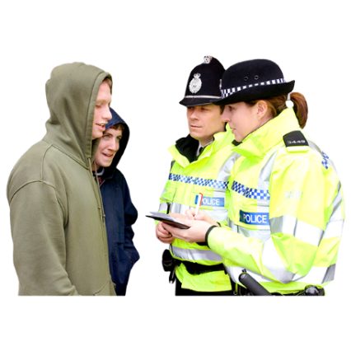 | - Think about how Police Scotland communicated with you.  How do you feel about this statement?  ‘Police responded in the right way for me and helped to keep me safe.  Staff and officers who communicated with me were honest, fair and respectful.  They protected my human rights.  They were thoughtful and understood me.’
 | I agree with this statement |  |  | ☐
 | I do not agree with this statement. |  |  | ☐
 | I am not sure. |  |  | ☐
- If you got a Victim Care Card how did you use it?

Tick all the answers that are right for you.

 | to remember:  - the crime incident number  - the crime reference number  - the date the crime happened |  |  | ☐
 | - the police officer’s name. |  |  | ☐
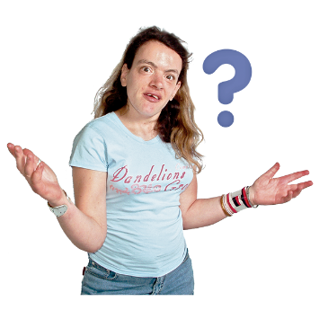 | to find out about standards of service for victims or witnesses of crime. |  |  | ☐
 | to find out about my rights as a victim or witness of crime. |  |  | ☐
 | to ask for a referral to a victim support service. |  |  | ☐
 | to contact Victim Support Scotland. |  |  | ☐
 | to contact a criminal justice organisation. |  |  | ☐
 | to find out how to stop crime. |  |  | ☐
 | I did not use it. |  |  | ☐
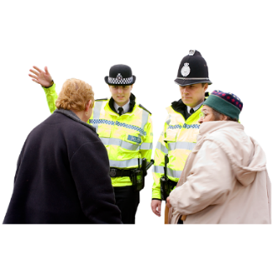 | - If the Police contacted you again after the crime would you have accepted a referral to support services?
 | Yes |  |  | ☐
 | I am not sure |  |  | ☐
 | No |  |  | ☐
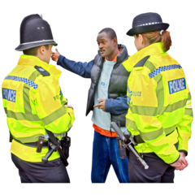 | - How would you like to get information or be contacted by Police Scotland?
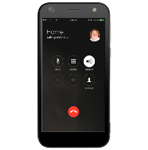  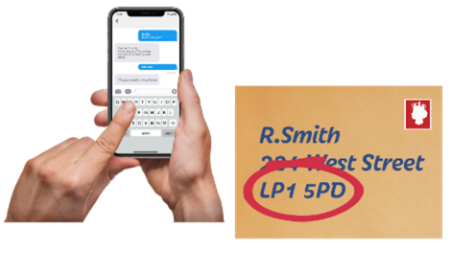 | Phone |  |  | ☐
 | Email |  |  | ☐
 | Text |  |  | ☐
 | Letter |  |  | ☐
 | Internet video services like Teams, Skype or Zoom |  |  | ☐
 | An online account you log in to and have a ‘profile’ |  |  | ☐
 | None of these ways |  |  | ☐
 | - If Police Scotland also sent you the Victim Care Card on an email or by text message would this be helpful?
 | Yes |  |  | ☐
 | I am not sure |  |  | ☐
 | No |  |  | ☐
10. Is there anything else you want to tell us about communicating with Police Scotland when you have been a victim of crime or witnessed a crime?

Write it here:

Part 4: What do you think about the Victim Care card?

11. Think about the wording on the Victim Care Card and how it looks.

What do you like about it?
Write it here:

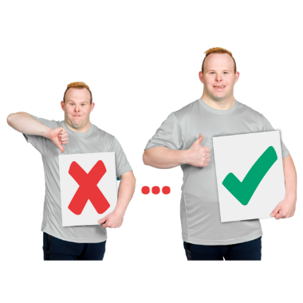 | 12. What would you change to make it better?  Write it here:
13. Are there any other support services or other information that should be on the card?

Write it here:

Part 5: Future thinking
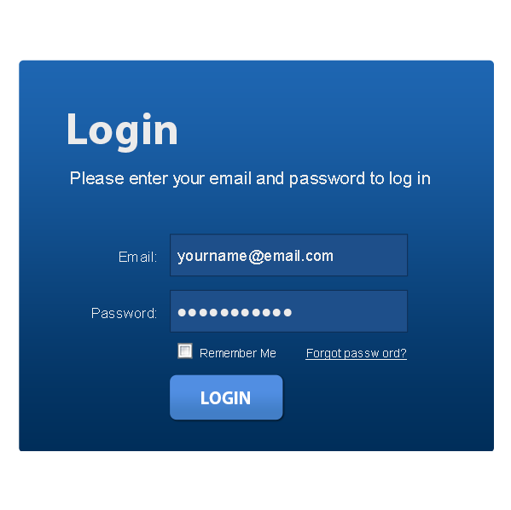 | 14. In the future Police Scotland might have an internet site you can log-in to.  This would help you:  - get updates on your case  - know how to contact the police officer who is helping you  - and know how to get other support services.  Do you think this would be a good idea?
 | Yes |  |  | ☐
 | I am not sure |  |  | ☐
 | No |  |  | ☐
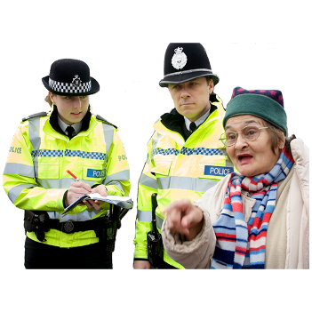 | 15. What could Police Scotland do to put you first after you have experienced or seen a crime?  Write it here:
16. Is there anything else you want to tell us about the Victim Care Card?

Write it here:

Part 6: Taking part in a research interview.
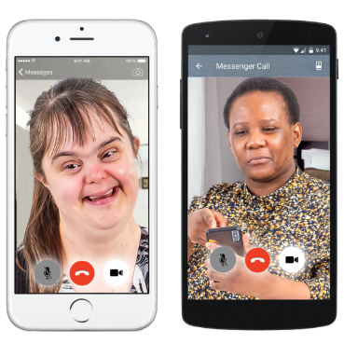 | As part of this project, Victim Support Scotland and Police Scotland will have telephone or video call discussions.  We want to know more about what people think about support for victims and witnesses.  If you want to do this we will send you more information.  You will have another chance to decide if you want to take part.
 | We will contact you before 31 July 2021 if you are picked to take part in a research interview.
 | 17. Would you like to take part in a research interview?
 | Yes | ☐
 | No | ☐
 | If you answered yes to this question please tell us how to contact you.
We will keep your information safe.
We will only use it to get in touch with you about the interviews.
Please only give details that are safe for us to contact you on.
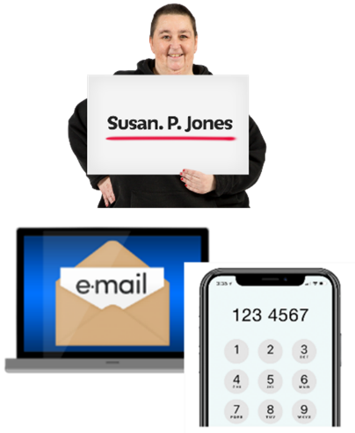 | Your name:  Phone number:  Email address:
 | If you want us to phone, when is the best time to reach you?
 | Morning  9 am -12 noon |  |  | ☐
 | Afternoon  12 noon to 5.30pm |  |  | ☐
 | Evening  5.30 to 7pm |  |  | ☐
Part 7: About you.

We ask these questions to make sure we get lots of different types of people answering the survey.

You can miss out any question that makes you feel uncomfortable.
You do not have to answer any of these questions if you do not want to.

 | 18. Are you answering this survey:
 | as an individual |  |  | ☐
 | or as an organisation.  Tell us the name of the organisation. |  |  | ☐
 | 19. Do you think of yourself as:
 | Female |  |  | ☐
 | Male |  |  | ☐
 | Non-binary (I don’t see myself as only male or only female) |  |  | ☐
 | In another way |  |  | ☐
20. Do you think of yourself as transgender or that you have a transgender history?
Transgender means you see yourself differently from your birth sex (male or female).
 | Yes |  |  | ☐
 | No |  |  | ☐
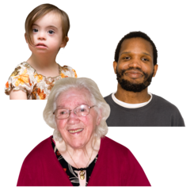 | 21. How old are you? Write it here:
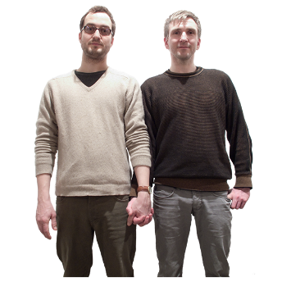 | 22. Sexual orientation means what kinds of people you love or have sexual or romantic feelings about.  Do you think of yourself as:
 | Heterosexual or straight |  |  | ☐
 | Bisexual |  |  | ☐
 | Gay |  |  | ☐
 | Lesbian |  |  | ☐
 | Any other sexual orientation |  |  | ☐
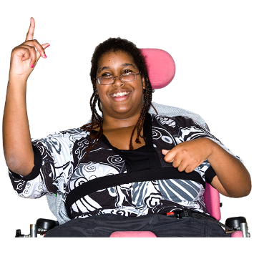 | 23. Do you consider yourself to have a disability, long-term illness or health condition?  Long term means it has lasted for over a year.  Yes ☐ go to question 24.  No ☐ go to question 25.
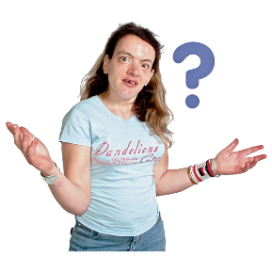 | 24. Does this disability or health condition affect you in any of these ways?
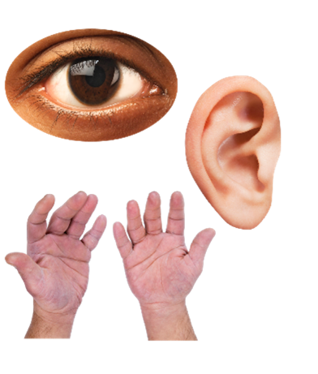 | Vision – how I see |  |  | ☐
 | Hearing |  |  | ☐
 | How I use my hands – for example if it is difficult to lift things or use a keyboard |  |  | ☐
 | Mobility – for example walking or climbing stairs |  |  | ☐
 | Learning or concentrating |  |  | ☐
 | Remembering things |  |  | ☐
 | Mental health |  |  | ☐
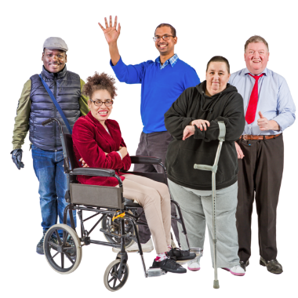 | I get out of breath or tired easily |  |  | ☐
 | How I behave around people |  |  | ☐
 | In another way. Please tell us what: |  |  | ☐
In other surveys disabled people told us they wanted to say how their disability affected them. We will use this information to make our service better.
3
25. What is your ethnicity?
Ethnicity is the word we use to describe our background.
People from an ethnic group might have the same language, culture or religion.
What best describes you?
If you tick ‘other’ please tell us what your ethnicity is.
 | White
 | Scottish |  |  | ☐
 | Other British |  |  | ☐
 | Irish |  |  | ☐
 | Gypsy or Traveller |  |  | ☐
 | Polish |  |  | ☐
 | Any other white ethnic group |  |  | ☐
 | Mixed or multiple ethnic group
 | Any mixed or multiple ethnic group |  |  | ☐
 | Asian, Asian Scottish or Asian British
 | Bangladeshi, Bangladeshi Scottish, Bangladeshi British
 | Chinese, Chinese Scottish, Chinese British |  |  | ☐
 | Indian, Indian Scottish, Indian British |  |  | ☐
 | Pakistani, Pakistani Scottish, Pakistani British |  |  | ☐
 | Any other Asian |  |  | ☐
 | African
 | African, African Scottish, African British |  |  | ☐
 | Any other African |  |  | ☐
 | Caribbean or Black
 | Black, Black Scottish, Black British |  |  | ☐
 | Caribbean, Caribbean Scottish, Caribbean British |  |  | ☐
 | Any other Caribbean or Black |  |  | ☐
 | Other ethnic group
 | Arab, Arab Scottish, Arab British |  |  | ☐
 | Any other ethnic group. Write your answer here: |  |  | ☐
 | 26. What religion do you belong to?
 | No religion |  |  | ☐
 | Church of Scotland |  |  | ☐
 | Roman Catholic |  |  | ☐
 | Other Christian |  |  | ☐
 | Buddhist |  |  | ☐
 | Hindu |  |  | ☐
 | Jewish |  |  | ☐
 | Muslim |  |  | ☐
 | Sikh |  |  | ☐
 | Any other religion. Write your answer here:
Part 8: Before you go.
If you have any questions about the survey or if you want to give us more information email:
Police Scotland’s Research & Insight Team: consultations@scotland.pnn.police.uk
or Victim Support Scotland National Office getinvolved@victimsupportsco.org.uk

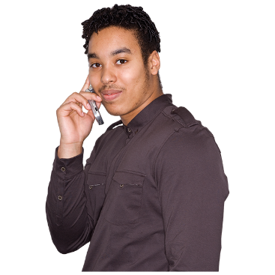 | If you need practical or emotional support call the Victim Support Scotland Helpline on 0800 160 1985.  You can contact Samaritans if you need someone to talk to.  They can listen to you and you can call them any time of the day or night on 116 123.
 | More information for victims and witnesses is available on the Police Scotland website.
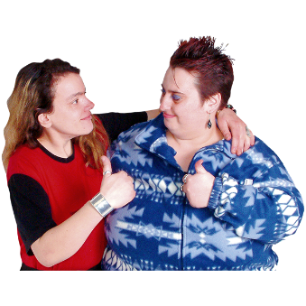 | Thank you for telling us what you think.  What you tell us is important.
Copyright images © Photosymbols. Prepared by Disability Equality Scotland

