Views about the support and aftercare provided by Police Scotland for survivors/witnesses of crime – Survey
What is the purpose of this survey?
This survey is about the aftercare options provided by Police Scotland for people who have been a survivor or witness of crime. It includes questions about referral to support services for people affected by crime. It also asks about the Victim Care Card, which provides aftercare information and important contact details.
This survey has been produced in collaboration between Police Scotland and Victim Support Scotland. It asks for individual views about how Police Scotland can best support survivors/witnesses of crime when it comes to providing immediate support and information. This is what we mean by ‘aftercare’. Your views will help to inform development and shape our services.
This survey asks for your views about aftercare support, rather than any other feedback/complaints. To give feedback on Victim Support Scotland’s services, please see details on the Victim Support Scotland website. To provide feedback about Police Scotland’s service, please see our public information on the Police Scotland website.
What does this survey involve?
- It is optional - you can choose if you want to take part and which questions you fill out or leave blank.
- It should only take around 10 minutes to complete.
- There will be the option for you to give us extra information later on in the survey if you would like to do so.
- You will not be required to give any details about any specific incident but you will be asked for a few basic details about if you have been a victim or witness to a crime. This is completely optional.
- All individual responses to the survey will be kept confidential.
- Police Scotland and Victim Support Scotland will use the anonymised findings of survey data in reports and publications and will use it to develop our services and approaches.
- Police Scotland and Victim Support Scotland will store all data from this survey securely and in line with the Data Protection Act 2018. Your data rights will not be affected by participation. By clicking the link below, you agree to take part in this survey and give your consent for your responses to be handled by Police Scotland and Victim Support Scotland for the purposes outlined here.
- As responses are anonymous, we cannot respond to you about what you have said.
- Anybody requiring emotional support is welcome to call the Victim Support Scotland Helpline on 0800 160 1985.
Complete the survey in a different way
Easy Read and BSL versions of the survey will become available soon.
Please let us know if you want to complete the survey in a different way (for example, over the phone, or if you require it in another language to be able to take part): consultations@scotland.pnn.police.uk.

SECTION ONE: YOUR POSTCODE
Postcodes are collected for the purpose of analysis only. We ask for the first part of your postcode as it helps us understand your response in relation to your local area - ensuring that we can act on what you tell us.
We cannot use the first part of your postcode to identify you or your address.
If you do not currently have a fixed abode, or your situation means you do not have a postcode, you can leave this blank and move on.

What is the first part your postcode?

If you don’t have an address, please skip on to the next section as we’d still love to hear your views.

SECTION TWO: YOUR EXPERIENCE
- Have you experienced a crime in the last two years – either as a victim or a witness?
I have been a victim of crime
I have been a witness of crime
I have been a victim and a witness of crime
I have not been a victim or crime or a witness of crime [direct to Q12]
Prefer not to say [direct to Q12]

[Branching – if 1 or 2 in Q1]
- Did your experience of this occur in Scotland?
Yes [continue to Q3]
No [direct to Q12]
I don’t know [direct to Q12]
Prefer not to say [direct to Q12]

[Branching – if yes in Q2]
- Thank you for telling us that you are someone who has survived or witnessed crime in Scotland. We’re keen to understand more about your experiences so that we can identify where improvements can be made.

Using your own words, can you tell us more about the type of crime you experienced?
_________________________________________________________________________________________________________________________________________________________________________________

Alternatively, you can select one of the options below (select the one which best applies to you)

Prefer not to say
Other type of incident (perhaps an incident you don’t think of as a crime, but where you needed additional support from the Police). If so, can you describe this in your own words? _________________________________________

- Did you have contact with the Police?
Yes
No
Prefer not to say
Other ____________________________________________

[Branching – if yes in Q4]
SECTION THREE: ABOUT YOUR INTERACTION WITH POLICE SCOTLAND
This section will ask you a few questions about your interaction with Police Scotland after the crime had occurred and any follow up information that was provided.

Some of the questions below will ask about the ‘Victim Care Card’. This is provided to people after they have reported a crime to the police. An example of a Victim Care Card is given below.

FRONT OF VICTIM CARE CARD
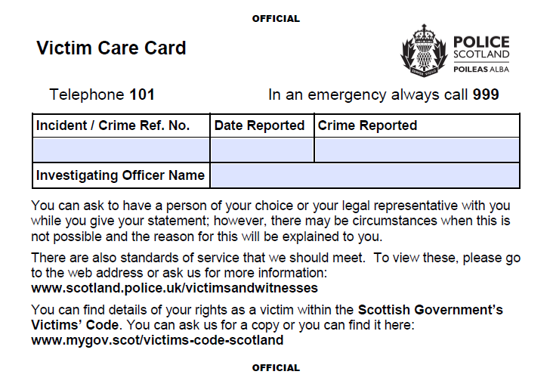

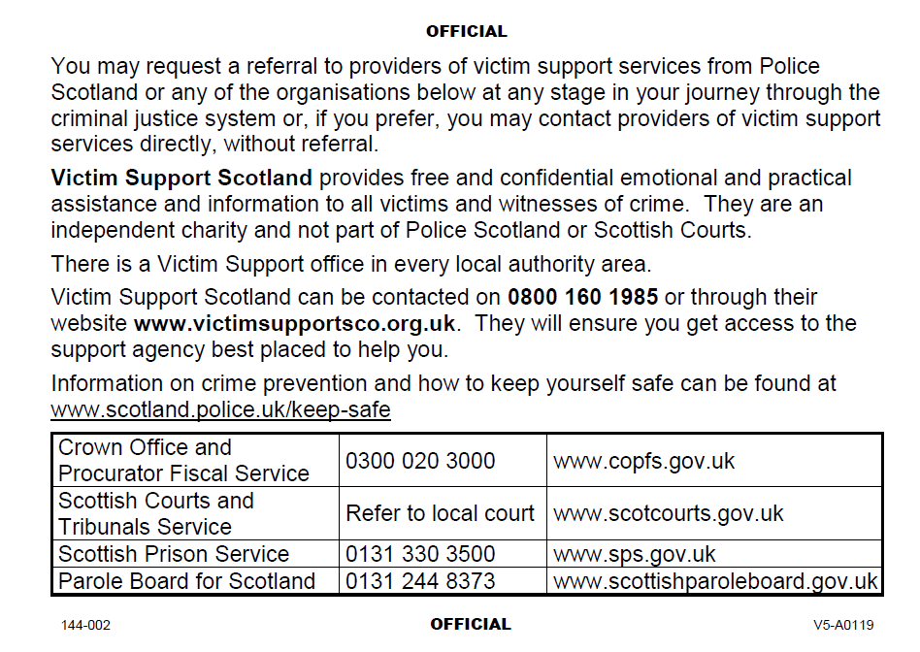
BACK OF VICTIM CARE CARD

5. In your interaction with Police Scotland, were you provided with a ‘Victim Care Card’?

Yes
No
I don’t know
Prefer not to say
Other ____________________________________________

[Branching – if 1 at Q5]
6. How did you use the Victim Care Card? (Select all that apply)

I used it to recall the crime incident number/ crime reference number and/or crime date
I used it to recall the attending officer’s name
I used the information on it to find out more about the expected standards of service for victims or witnesses of crime
I used the information on it to find out more about my rights as a victim or witness of crime
I used the information on it to request a referral by Police Scotland to a victim support service
I used the information on it to contact Victim Support Scotland myself directly
I used the information on it to contact one of the criminal justice agencies featured or visited one of their websites
I used the information on it to find out more about crime prevention
I did not use the Victim Care Card after receiving it
Prefer not to say
Other ____________________________________________

7. Reflecting back, when Police Scotland talked to you after the crime, did they offer to refer you to receive emotional or practical support from an organisation such as Victim Support Scotland or another support organisation?

Yes
No
I don’t know
Prefer not to say
Other ______________________________

8. If the Police had contacted you again soon after the incident, how likely is it that you would have accepted a referral to support services at that point if not already?

Highly likely
Likely
Neither likely nor unlikely
Unlikely
Highly unlikely
I don’t know / not sure

9. Thinking about how we provide the best possible service, how would you like to receive information or be contacted by Police Scotland regarding immediate aftercare as a survivor or witness of crime? (Select all that apply)

Telephone
Email
Text message/IM
Letter/post
Web/video service such as Microsoft Teams
A digital platform/online account you log in to and access a ‘profile’
None of the above
Prefer not to say
Other:_________________________

10. Thinking about how Police Scotland interacted with you, how strongly do you agree or disagree with the following statements:
‘Police provided a response which was appropriate and which met my needs to help keep me safe.
Strongly agree
Agree
Neither agree nor disagree
Disagree
Strongly disagree

‘Staff and officers who engaged with me displayed Police Scotland’s values of integrity, fairness and respect, and protected my human rights.’

Strongly agree
Agree
Neither agree nor disagree
Disagree
Strongly disagree

‘Staff and officers were empathetic and understood me.’

Strongly agree
Agree
Neither agree nor disagree
Disagree
Strongly disagree

Comments: ________________________________________

11. What other feedback or ideas do you have, thinking about interactions (as a survivor/witnesses of crime) with Police Scotland?
________________________________________________________________________________________________________________________________________________________________________________________________

SECTION FOUR: VIEWS ABOUT THE VICTIM CARE CARD
This section asks about your views of the Victim Care Card, which is provided to people after they have reported a crime to the police. An example of the Victim Care Card is provided to help you.

FRONT OF VICTIM CARE CARD

BACK OF VICTIM CARE CARD

12. Thinking about the wording, format and style of the Victim Care Card, what, if anything, do you like about it?

________________________________________________________________________________________________________________________________________________________________________________________________

13. What, if anything, would you would change to make it better?

___________________________________________________________________________________________________________________________________________________________________________

14. Are there any other support services/organisations or information you think should be included on the Victim Care Card? If so, please describe using your own words below.
_________________________________________________________________________________________________________________________________________________________________________________

15. If Police Scotland was to issue you with an additional electronic version of the Victim Care Card, how helpful would this be? (1 – not at all helpful, 5 extremely helpful)

[Insert ranking scale]

16. Is there anything else that you would like to tell us about the Victim Care Card?
________________________________________________________________________________________________________________________________________________________________________________________________

17. Imagine you are speaking to a friend, colleague or family member who has recently had contact with the Police as a survivor or a witness of crime. You know that they have been given a Victim Care Card or information about support services. They are unsure if they need extra support right now.

We want to understand what you might already know about support services available in your community – it is fine if you don’t know much or anything.

What, if anything, could you tell them about accessing a support service to help them make up their mind?
__________________________________________________________________________________________________________________________________________________________________________________________

SECTION FIVE: FUTURE THINKING
18. Police Scotland aims to provide services that are modern to play our part in improving the safety and wellbeing of Scotland’s communities. Police Scotland want to make it as easy as possible for people affected by crime to know about and access support services if they need extra support.

[Insert futuristic image to set the scene?]

Imagine it is some time in the future and a person has just experienced a crime or other incident where the police were required to help them.

They received the appropriate response which met their needs and they feel safe now. A Police Officer has just taken their details and maybe a statement from them about the incident using their mobile device.

After the officer has taken the person's details, an automated message is then emailed and/or messaged to the person's mobile phone. This message gives helpful details about the incident, who the response officer was, how to contact the right person and how their case is progressing. It also includes more information about keeping safe and accessing support services.

If Police Scotland developed a system like this in the future, how much do you agree or disagree that it would it improve that person's aftercare experience?

Strongly agree
Agree
Neither agree nor disagree
Disagree
Strongly disagree

19. What do you think a Police Scotland ‘aftercare system’ which effectively directs people to support after they experience crime would look or feel like, if it had users at its heart?
________________________________________________________________________________________________________________________________
20. We have tried to avoid using the term ‘victim’ in places throughout this survey. Sometimes we have used the word ‘survivor’ instead. We want to describe people who have experienced crime in non-stigmatising ways.

Tell us more about any views you have about how we describe someone who has experienced a crime. For example, should we use the term ‘survivor’ instead?
________________________________________________________________________________________________________________________________

SECTION SIX: ABOUT YOU
This section asks equality and diversity questions. The reason we ask these questions is to understand more about the people completing this survey. Completing this section is optional.

21. Which of the following best describes you?
Male
Female
Non-binary (gender neutral)
Other (please specify)
Prefer not to say
If you selected other, please specify below:

22. Do you consider yourself to be trans or to have a trans history?
Yes
No
Prefer not to say

23. Which of the following age groups best applies to you?
Under 16
16 – 19
20 – 29
30 – 39
40 – 49
50 – 59
60 – 69
70+
Prefer not to say

If you are aged under 30:-
We are keen to understand the experiences of children and young people. As someone aged under 30, what, if anything, could Police Scotland do to improve the aftercare for children and young people who have experienced crime?
__________________________________________________________________________________________________________________

24. Which of the following best describes your sexual orientation?
☐ Heterosexual
☐ Gay
☐ Lesbian
☐ Bisexual
☐ Other (please specify)
☐ Prefer not to say

If you selected other, please specify below.
Your comments

25. Do you have any physical or mental health conditions or illnesses lasting or expected to last for 12 months or more?
☐ Yes (move to Q26)
☐ No (move to Q27)
☐ Don’t know (move to Q27)
☐ Prefer not to say (move to Q27)

- Does this condition or illness affect you in any of the following areas?
☐ Vision (e.g. blindness or partial sight)
☐ Hearing (e.g. deafness or partial hearing)
☐ Mobility (e.g. walking short distances or climbing stairs)
☐ Dexterity (e.g. lifting or carrying objects, using a keyboard)
☐ Learning or understanding or concentrating
☐ Memory
☐ Mental health
☐ Stamina or breathing or fatigue
☐ Socially or behaviourally (e.g. Autism, Asperger's, and ADD)
☐ Other (please specify)
☐ None of the above
☐ Prefer not to say

If you selected other, please specify below.
Your comments

- What is your ethnic group?
White
☐ Scottish
☐ British other
☐ Irish
☐ Gypsy/traveller
☐ Polish
☐ Any other white ethnic group
Mixed or multiple ethnic group
☐ Any mixed or multiple ethnic group
Asian, Asian Scottish or Asian British
☐ Pakistani, Pakistani Scottish or Pakistani British
☐ Indian, Indian Scottish or Indian British
☐ Bangladeshi, Bangladeshi Scottish or Bangladeshi British
☐ Chinese, Chinese Scottish or Chinese British
☐ Any other Asian
African
☐ African, African Scottish or African British
☐ Any other African
Caribbean or Black
☐ Caribbean, Caribbean Scottish or Caribbean British
☐ Black, Black Scottish or Black British
☐ Any other Caribbean or Black
Other ethnic group
☐ Arab, Arab Scottish or Arab British
☐ Any other ethnic group
☐ Other (please specify)
☐ Prefer not to say

If you selected other, please specify below.
Your comments

- What is your religion?
☐ No religion
☐ Church of Scotland
☐ Roman Catholic
☐ Other Christian
☐ Buddhist
☐ Hindu
☐ Jewish
☐ Muslim
☐ Sikh
☐ Any other religion
☐ Prefer not to say

SECTION SEVEN: OPTION TO TAKE PART IN A FOLLOW UP ONE-TO-ONE RESEARCH DISCUSSION
As part of this project, Victim Support Scotland and Police Scotland will be holding telephone or video call discussions. We are looking to understand people’s thoughts and views about aftercare support for victims and witnesses in more detail. We would like to know if this is something you’d be interested in?
If you select ‘yes’ below, more information will be sent or given to you and you will have another opportunity to think about whether or not you would like to take part.
This is completely optional.
- Would you like to take part in a follow-up research discussion?
Yes
No

[Branching - If yes to contact request]
We will hold your information securely and only use your details for the purpose of contacting you about this survey/ follow up interviews.
Your contact details
Your name
________________________________________________________________
Suitable phone and/or email address (Please only give provide contact details at which it is safe to contact you)
________________________________________________________________
________________________________________________________________

If phone is preferred for contact, when is the best time to reach you?

Morning
Afternoon
Evening

SECTION EIGHT: BEFORE YOU GO
Thank you very much for taking the time to take part in this survey. Your participation is greatly appreciated.

If you have any questions about the survey or if you want to give additional feedback you are very welcome to contact us:
- Police Scotland’s Research & Insight Team – consultations@scotland.pnn.police.uk
- Victim Support Scotland National Office - getinvolved@victimsupportsco.org.uk
If you require practical or emotional support you are welcome to call the Victim Support Scotland Helpline on 0800 160 1985.
Contact BSL can provide a free service for those who require BSL interpretation services.
More information for victims and witnesses is available on the Police Scotland website.

