Tell us what you think of Police Scotland

This form is for anyone who has reported domestic abuse, rape or other sexual crime to Police Scotland

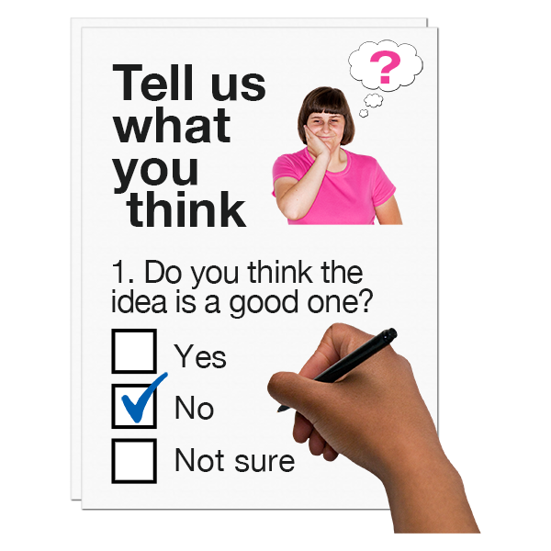
Part 2

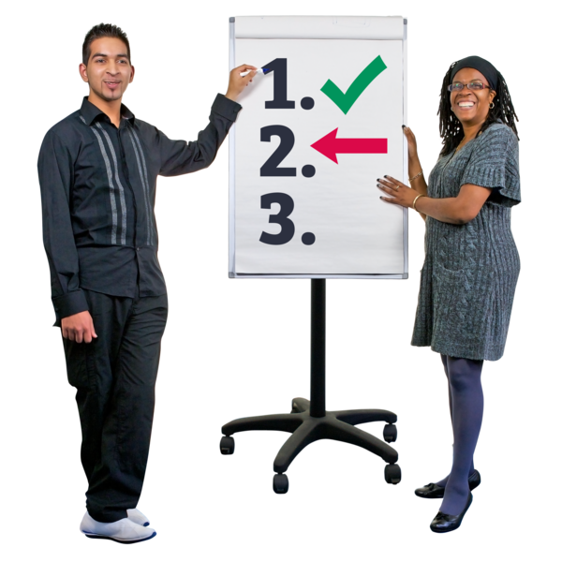

Copyright images © Photosymbols. Prepared by Disability Equality Scotland

Part 2 Questions
This is Part 2 of the feedback form.

This form is one of the ways we find out what you think about police services.

This helps us understand what we are getting right, and what we could do better.

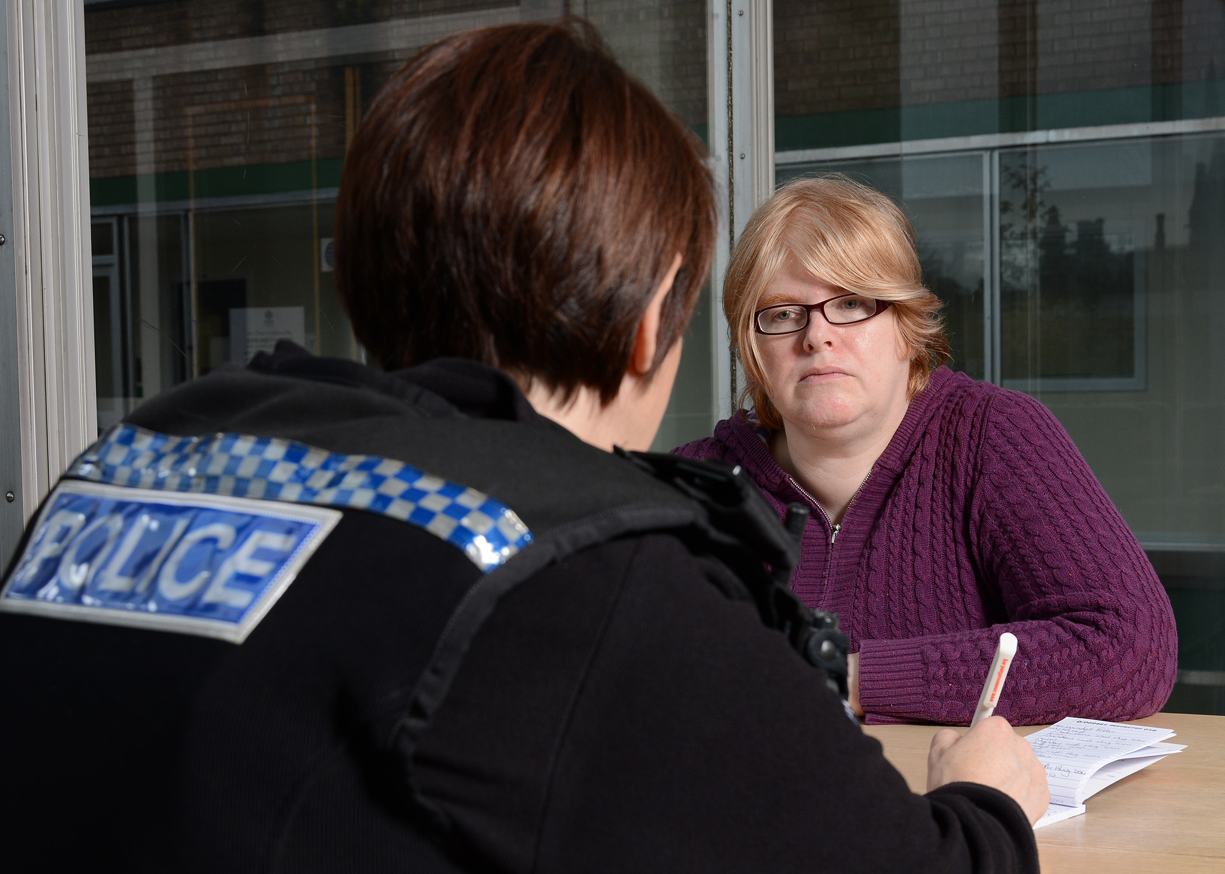 | 22. How happy or unhappy are you with the way you were treated by specialised officers?  For example:  - sexual offences liaison officers (SOLO)  - domestic abuse liaison officers  - domestic abuse investigators  - specialist child interview officers  Please choose 1 answer.
 | Very happy |  | ☐
 | Happy |  | ☐
 | Not happy or unhappy |  | ☐
 | Not happy |  | ☐
 | Very unhappy |  | ☐
 | I do not know |  | ☐
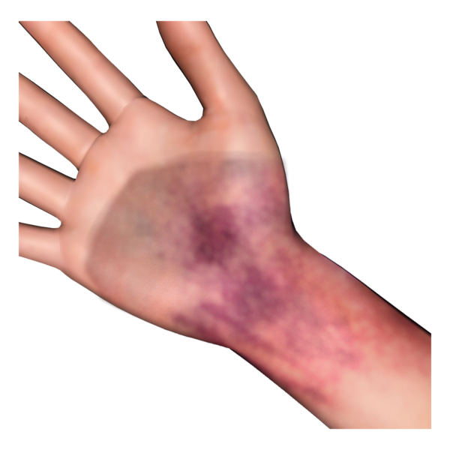 | 23. Please tell us more about your experience with specialised officers.  Think about:  - do you think the police officers understood how you were feeling?  - do you feel like the officers understood how the crime can make you feel or behave?  - did you feel in control of what was happening?  - did you feel informed about the role of the specialised officer?  - were you told what a forensic examination involves before you agreed to have one?  A forensic examination is a medical examination that collects evidence of a crime and records any injuries you have.  - did you feel safe and comfortable?  - were you offered support for your forensic examination?
Type your answer here:

24. How happy or unhappy are you with communication from the police about your case?

Please choose 1 answer.

 | Very happy
 | Happy
 | Not happy or unhappy
 | Not happy
 | Very unhappy
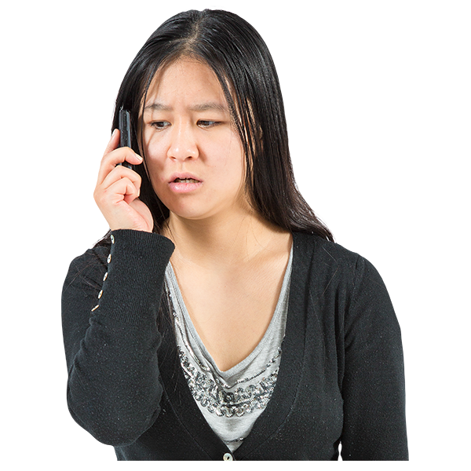 | 25. Please tell us more about the communication between yourself and the police  Think about:  - were you told what was happening, what would happen next, and what happened at the end of the police investigation?  - did you get regular updates?  - could you speak to someone when you needed to?
Type your answer here:

26. How happy or unhappy are you with things that were done to keep you safe?

Please choose 1 answer.

 | Very happy
 | Happy
 | Not happy or unhappy
 | Not happy
 | Very unhappy
 | I do not know
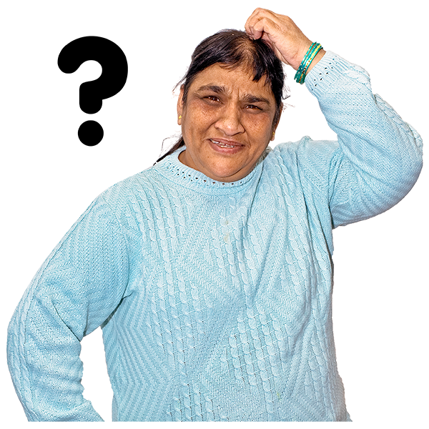 | 27. Please tell us more about what was done to keep you safe.  Think about:  - were safety measures offered or put in place?  - if you reported domestic abuse, did officers fill in a risk assessment, known as a Domestic Abuse Questionnaire or DAQ?
Type your answer here:

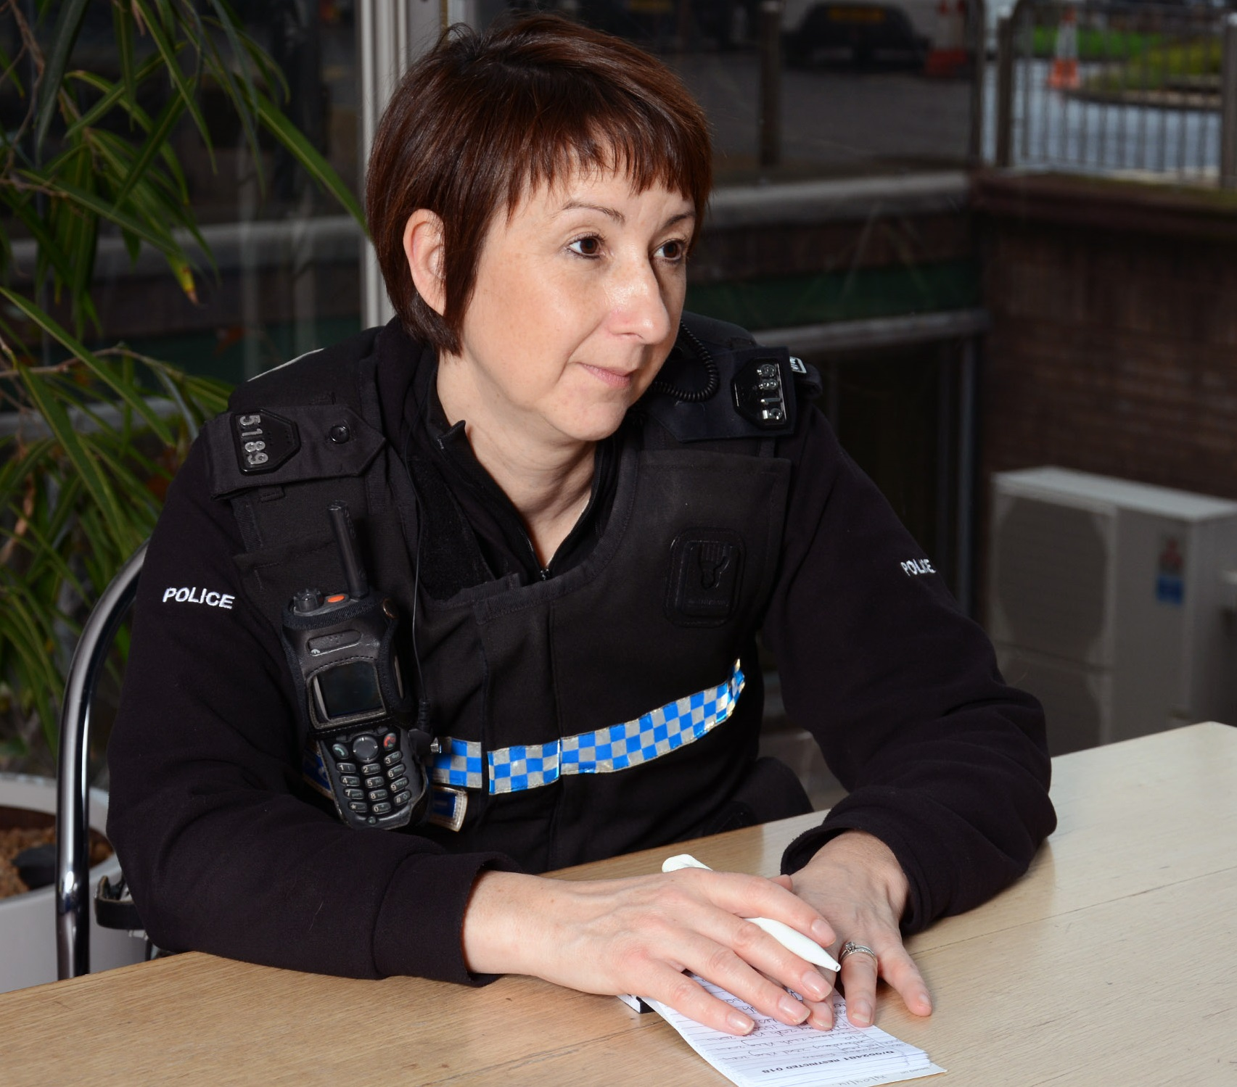 | 28. How much do you agree or disagree with these statements?  I felt that the police were respectful towards me and my situation
 | I strongly agree | ☐
 | I agree | ☐
 | I do not agree or disagree | ☐
 | I disagree | ☐
 | I strongly disagree | ☐
 | I do not know | ☐
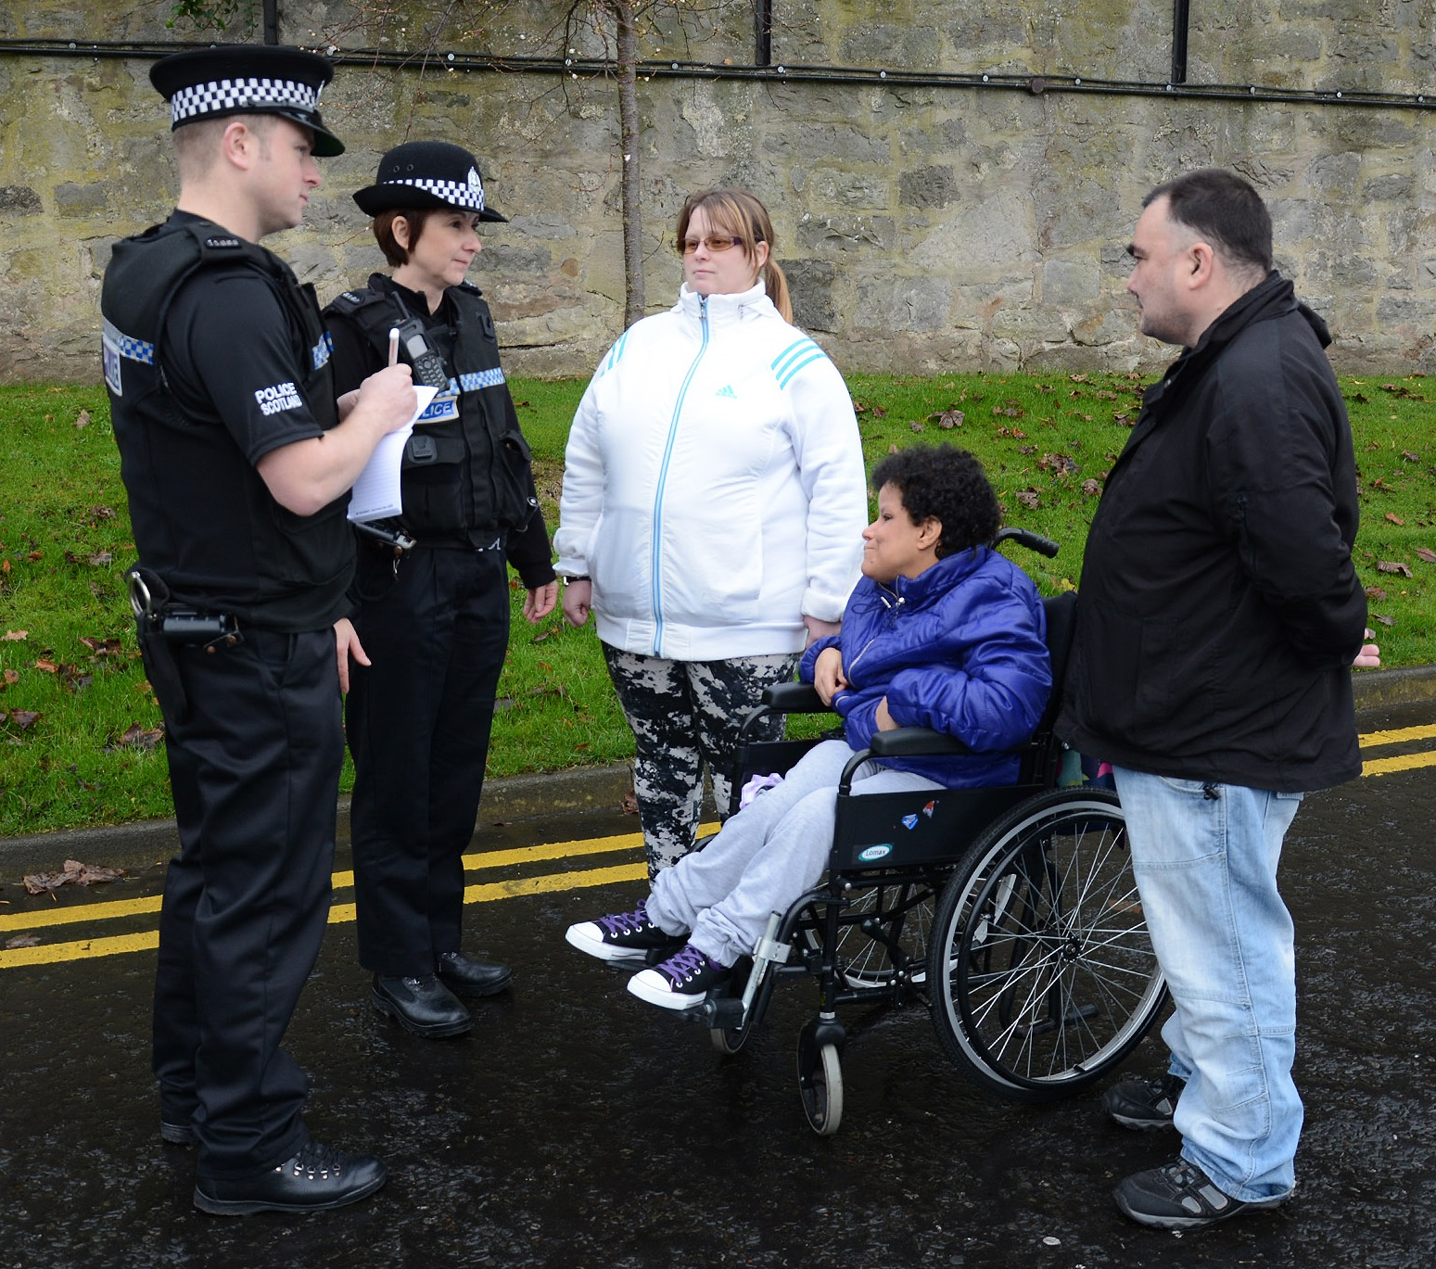 | I felt reassured that the police would help me
 | I strongly agree | ☐
 | I agree | ☐
 | I do not agree or disagree | ☐
 | I disagree | ☐
 | I strongly disagree | ☐
 | I do not know | ☐
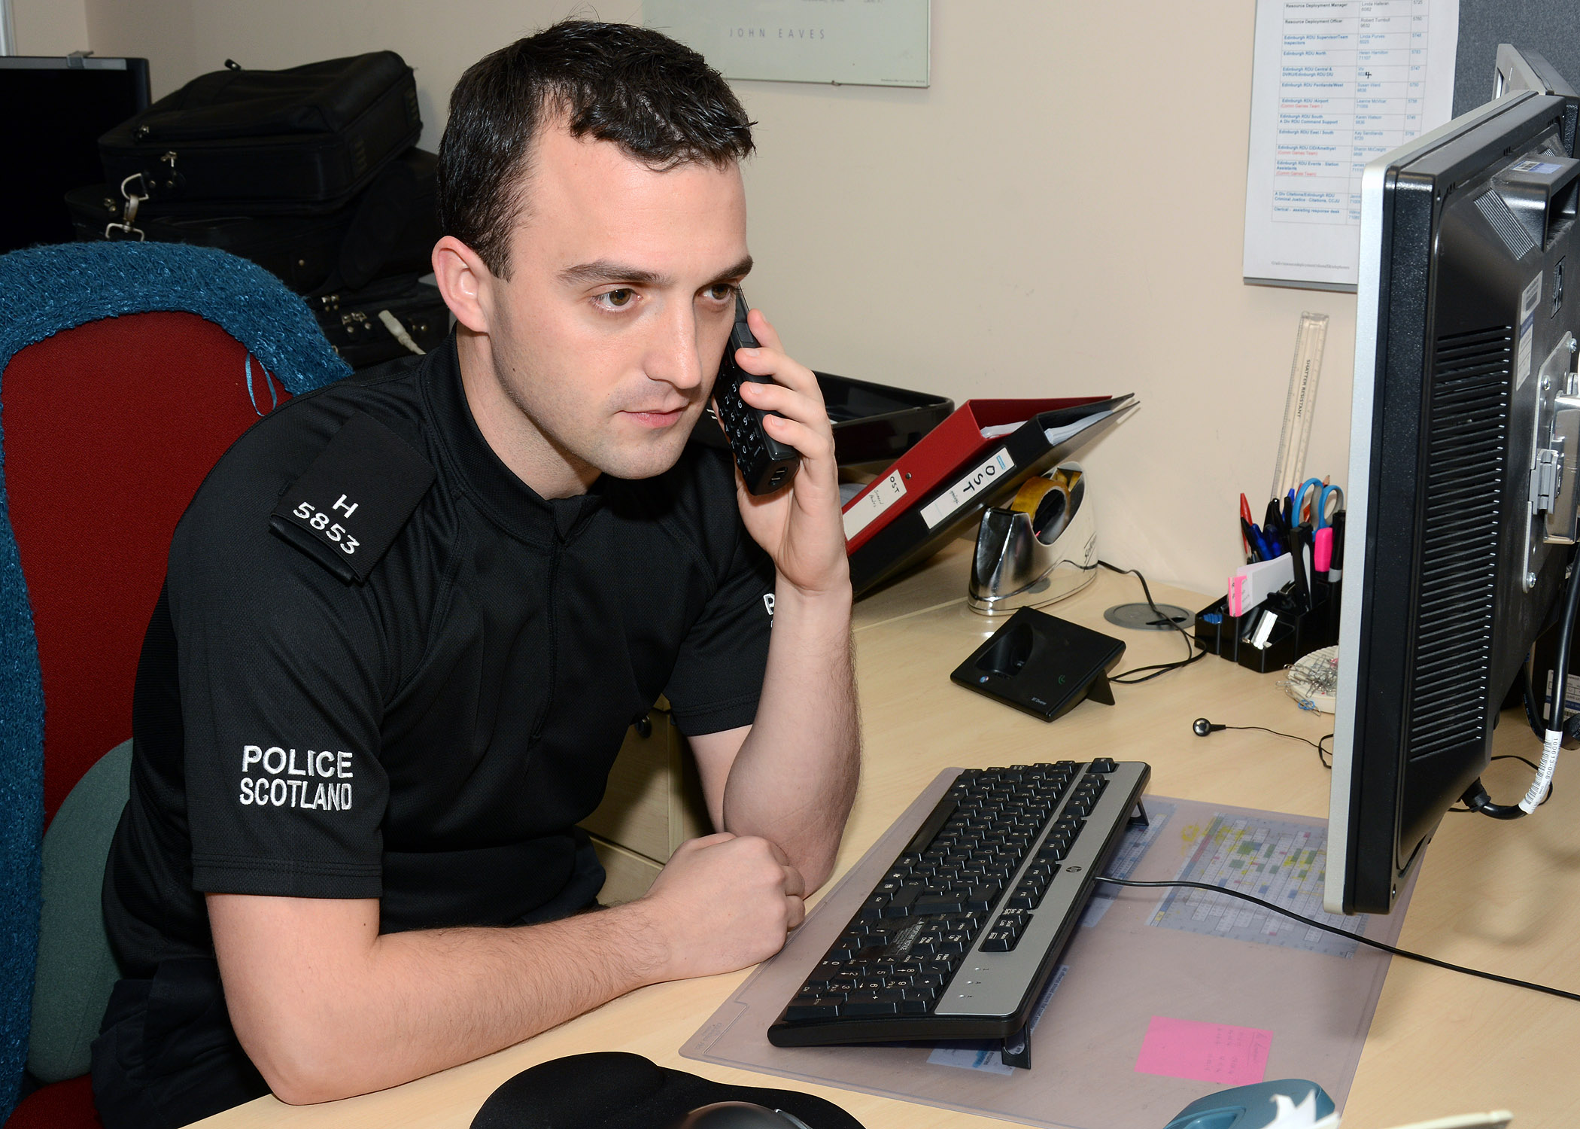 | I felt confident that the police had taken my complaint seriously
 | I strongly agree | ☐
 | I agree | ☐
 | I do not agree or disagree | ☐
 | I disagree | ☐
 | I strongly disagree | ☐
 | I felt safer after reporting
 | I strongly agree | ☐
 | I agree | ☐
 | I do not agree or disagree | ☐
 | I disagree | ☐
 | I strongly disagree | ☐
 | I do not know | ☐
 | The police explained to me what would happen with the reports and the investigation
 | I strongly agree | ☐
 | I agree | ☐
 | I do not agree or disagree | ☐
 | I disagree | ☐
 | I strongly disagree | ☐
 | I do not know | ☐
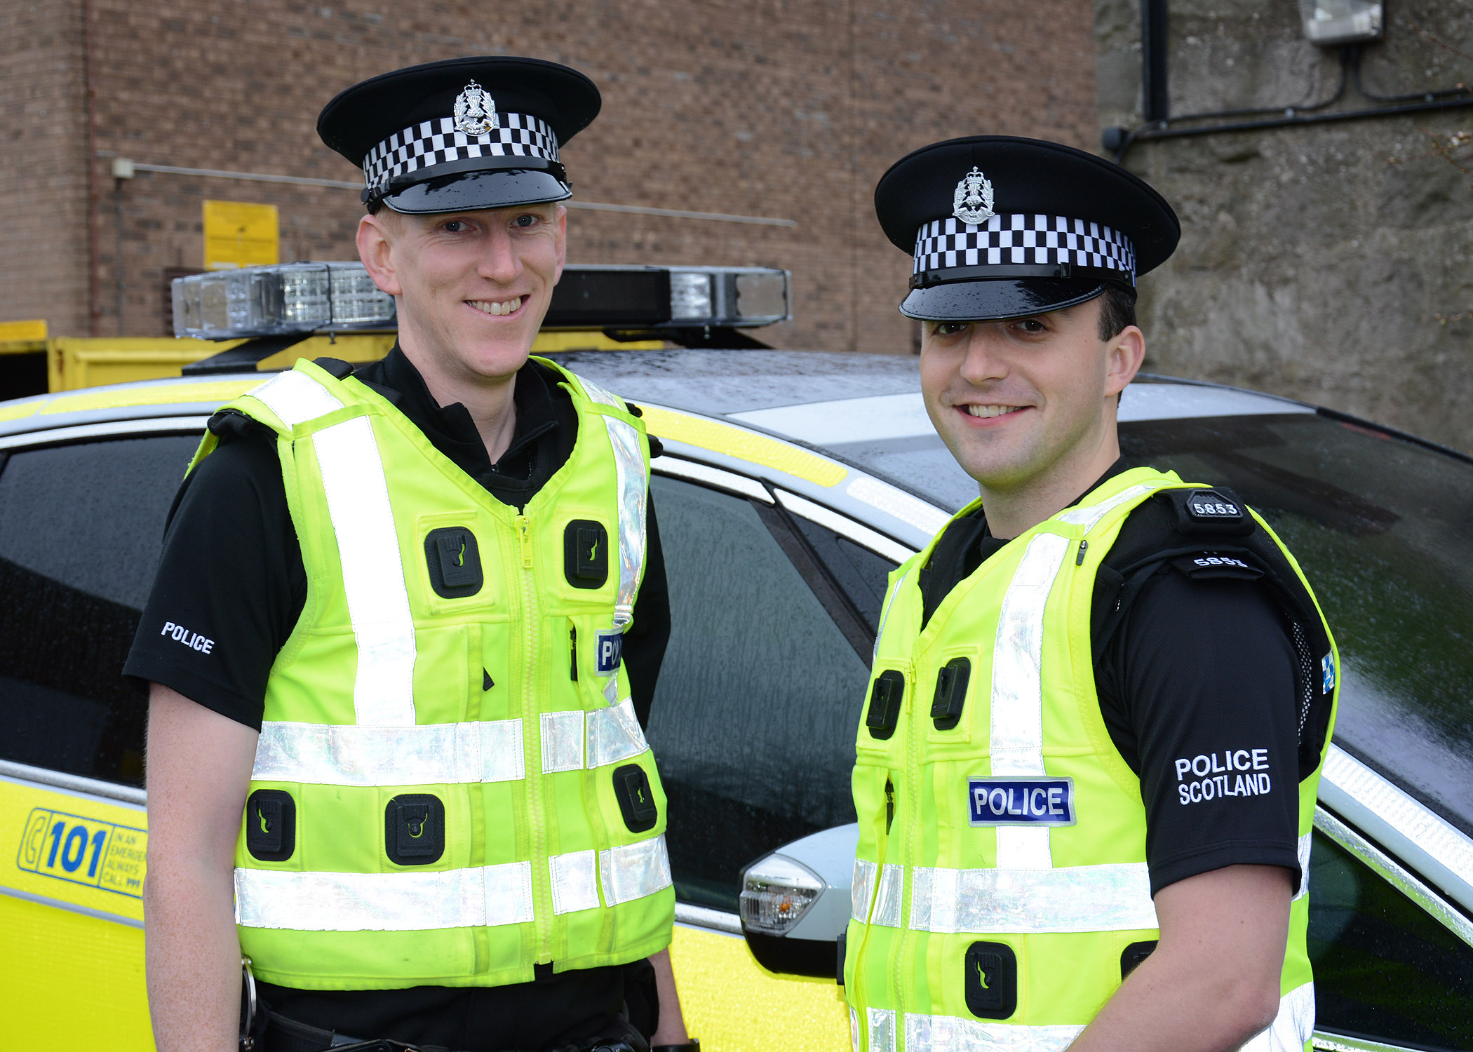 | I knew who my specialist officer or officers were
 | I strongly agree | ☐
 | I agree | ☐
 | I do not agree or disagree | ☐
 | I disagree | ☐
 | I strongly disagree | ☐
 | I do not know | ☐
 | I knew how to contact my specialist officer or officers
 | I strongly agree | ☐
 | I agree | ☐
 | I do not agree or disagree | ☐
 | I disagree | ☐
 | I strongly disagree | ☐
 | I do not know | ☐

The next questions are about safety and support choices.

Please only answer the questions that are right for you.

 | 29. How happy or unhappy are you with any safety and support choices offered to you by police?
 | Very happy | ☐
 | Happy | ☐
 | Not happy or unhappy | ☐
 | Not happy | ☐
 | Very unhappy | ☐
 | I do not know | ☐
30. Please tell us more about the support offered

Think about:

- were you offered support?

If so, what was offered or given?

- did you take up these choices?

- did you find the support choices helpful and supportive?

Type your answer here:

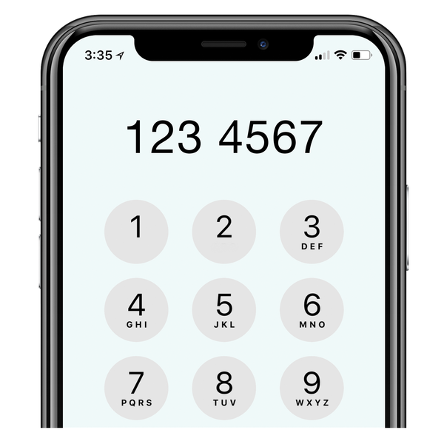  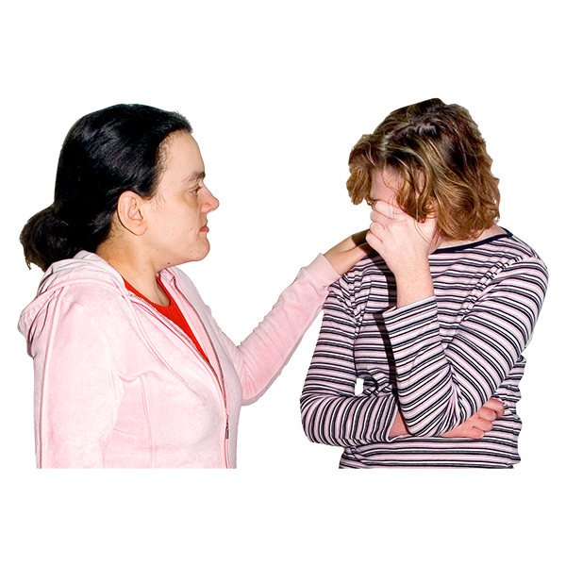 | 31. What support services, if any, were you referred to?  Tick as many as are right for you.
 | Samaritans | ☐
 | Hemat Gryffe Women's Aid | ☐
 | Shakti Women's Aid | ☐
 | Breathing Space | ☐
 | NHS 24 | ☐
 | Childline | ☐
 | LGBT Helpline Scotland | ☐
 | Scottish Domestic Abuse and Forced Marriage Helpline | ☐
 | Abused Men in Scotland | ☐
 | a local Women's Aid organisation | ☐
 | other – tell us what | ☐
 | I was offered support but I did not want it | ☐
 | None | ☐
 | I do not know | ☐
32. We want to find out more about how we can support people in the best way.

Think about:

- do you think the police officers understood how you were feeling?
- do you feel like the officers understood how the crime can make you feel or behave?

- did you feel in control of what was happening?

- were you asked if you wanted to be interviewed by a male or female officer?

- were you offered breaks?

- were you offered support when you gave your statement?

Type your answer here:

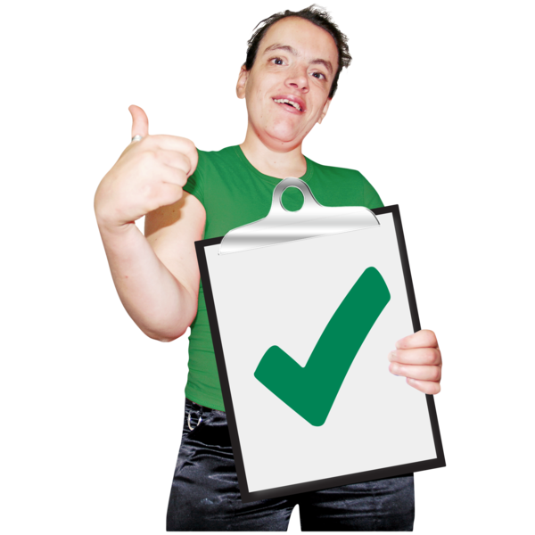 | 33. What, if anything, was good about our support?
Type your answer here:

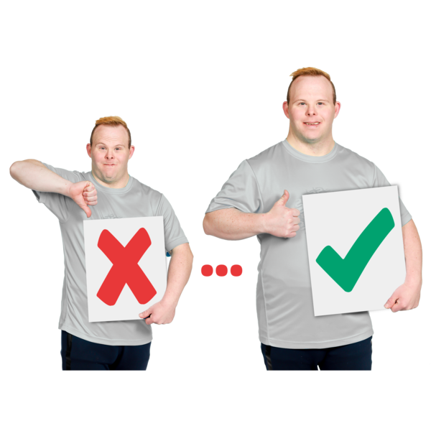 | 34. What, if anything, could be changed or made better?
Type your answer here:

 | 35. What, if anything, helped make you feel safe and comfortable?
Type your answer here:

 | 36. If your experience was not good, please tell us more.
Type your answer here:

Think about your whole experience with Police Scotland

 |  | 37. How happy or unhappy are you with your experience with Police Scotland?
 |  | Very happy | ☐
 |  | Happy | ☐
 |  | Not happy or unhappy | ☐
 |  | Not happy | ☐
 |  | Very unhappy | ☐
 |  | I do not know | ☐
38. Is there anything else you want to tell us?
Type your answer here:

 | 39. What could Police Scotland have done to make your experience better?
Type your answer here:

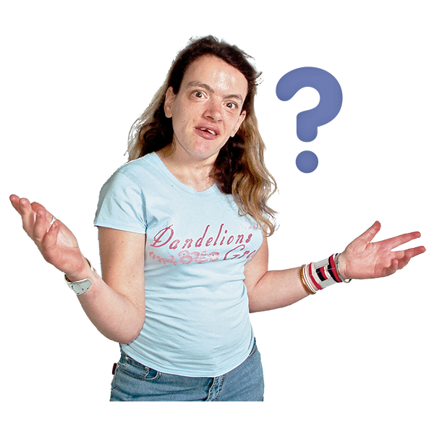 | 40. Is there anything else about your experience with Police Scotland that you want to tell us about?
Type your answer here:

About you
These questions help us understand the views and experiences of everyone in Scotland's diverse communities.

Your answers will help us to make sure everyone is treated fairly.

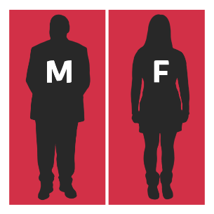 | 1. Do you think of yourself as:
 | female | ☐
 | male | ☐
 | non-binary (I don’t see myself as only male or only female) | ☐
 | in another way | ☐
2. Do you consider yourself to be trans or to have a trans history?
Transgender means you see yourself differently from your birth sex (male or female).
 | Yes
 | No
 | I do not want to say
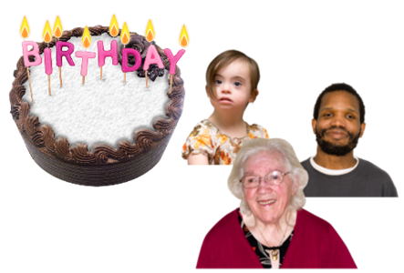 | 3. How old are you?  Write it here:
4. Sexual orientation means what kinds of people you love or have sexual or romantic feelings about.
Do you think of yourself as:
 | Heterosexual or straight | ☐
 | Bisexual | ☐
 | Gay | ☐
 | Lesbian | ☐
 | Any other sexual orientation. | ☐
 | I do not want to say | ☐
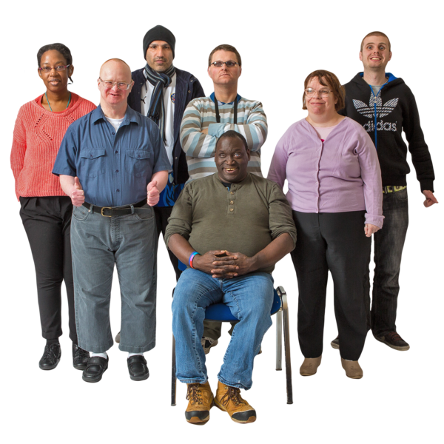 | 5. What is your ethnicity?  Ethnicity is the word we use to describe our background.  People from an ethnic group might have the same language, culture or religion.  What best describes you?
 | White
 | Scottish | ☐
 | Other British | ☐
 | Irish | ☐
 | Gypsy or Traveller | ☐
 | Polish | ☐
 | Any other white ethnic group | ☐
 | Mixed or multiple ethnic group
 | Any mixed or multiple ethnic group | ☐
 | Asian, Asian Scottish or Asian British
 | Bangladeshi, Bangladeshi Scottish, Bangladeshi British | ☐
 | Chinese, Chinese Scottish, Chinese British | ☐
 | Indian, Indian Scottish, Indian British | ☐
 | Pakistani, Pakistani Scottish, Pakistani British | ☐
 | Any other Asian | ☐
 | African
 | African, African Scottish, African British | ☐
 | Any other African | ☐
 | Caribbean or Black
 | Black, Black Scottish, Black British | ☐
 | Caribbean, Caribbean Scottish, Caribbean British | ☐
 | Any other Caribbean or Black
 | Other ethnic group | ☐
 | Arab, Arab Scottish, Arab British | ☐
 | Any other ethnic group. Write your answer here: | ☐
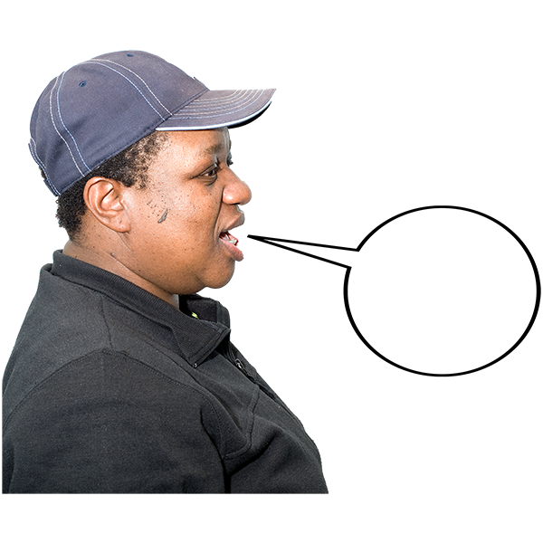 | 6. Is English your first language?
 | Yes
 | No
 | I do not want to say
 | 7. What is your religion do you belong to?
 | No religion | ☐
 | Church of Scotland | ☐
 | Roman Catholic | ☐
 | Other Christian | ☐
 | Buddhist | ☐
 | Hindu | ☐
 | Jewish | ☐
 | Muslim | ☐
 | Sikh | ☐
 | Any other religion. Write your answer here:
 | I do not want to say
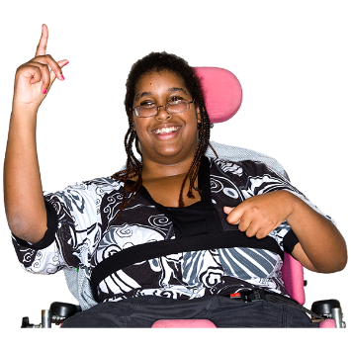 | 8. Do you consider yourself to have a disability, long-term illness or health condition?  Long term means it has lasted for over a year.  Yes ☐ go to question 9.  No ☐ go to question 10.
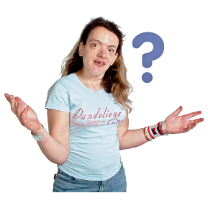 | 9. Does this disability or long-term health condition affect you in any of these ways?
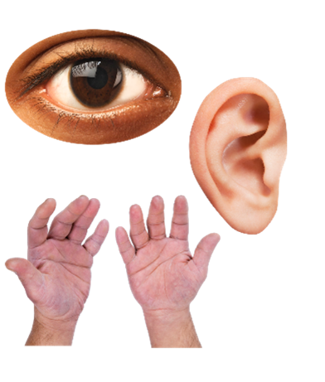  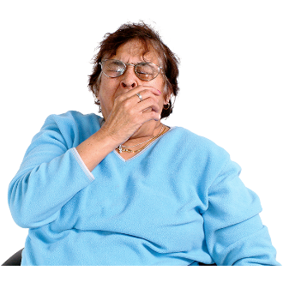  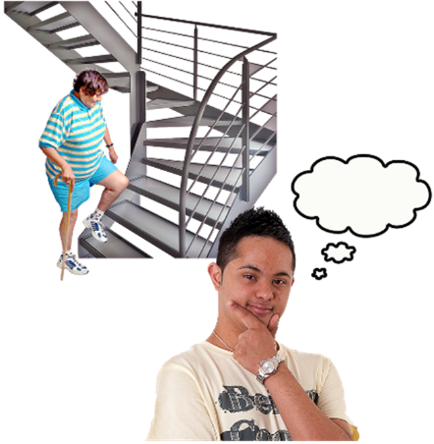 | Vision – how I see | ☐
 | Hearing | ☐
 | How I use my hands – for example if it is difficult for me to lift things or use a keyboard | ☐
 | Mobility – for example walking or climbing stairs | ☐
 | How I look – for example a mark, scar or condition that has changed how I look. | ☐
 | Learning, understanding or concentrating | ☐
 | Remembering things | ☐
 | Mental health | ☐
 | I get out of breath or tired easily | ☐
 | How I behave around other people | ☐
 | None of the above | ☐
 | In another way. Please tell us what: | ☐
In other surveys disabled people told us they wanted to say how their disability affected them.

We will use this information to give people a service that is right for them.

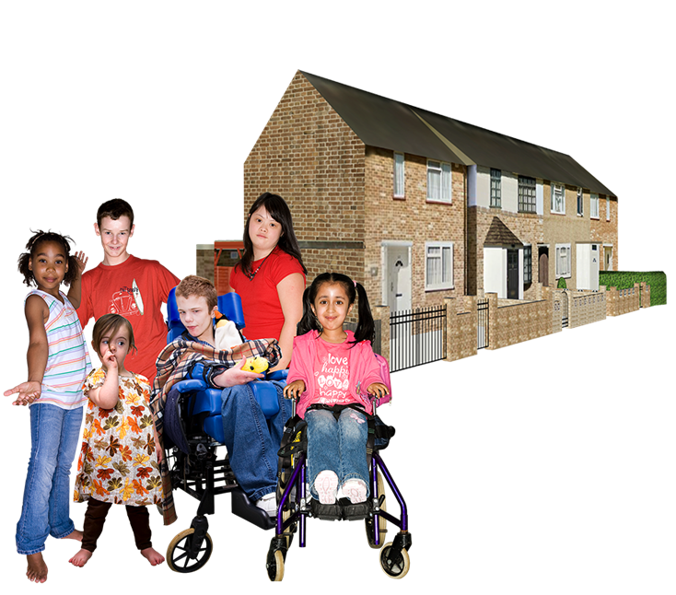  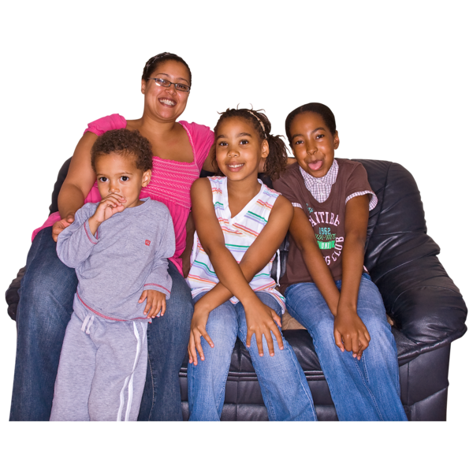 | 10. Are you care experienced and are aged under 26?  Care experienced means you are or were looked after by someone who is not your parent, for example:  - in the family home with support from social services or a social worker  - foster care  - residential or secure care like a children’s home  - kinship care - with family friends or relatives
 | Yes | ☐
 | No | ☐
 | I do not want to say | ☐
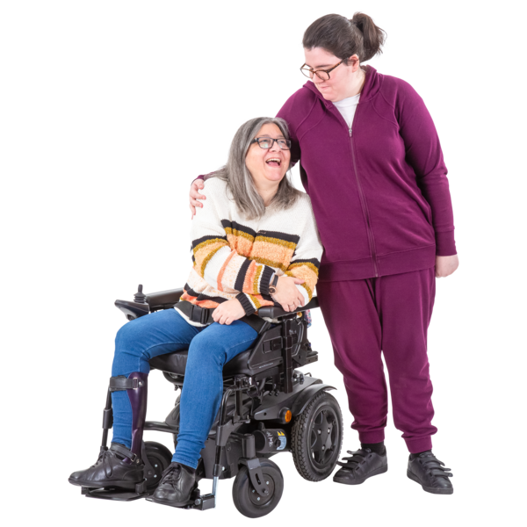 | 11. Do you look after or give help or support to family members, friends, neighbours or others because they have:  - physical difficulties  - mental ill-health  - a disability  - problems related to old age
 | Yes I am a full-time unpaid carer | ☐
 | Yes I am a part-time unpaid carer | ☐
 | No I am not a carer | ☐
 | I do not want to say | ☐
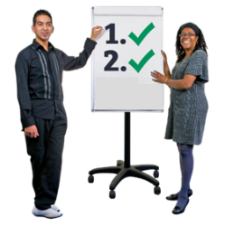 | You have now finished part 2 of the survey.  Please save your answers and email the survey to: insightengagement@scotland.police.uk
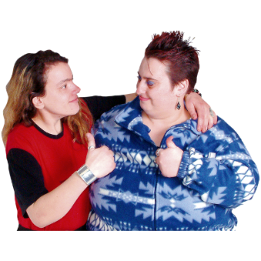 | Thank you for telling us what you think.  What you tell us is important.

Copyright images © Photosymbols. Prepared by Disability Equality Scotland

