Tell us what you think of Police Scotland

This form is for anyone who has reported domestic abuse, rape or other sexual crime to Police Scotland

Part 1

Copyright images © Photosymbols. Prepared by Disability Equality Scotland

Introduction
This feedback form is one of the ways we find out what you think about police services.

This helps us understand what we are getting right, and what we could do better.

Reporting a crime
Please do not use this form to report crime or ask us for help.

If you or someone else needs police help:

- call 999 in an emergency

- if it is not an emergency:
  - call 101

  - or email: contactus@scotland.police.uk

For more contact information please visit our website: https://www.scotland.police.uk/contact-us/

If you have any questions about this form, email us at: insightengagement@scotland.police.uk.

What is this form for?
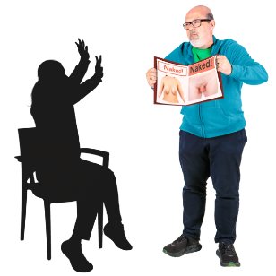  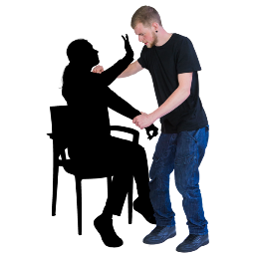 | This form is for anyone who has reported domestic abuse, rape or other sexual crime, to tell us what you think about the service you got from Police Scotland.  Domestic abuse is when you are hurt,  bullied or frightened by:  - your husband, wife or partner  - your boyfriend or girlfriend  - an ex-partner - someone who used to be your partner  Rape is when someone makes you have sex with them when you do not want to.  Sexual crime includes:  - sexual assault - when someone:  - kisses or touches another person in a sexual way without their agreement  - makes another person take part in a sexual activity with them without their agreement  - sexual abuse is when you are made to do anything sexual that you do not want to do

Your personal information and consent
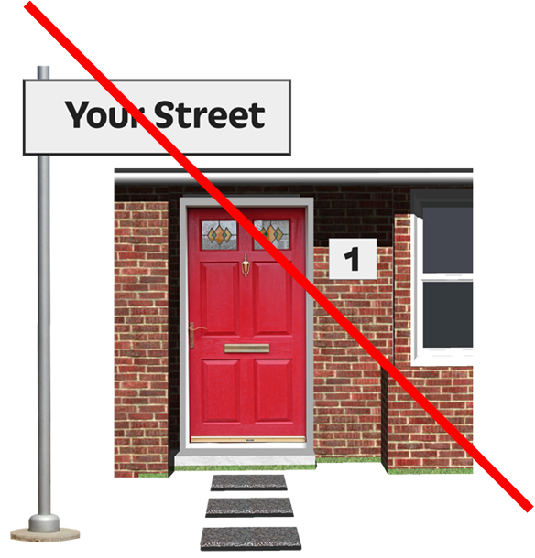  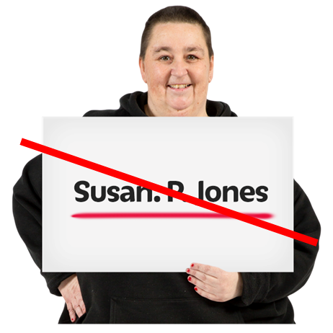  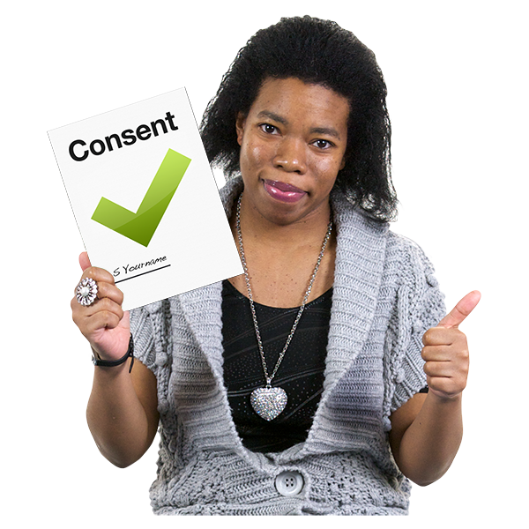  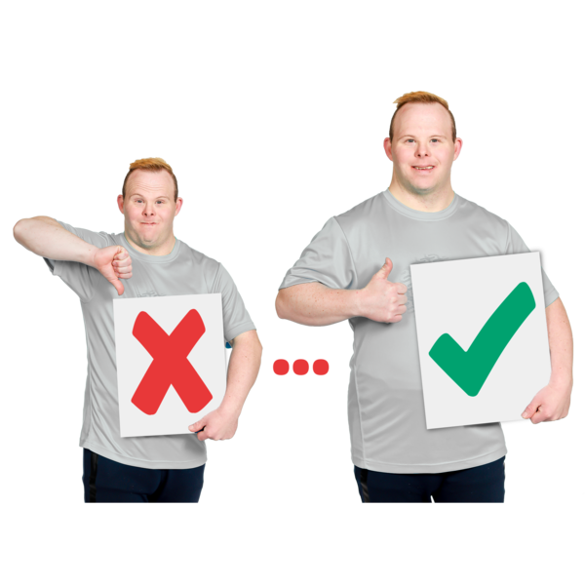  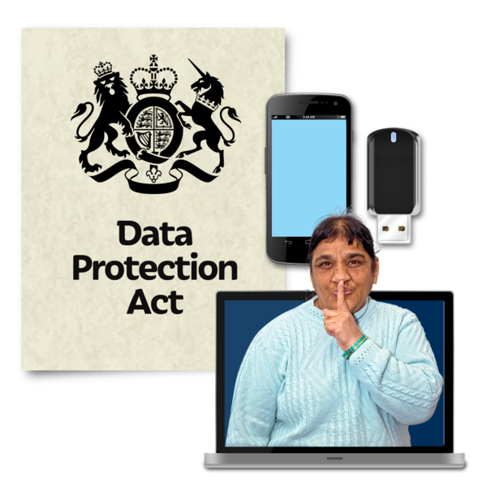 |  | Your answers are anonymous.  Anonymous means you do not have to give your name.  Consent means to agree.  Please do not write anything in your answers that someone could use to work out who you are, like names or addresses.  We will delete any information like this.  We will use the information we get to:  - make reports for people who make decisions in Police Scotland  - help us when providing training  - make changes to our services  Police Scotland will make sure your data is kept safe.  We will never pass your information on to any other people or organisations unless you say we can.
You must answer the questions that are in red.

All the other questions are in black, bold writing.

If you do not want to answer a question miss it out.

You do not have to give us details of any personal experiences in this form if you do not want to.

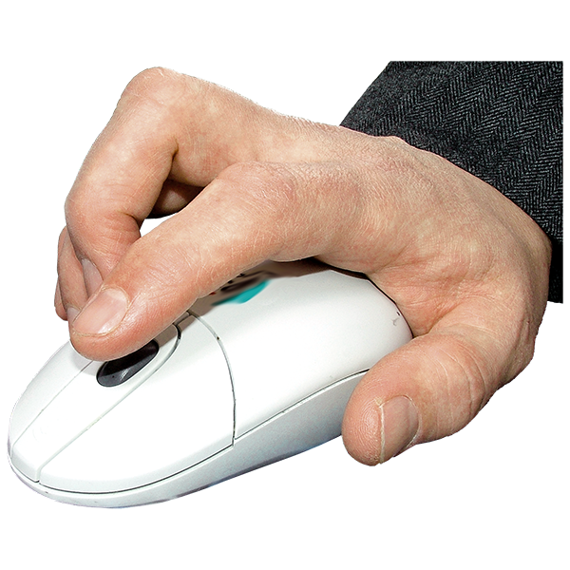 |  | Click on the box of the answer you agree with and a tick will appear. ☐  If you change your mind you can click on it again to untick it.
If you have more to say type your answer in the ‘Type your answer here’ spaces.

The space will grow as you type.

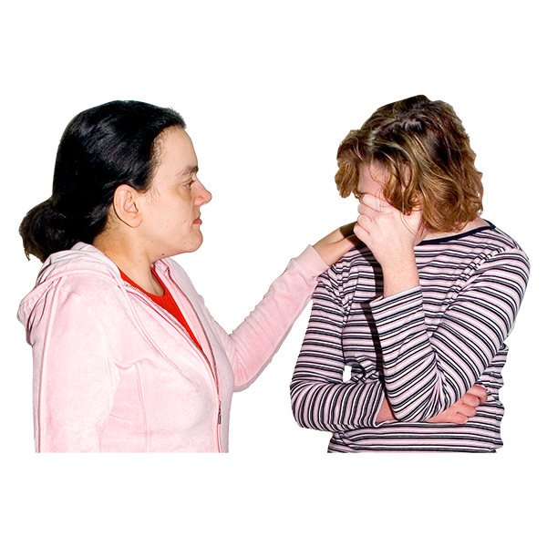 |  | There is information about organisations that can support you on page 6.
 |  | I consent to my anonymous feedback being used to make Police Scotland’s services better
 |  | Yes | ☐
 |  | No | ☐
 |  | I consent to my anonymous comments being copied into reports to make Police Scotland's services better
 |  | Yes | ☐
 |  | No | ☐
Reporting the crime - Support information
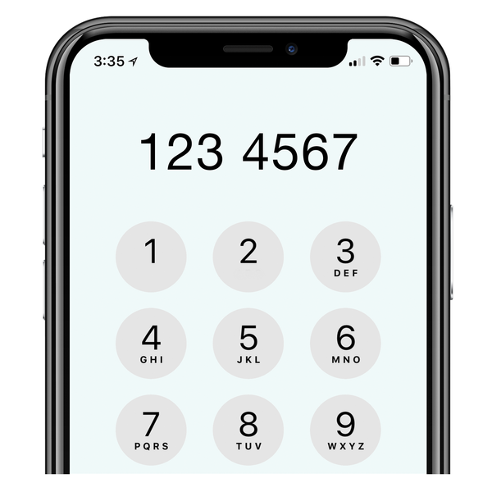 |  | If you need support please contact:  - Rape Crisis Scotland helpline on 08088 01 03 02  - Scottish Domestic Abuse and Forced Marriage Helpline on 0800 027 1234  - Scottish Women's Aid to find your local Women's Aid service  - Hemat Gryffe Women's Aid for BME women, children and young people on 0141 353 0859  - Shakti Women's Aid for BME women, children and young people on 0131 475 2399  - Abused Men in Scotland on 03300 949 395
- LGBT Helpline Scotland on 0300 123 2523
- Samaritans on 116 113
- Breathing Space on 0800 83 85 87
- NHS Inform or NHS 24 on 111
- Scottish Women's Rights Centre on 08088 010 789
- Childline on 0800 1111

More support information is at: safer.scot

Questions
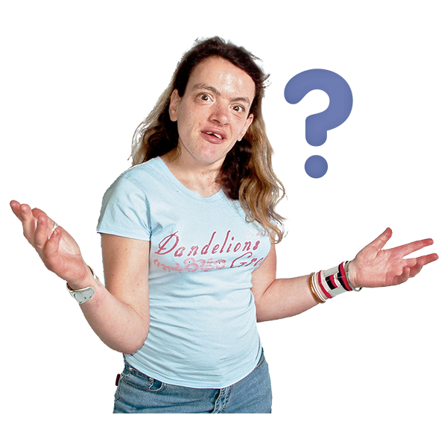 |  | 1. Did you know the person or people who committed the crime against you?
 |  | I am in a relationship with them, or have been in the past | ☐
 |  | I knew them but I have never been in a relationship with them | ☐
 |  | They were a stranger to me | ☐
 |  | 2. What type of crime are your answers about?
 |  | Domestic abuse | ☐
 |  | Rape | ☐
 |  | Any other sexual crime | ☐
 |  | All of the above | ☐
 |  | I do not know | ☐
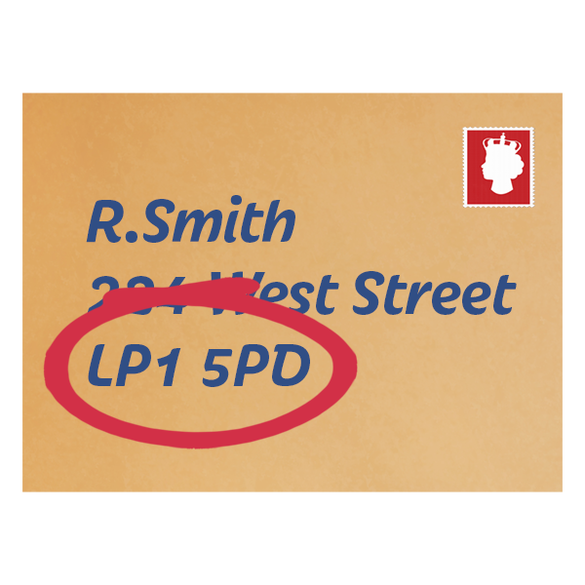 |  | 3. What is your postcode?  Write it here:  Your postcode makes sure we can act on what you tell us.  We will not use postcodes to identify you or your address.  If you move between places a lot or you are homeless, please give us the postcode of the place where you spend most time.
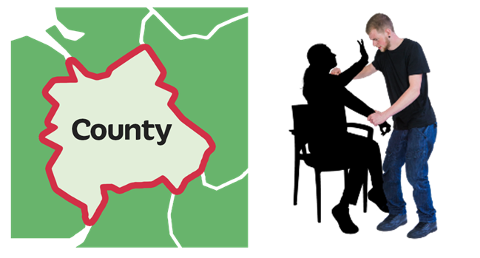 |  | 4. Which council area did the crime happen in?  Write it here:
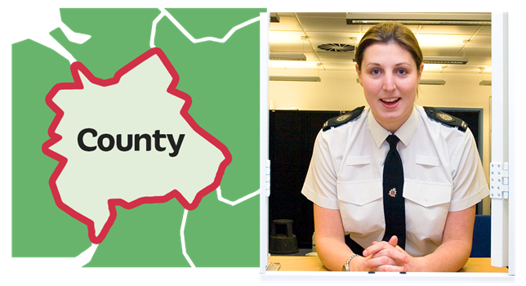 |  | 5. Which council area did you make your report to police in?  Write it here:
 |  | 6. Who contacted Police Scotland?
 |  | I reported it directly to the police | ☐
 |  | Someone else – like a family member, neighbour or friend | ☐
 |  | A support person or organisation | ☐
 |  | The abuser made a report against me | ☐
 |  | Other - tell us who – type it here: | ☐
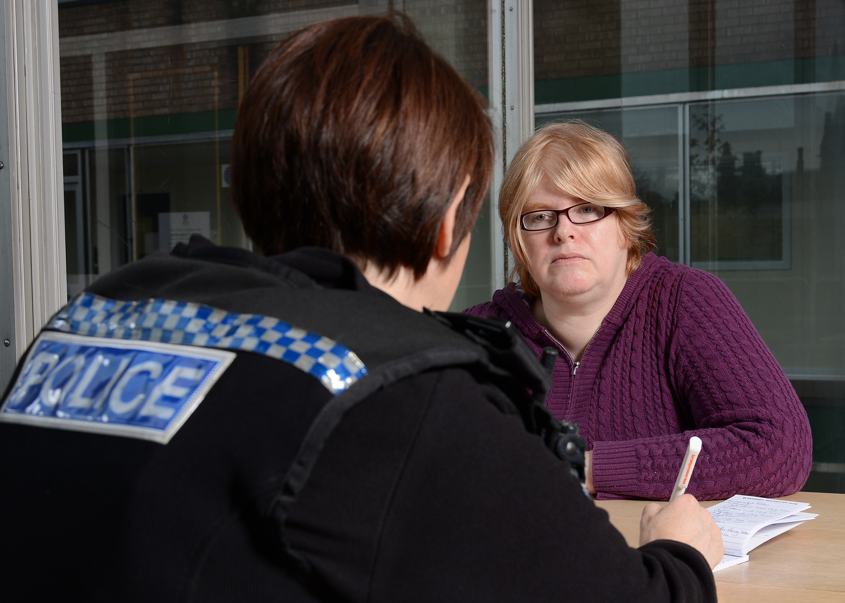 |  | 7. How was the report made to Police Scotland?  Please choose all the answers that are right for you.
 |  | Online | ☐
 |  | In person – like telling an officer on the street, in a police station or at my home address | ☐
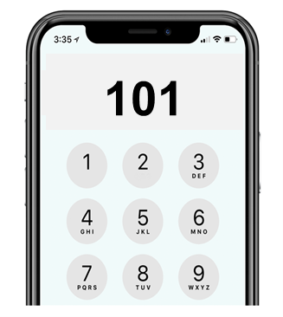 |  | Support services | ☐
 |  | 999 call | ☐
 |  | 101 call | ☐
 |  | In another way – please tell us how:  Type your answer here: | ☐
 |  | 8. When did the crime happen?
 |  | in the last day |  | ☐
 |  | in the last week |  | ☐
 |  | in the last month |  | ☐
 |  | in the last year |  | ☐
 |  | longer than 1year ago |  | ☐
 |  | more than 10 years ago |  | ☐
9. What encouraged you to contact police?

Type your answer here:

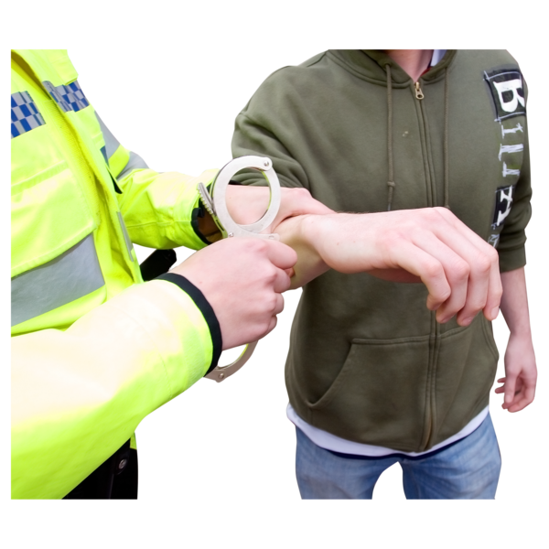 |  | 10. Did your report lead to the person being charged with a crime?
 |  | Yes | ☐
 |  | No | ☐
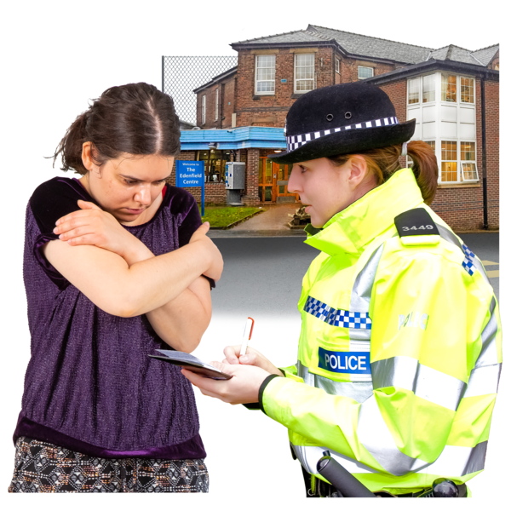 |  | The investigation is still happening  An investigation is when police look for facts to find out exactly what happened and if a crime has been committed. | ☐
 |  | I do not know | ☐
11. Is there anything else you want to tell us about this?

Type your answer here:

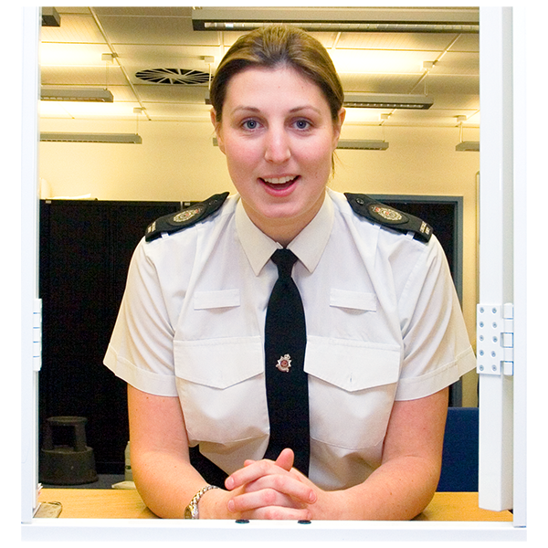 |  | 12. Tell us how much you agree or do not agree with this sentence:  I would report any matter to Police Scotland in the future
 |  | Strongly agree | ☐
 |  | Agree | ☐
 |  | Neither agree nor disagree | ☐
 |  | Disagree | ☐
 |  | Strongly disagree | ☐
 |  | Don’t know | ☐
13. Is there anything else you want to tell us?

Type your answer here:

 |  | 14. Thinking about your experience, how easy or hard was it to contact Police Scotland?
 |  | Very easy |  | ☐
 |  | Easy |  | ☐
 |  | Not easy or hard |  | ☐
 |  | Hard |  | ☐
 |  | Very hard |  | ☐
 |  | I do not know |  | ☐
15. Please tell us more about this.

Type your answer here:

 |  | 16. Did staff understand what you needed?
 |  | Yes | ☐
 |  | No | ☐
 |  | I do not know
17. Please tell us more about when you first contacted police.

Think about:

- did they give you what you needed?
- did you feel comfortable and safe?
- did you feel understood and listened to?

Type your answer here:

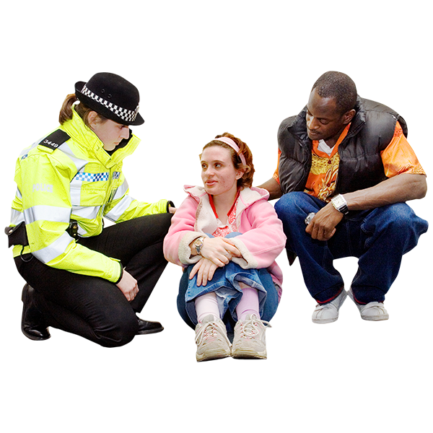 |  | 18. How happy or unhappy are you with the way you were treated by the first responder officers?  First responder officers are the officers who were first to contact you.  Please choose 1 answer.
 |  | Very happy |  |  | ☐
 |  | Happy |  |  | ☐
 |  | Not happy or unhappy |  |  | ☐
 |  | Not happy |  |  | ☐
 |  | Very unhappy |  |  | ☐
 |  | I do not know |  |  | ☐
19. Please tell us more about your treatment by first responder officers.

Think about:
- did the first responder officers give you the choice of a male or female officer to take your statement?

- if you needed information in another language, were you offered a translator and could you choose if you got a male or female translator?

- did you get breaks?

- if you reported sexual crime, were you told that a Sexual Offences Liaison Officer (SOLO) would contact you?
- were you offered support when giving your statement?

- do you feel like the officers understood how you were feeling?

- do you feel like the officers understood how the crime can make you feel or behave?

- did you feel in control of what was happening?

Type your answer here:

20. How much do you agree or disagree with this sentence:

I knew what would happen next.

 |  | Strongly agree | ☐
 |  | Agree | ☐
 |  | Neither agree nor disagree | ☐
 |  | Disagree | ☐
 |  | Strongly disagree | ☐
 |  | I do not know | ☐
21. Please tell us more - think about:

- how long things took?

- how often you might be contacted with updates?

- who to contact and how to contact them if needed?

Type your answer here:

You have now finished part 1 of the survey.

Please save your answers and email the survey to: insightengagement@scotland.police.uk

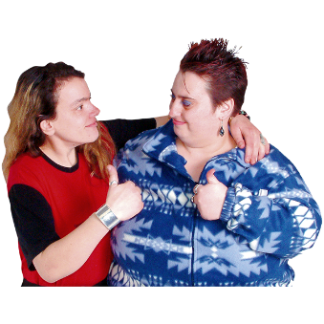 |  | Then please go back to the website: consult.scotland.police.uk  and fill in part 2 of the survey.  Thank you for telling us what you think.  What you tell us is important.

Copyright images © Photosymbols. Prepared by Disability Equality Scotland

