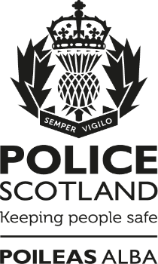

Tell us what you think about events in Scotland

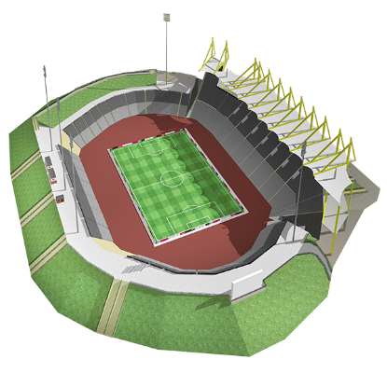
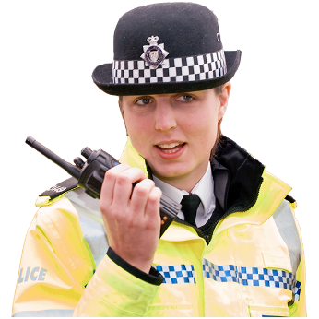

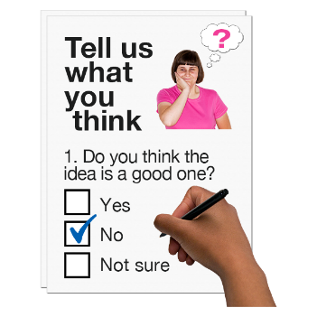

Copyright images © Photosymbols. Prepared by Disability Equality Scotland

What is this survey for?
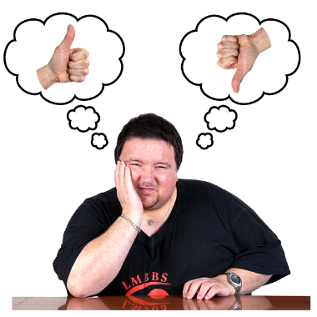 | We want to know what you think about the work of Police Scotland.  This survey will help us listen, understand and respond to what you think.
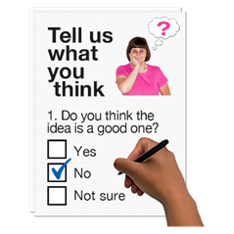 | We want to hear from people who have:  - been to events  - experienced an event you were not part of – for example if you live near where an event happened.

What is an event?
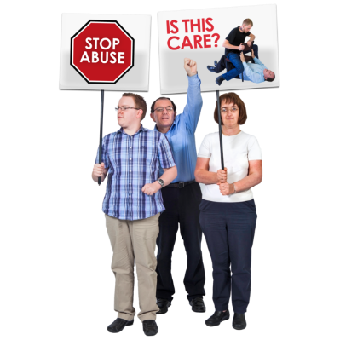  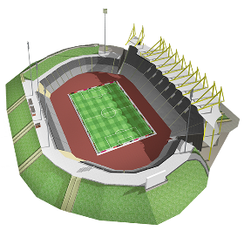 | An event is an organised gathering of people.  It could be events like:  - festivals, concerts, sports or parades  - or to take part in a protest or demonstration  A protest or demonstration is when people show how they feel about something that is important to them.
This survey is not about reporting crime.
There are ways to contact Police Scotland.
Find out more online at:
https://www.scotland.police.uk/contact-us/
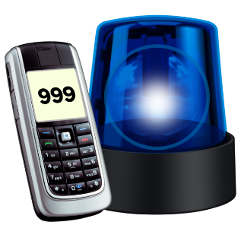 | If you need help from the Police in an emergency call 999.

How will we use your personal information?
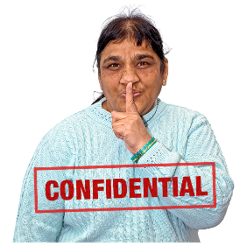 | When you send the survey back we save it separately from your email.  Your replies are confidential.  This means your information will be kept private.
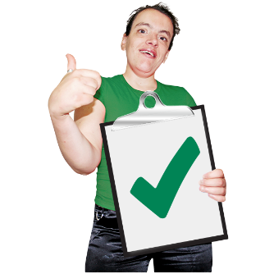 | If you fill out the survey you agree to Police Scotland using your data for their reports.  No-one will know it is your information.

How do I take part in the survey?
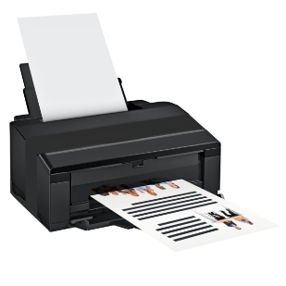 | You can fill out this survey on your computer then save it and email it to:  consultations@scotland.pnn.police.uk
 | or print a copy and write in your answers then scan it and email it to: consultations@scotland.pnn.police.uk
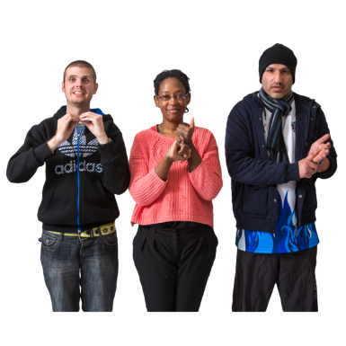 | You can send us your answers in a British Sign Language video.
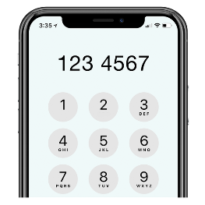 | If you have questions or if you want to do the survey over the phone please phone the Insight Team on: 07717 188 184  or email: consultations@scotland.pnn.police.uk  Give them a phone number our team can reach you on.
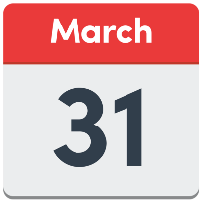 | Send us your survey before 31 March 2022.
If you are a Young Scot member you will get an email with a code to claim 150 rewards points when you send us your survey.
Go to young.scot to sign up.
There are 7 parts in the survey.

Click on the box of the answer you agree with and a tick will appear. ☐

If you change your mind you can click on it again to untick it.

If you are filling out a paper copy, tick the box of the answer you agree with, and if you have more to say write your answer in the ‘Write your answer here’ spaces.

Miss out a question if you do not know the answer.

You do not have to answer a question if you do not want to.

Part 1: Introduction

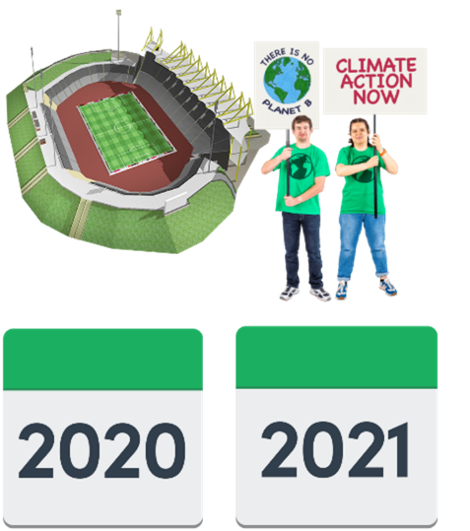 | - Have you gone to an event or experienced an event in Scotland in 2020 or 2021?
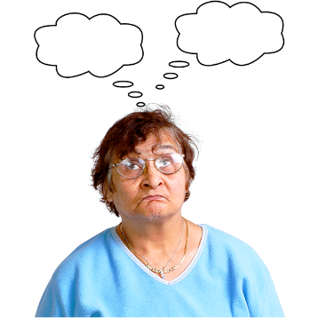 | Yes I have gone to an event | ☐
 | I live close to where an event has taken place in my community | ☐
 | I have not gone to an event or experienced an event but I would like to say what I think about them | ☐
 | I have not gone to an event | ☐
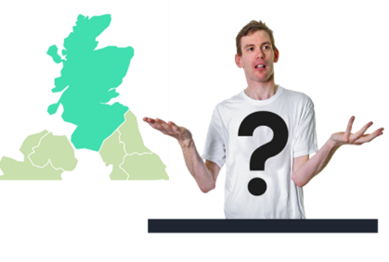 | - Where in Scotland was the event?
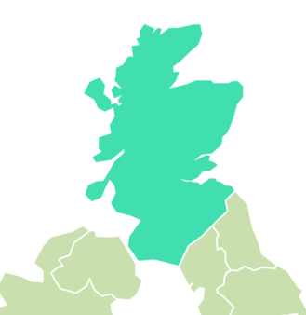 | Aberdeen | ☐
 | Dundee | ☐
 | Edinburgh | ☐
 | Glasgow | ☐
 | Inverness | ☐
 | Perth | ☐
 | Stirling | ☐
 | In another place.  Tell us where: | ☐
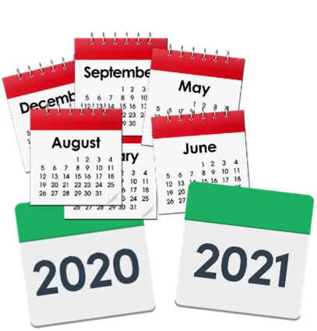 | - When was the event?  Tell us the month and year if you can.  Write your answer here:
 | - How often do you go to or experience events like this?
 | Never – this was my first event | ☐
 | Sometimes | ☐
 | I got to events like this a lot | ☐
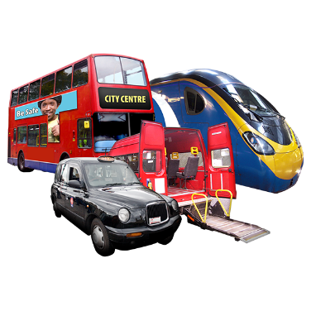 | 5. How far do you usually travel to attend an event?
 | less than a mile | ☐
 | 1 to 2 miles | ☐
 | 3 to 4 miles | ☐
 | 5 to 10 miles | ☐
 | more than 10 miles | ☐
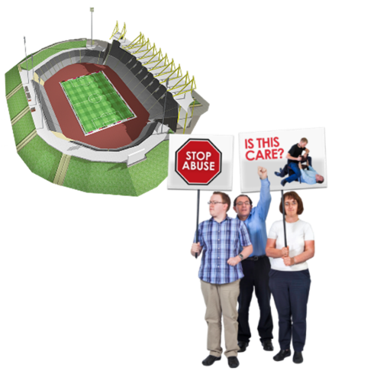 | - Think about any events, protests or demonstrations you have gone to in the past 2 years.  What were they about?  Write your answer here:

Part 2: Public confidence
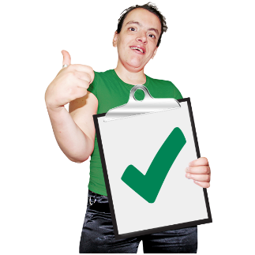 | Public confidence in the police means people trust the police and think they do a good job.  - Do you have confidence in the police?
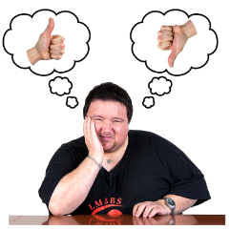 | Yes | ☐
 | No | ☐
- Please tell us more about your answer to question 7.
Write it here:

Part 3: Police presence
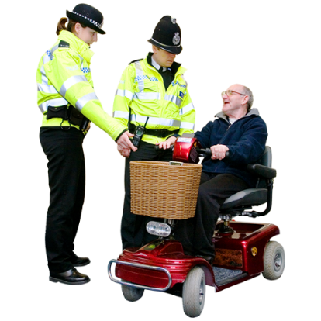 | Police presence means you could see that police were there.  9. Thinking about an event you went to or experienced recently, did you know the police were there?
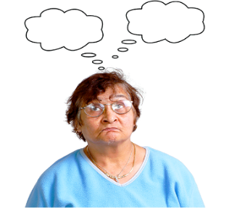 | Yes | ☐
 | No | ☐

Part 4: Police management of the event
Police management of the event means the things police did to make sure people stayed safe.

- Think about the way police officers managed the event.

Which of the following is closest to your view?

 | They managed the event well all the time | ☐
 | They managed the event well some of the time | ☐
 | They did not manage the event well | ☐
11. Please tell us more about your answer to question 10.
Write your answer here:

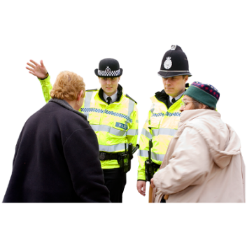 | 12. Do you think future events will be managed in the right way by the police?
 | Yes I think future events will be managed in the right way by the police | ☐
 | No I do not think future events will be managed in the right way by the police | ☐
13. Please tell us more about your answer to question 12.
Write it here:

Part 5: Police communication
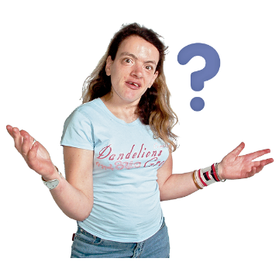 | 14. Which of these describes what happened to you?
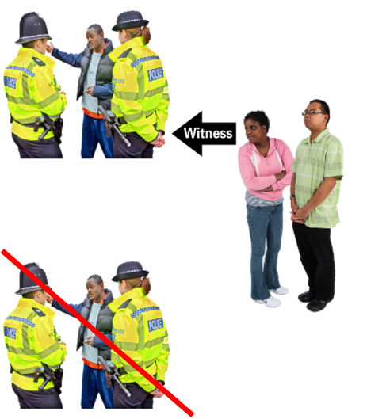 | I communicated with police officers | ☐
 | I saw other people communicate with police officers | ☐
 | I did not communicate with police officers or see other people communicate with them. | ☐
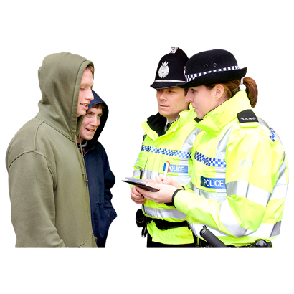 | 15. How did you feel about your communication with police officers?
 | Very happy | ☐
 | Happy | ☐
 | Not happy | ☐
 | Very unhappy | ☐
- Please tell us more about your answer to question 15.
Write your answer here:

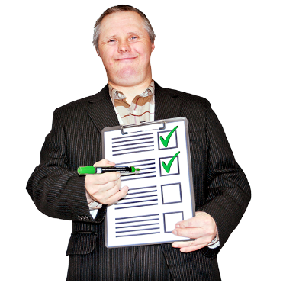 | - Is there anything police officers could have done to make the way they communicate better?  Write your answer here:

Part 6: How did people at the event behave?
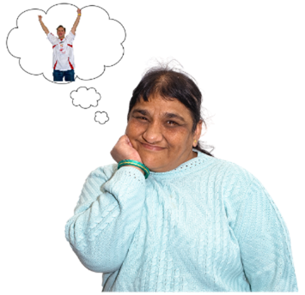 | 18. Think about how people at the event behaved.  Which of these is closest to what you think?
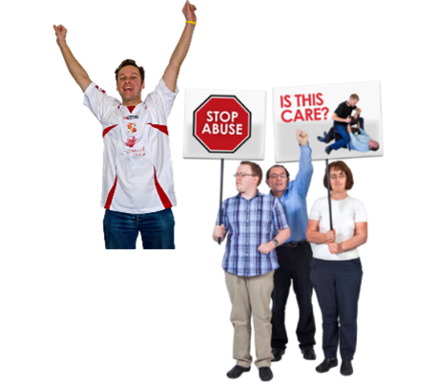 | People behaved well all the time | ☐
 | People behaved well some of the time | ☐
 | People did not behave well | ☐
- Please tell us more information about your answer to question 18.
Write it here:

Part 7: About you.

We ask these questions to make sure we get lots of different types of people answering the survey.

You do not have to answer any of these questions if you do not want to.

 | 20. Are you answering this survey:
 | - as an individual (go to question 22) | ☐
 | - or as an organisation (go to question 21)  21. Tell us the name of the organisation. | ☐
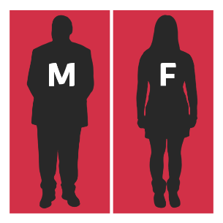 | 22. Do you think of yourself as:
 | Female | ☐
 | Male | ☐
 | Non-binary (I don’t see myself as only male or only female) | ☐
 | In another way. | ☐
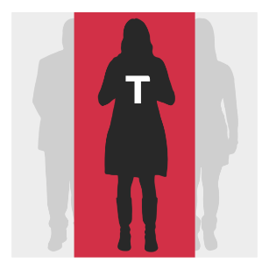 | 23. Do you think of yourself as trans or that you have a transgender history?  Transgender means you see yourself differently from your birth sex (male or female).
 | Yes | ☐
 | No | ☐
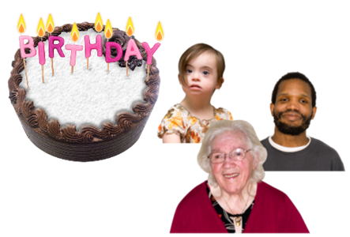 | 24. How old are you? Write it here:
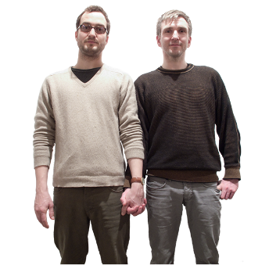 | 25. Sexual orientation means what kinds of people you love or have sexual or romantic feelings about.  Do you think of yourself as:
 | Heterosexual or straight | ☐
 | Bisexual | ☐
 | Gay | ☐
 | Lesbian | ☐
 | Any other sexual orientation. | ☐
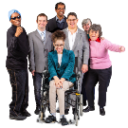 | 28. What is your ethnicity?  Ethnicity is the word we use to describe our background.  People from an ethnic group might have the same language, culture or religion.  What best describes you?  If you tick ‘other’ please tell us what your ethnicity is.
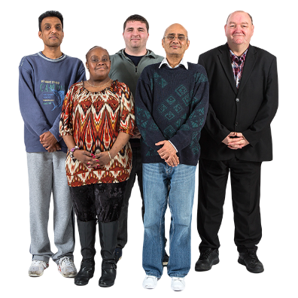 | White
 | Scottish | ☐
 | Other British | ☐
 | Irish | ☐
 | Gypsy or Traveller | ☐
 | Polish | ☐
 | Any other white ethnic group | ☐
 | Mixed or multiple ethnic group
 | Any mixed or multiple ethnic group | ☐
 | Asian, Asian Scottish or Asian British
 | Bangladeshi, Bangladeshi Scottish, Bangladeshi British
 | Chinese, Chinese Scottish, Chinese British | ☐
 | Indian, Indian Scottish, Indian British | ☐
 | Pakistani, Pakistani Scottish, Pakistani British | ☐
 | Any other Asian | ☐
 | African
 | African, African Scottish, African British | ☐
 | Any other African | ☐
 | Caribbean or Black
 | Black, Black Scottish, Black British | ☐
 | Caribbean, Caribbean Scottish, Caribbean British | ☐
 | Any other Caribbean or Black | ☐
 | Other ethnic group
 | Arab, Arab Scottish, Arab British | ☐
 | Any other ethnic group. Write your answer here: | ☐
 | 7. What religion do you belong to?
 | No religion | ☐
 | Church of Scotland | ☐
 | Roman Catholic | ☐
 | Other Christian | ☐
 | Buddhist | ☐
 | Hindu | ☐
 | Jewish | ☐
 | Muslim | ☐
 | Sikh | ☐
 | Any other religion. Write your answer here:
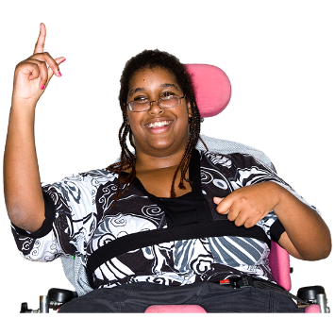 | 28. Do you consider yourself to have a disability, long-term illness or health condition?  Long term means it has lasted for over a year.  Yes ☐ go to question 29.  No ☐ go to question 30.
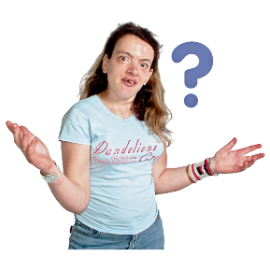 | 29. Does this disability or long-term health condition affect you in any of these ways?
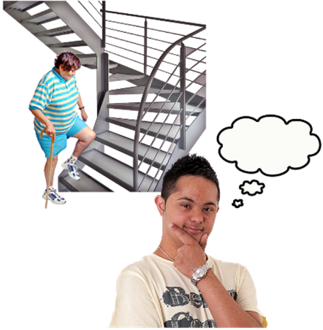  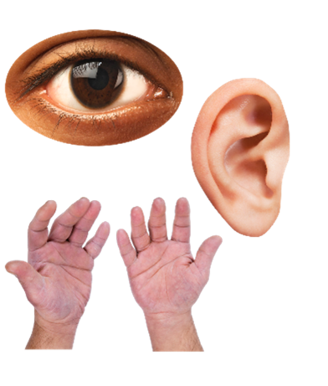 | Vision – how I see | ☐
 | Hearing | ☐
 | How I use my hands – for example if it is difficult for me to lift things or use a keyboard | ☐
 | Mobility – for example walking or climbing stairs
 | How I look – for example a mark, scar or condition that has changed how I look. | ☐
 | Learning, understanding or concentrating | ☐
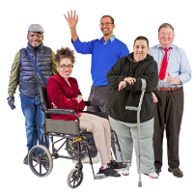  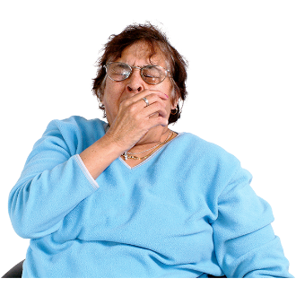  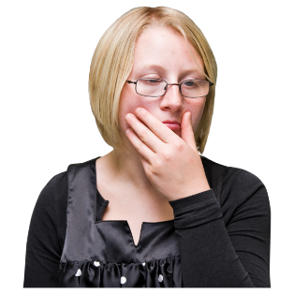 | Remembering things | ☐
 | Mental health | ☐
 | I get out of breath or tired easily | ☐
 | How I behave around other people | ☐
 | None of the above. | ☐
 | In another way. Please tell us what: | ☐
In other surveys disabled people told us they wanted to say how their disability affected them.
We will use this information to give people a service that is right for them.
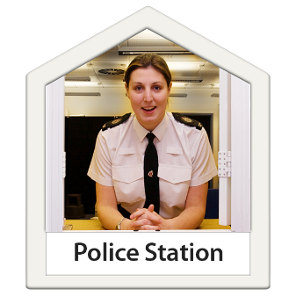 | You can also tell police officers in your local police service about events in your area.  If you have questions or need advice, please visit the Police Scotland website or please email: consultations@scotland.pnn.police.uk
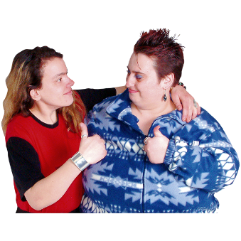 | Thank you for telling us what you think.  What you tell us is important.

Copyright images © Photosymbols. Prepared by Disability Equality Scotland

