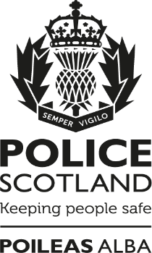

Your Police 2026-2027
Keeping People Safe

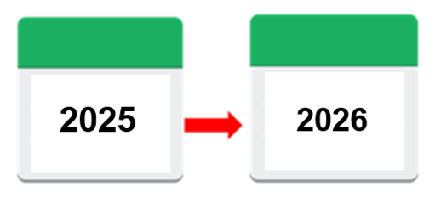
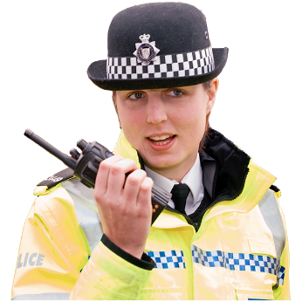
2026
2027


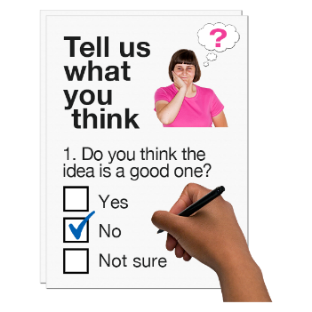

Copyright images © Photosymbols. Prepared by Disability Equality Scotland 

What is this survey for?
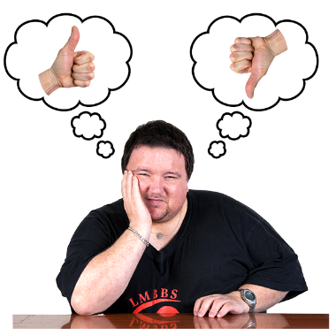 | We want to know what you think about the work of Police Scotland.  It is more important because we want to understand how communities are doing and how we can help.
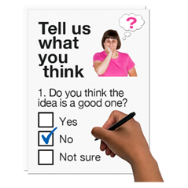 | This survey will help us listen, understand and respond to what you think.
 | This survey is not about reporting crime.  There are ways to contact Police Scotland.  Find out more online at:  https://www.scotland.police.uk/contact-us/
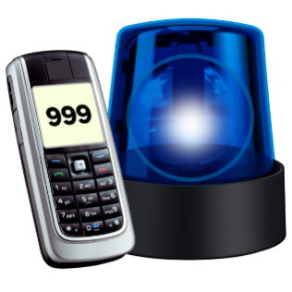 | If you need help from the Police in an emergency call 999.

How will we use your personal information?
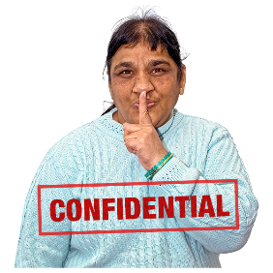 | When you send the survey back to us we save it separately from your email.  Your replies are confidential.  This means your information will be kept private.
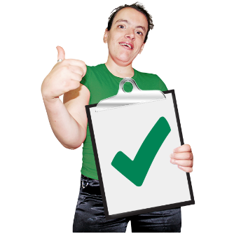 | If you fill out the survey you agree to Police Scotland using your data for their reports.  No-one will know it is your information in any reports.

How do I take part in the survey?
 | You can fill out this survey on your computer, then save it and email it to:  insightengagement@scotland.police.uk
 | or print a copy, write in your answers then scan it and email it to: insightengagement@scotland.police.uk
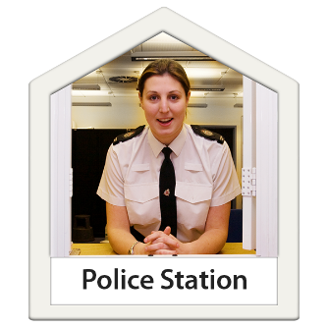 | If you cannot use the internet to send an email with your completed survey, please go to the public counter of your local police station.  Take this survey with you.  Ask the staff member to send this in internal mail to ‘Strategy, Insight and Engagement – Research & Insight’ at Fettes and then it will get to us.
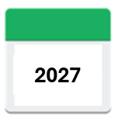  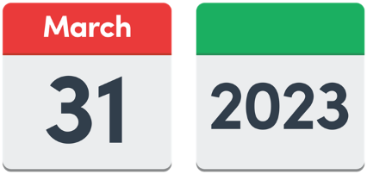 | Send us your survey before 31 March 2027.
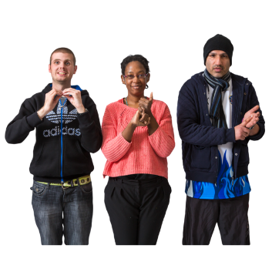 | A British Sign Language version of the survey is available online at: consult.scotland.police.uk
 | If you are a Young Scot member you will get an email with a code to claim 150 rewards points when you send us your survey.  Go to https://young.scot to sign up.
 | If you have questions or if you want to do the survey over the phone please phone the Insight Team on: 07467 118 010  or email: insightengagement@scotland.police.uk
There are several parts in the survey.

Click on the box of the answer you agree with and a tick will appear. ☐

If you change your mind you can click on it again to untick it.

If you are filling out a paper copy, tick the box of the answer you agree with, and if you have more to say write your answer in the ‘Write your answer here’ spaces.
If you are typing, the space will get bigger as you type.

Miss out a question if you do not know the answer.

You do not have to answer a question if you do not want to.

Part 1: The area you live in.
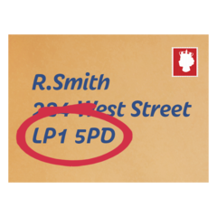 | - What is your postcode?  Write it here:  We use postcodes for our reports.  We do not use them to find out who you are or where you live.  Your information is kept private.
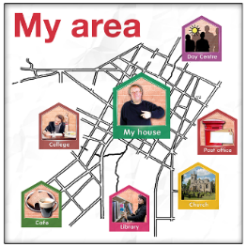 | - How safe do you feel in your local area?
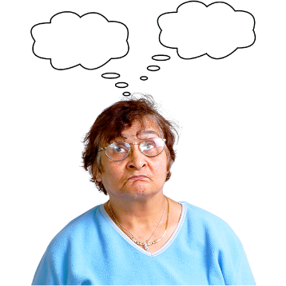     |     Very safe | ☐
 | Quite safe | ☐
 | Not safe | ☐
 | I’m not sure | ☐
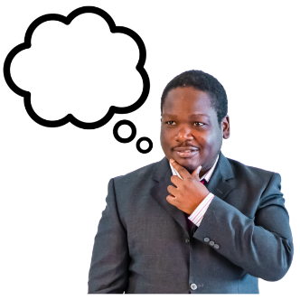 | - What worries you most about your local area that the police can help with?  Write your answer here:
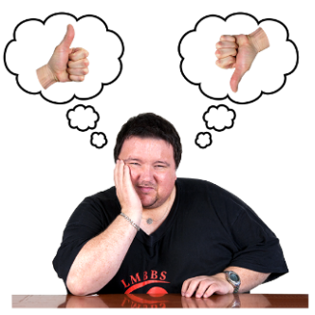 | - Think about crime in your area.  Have your worries about crime changed in the last year?
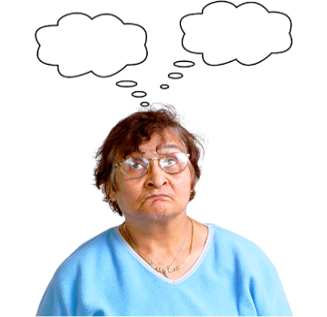 | I am more worried | ☐
 | My worries are the same | ☐
 | I am less worried | ☐
 | I am not sure | ☐

Part 2: The Police in your area.
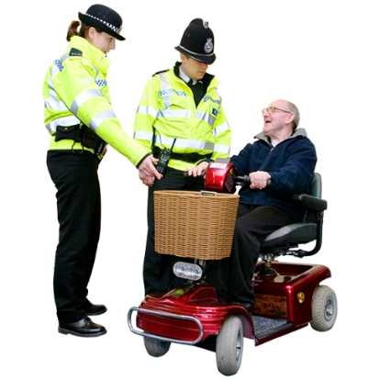 | 6. The police listen to what local people are worried about.  What do you think about this?
 | I agree | ☐
 | I am not sure | ☐
 | I do not agree | ☐
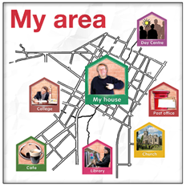 | - The police are dealing with the problems in my local area.  What do you think about this?
 | I agree | ☐
 | I am not sure | ☐
 | I do not agree | ☐
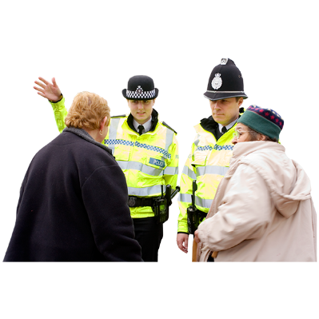 | - The police are friendly, easy to talk to and I can ask them questions.  What do you think about this?
 | I agree | ☐
 | I am not sure | ☐
 | I do not agree | ☐
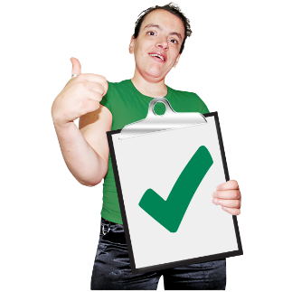 | - I have respect for the police in my area.  What do you think about this?
 | I agree | ☐
 | I am not sure | ☐
 | I do not agree | ☐
10. I have confidence in the police in my area.

What do you think about this?

 | I agree | ☐
 | I am not sure | ☐
 | I do not agree | ☐
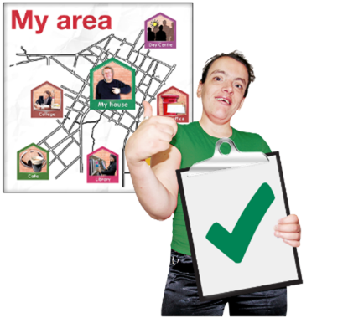 | - The police are doing a good job in my area.  What do you think about this?
 | I agree | ☐
 | I am not sure | ☐
 | I do not agree | ☐
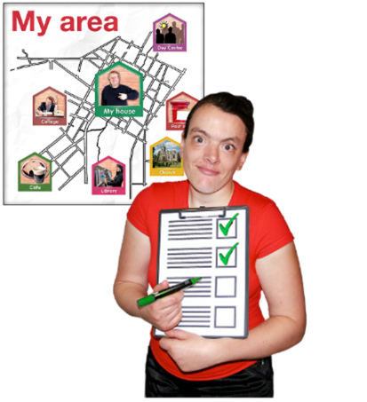 | - What are the Police doing well in your area?  Write it here:
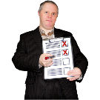 | - Is there anything the police could do better to support communities in your local area?  Write it here:

Part 3: Getting in touch with Police Scotland
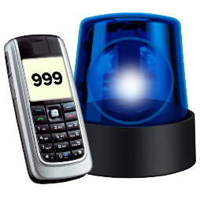 | - Have you been in touch with Police Scotland in the last 12 months?
 | Yes, to report an incident or crime.  (go to question 15) | ☐
 | Yes, to report an incident or crime about Coronavirus. (go to question 15) | ☐
 | Yes, to get information.  (go to question 15) | ☐
 | No  (go to question 19) | ☐
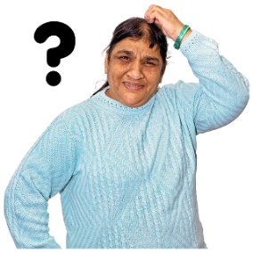 | 15. How did you get in touch with Police Scotland?
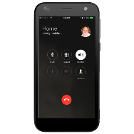 | Phoned 101 | ☐
 | Phoned 999 | ☐
 | Text | ☐
 | Used the online form on the Police Scotland website | ☐
 | Email | ☐
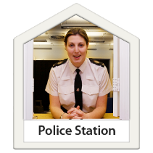 | Went to a police station | ☐
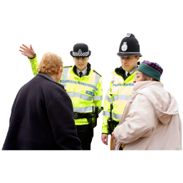 | Spoke to an officer on the street | ☐
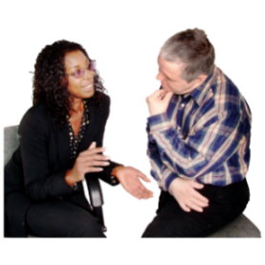 | Through another organisation, a friend or family member | ☐
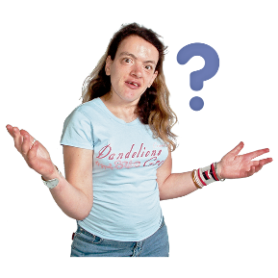 | Another way | ☐
 | I can’t remember | ☐
 | 16. How easy was it to get in touch with Police Scotland?
 | Very easy | ☐
 | Easy | ☐
 | Not easy or hard (in the middle) | ☐
 | Hard | ☐
 | Very hard | ☐
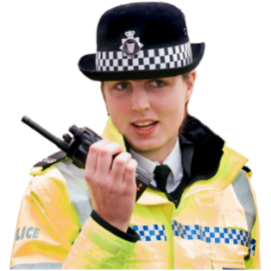 | 17. Think about the last time you have been in touch with Police Scotland.  How do you feel about your experiences?
 | Very happy | ☐
 | Happy | ☐
 | Not happy or happy (in the middle) | ☐
 | Not happy | ☐
 | Very unhappy | ☐
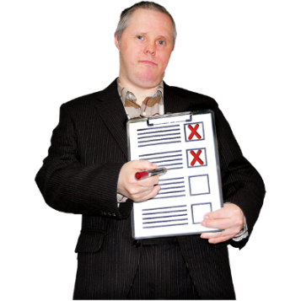 | 18. What could we have done better?  Write it here:
Part 4: About you.

We ask these questions to make sure we get lots of different types of people answering the survey.

You do not have to answer any of these questions if you do not want to.

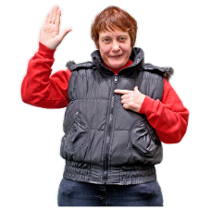 | 19. Are you answering this survey:
 | - as an individual (go to question 21) | ☐
 | - or as an organisation (go to question 20)  20. Tell us the name of the organisation:  If you are answering for an organisation you are now finished the survey.  Thank you. | ☐
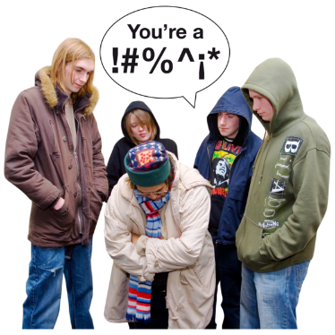 | 21. In the last 12 months have any of these things happened to you?
 | I have been a victim of crime | ☐
 | I have seen a crime | ☐
 | I have been a victim of crime and I have seen a crime | ☐
 | I have not been a victim and have not seen a crime | ☐
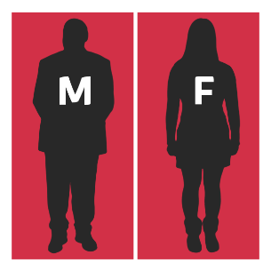 | 22. Do you think of yourself as:
 | A man | ☐
 | A woman | ☐
 | Non-binary (I don’t see myself as only a man or only a woman) | ☐
 | In another way | ☐
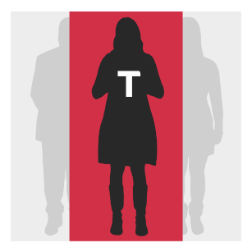 | 23. Do you think of yourself as trans or do you have a transgender history?  Transgender means you don’t identify with the sex that was recorded when you were born.
 | Yes | ☐
 | No | ☐
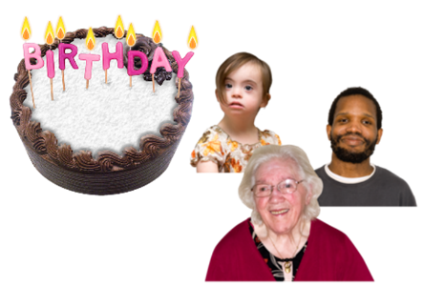 | 24. How old are you?  Write it here:
  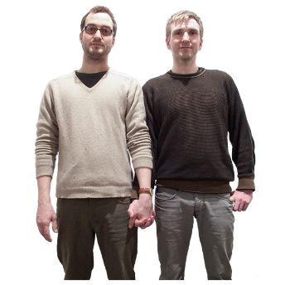 | 25. Sexual orientation means what kinds of people you love or have sexual or romantic feelings about.  Do you think of yourself as:
 | Heterosexual or straight | ☐
 | Bisexual | ☐
 | Gay | ☐
 | Lesbian | ☐
 | Any other sexual orientation | ☐
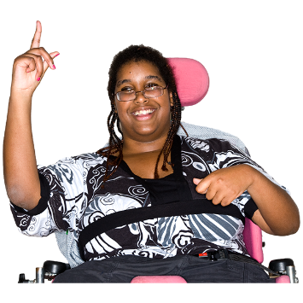 | 26. Do you consider yourself to have a disability, long-term illness or health condition?  Long term means it has lasted for over a year.  Yes ☐ go to question 27.  No ☐ go to question 28.
 | 27. Does this disability or health condition affect you in any of these ways?
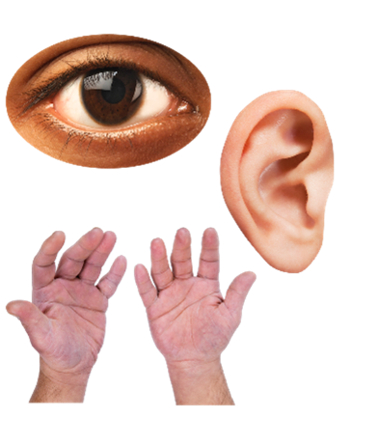  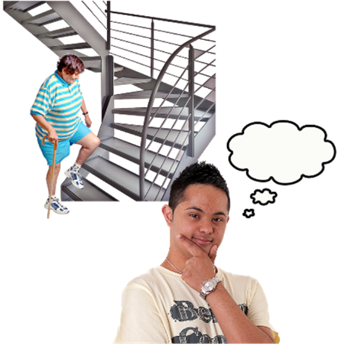 | Vision – how I see | ☐
 | Hearing | ☐
 | How I use my hands – for example if it is difficult for me to lift things or use a keyboard | ☐
 | Mobility – for example walking or climbing stairs | ☐
 | Learning, understanding or concentrating | ☐
 | Remembering things | ☐
 | Mental health | ☐
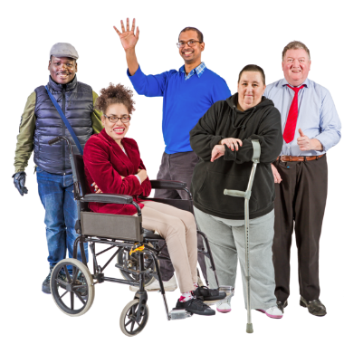 | I get out of breath or tired easily | ☐
 | How I behave around other people | ☐
 | None of the above. | ☐
 | In another way. Please tell us what: | ☐
In last year’s survey disabled people told us they wanted to say how their disability affected them.
We will use this information to make our service better to give people a service that is right for them.
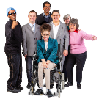 | 28. What is your ethnicity?  Ethnicity is the word we use to describe our background.  People from an ethnic group might have the same language, culture or religion.  What best describes you?  If you tick ‘other’ please tell us what your ethnicity is.
 | White
 | Scottish | ☐
 | Other British | ☐
 | Irish | ☐
 | Gypsy or Traveller | ☐
 | Polish | ☐
 | Roma | ☐
 | Showman/Showwoman | ☐
 | Any other white ethnic group | ☐
 | Mixed or multiple ethnic group
 | Any mixed or multiple ethnic group | ☐
 | Asian, Asian Scottish or Asian British
 | Bangladeshi, Bangladeshi Scottish, Bangladeshi British | ☐
 | Chinese, Chinese Scottish, Chinese British | ☐
 | Indian, Indian Scottish, Indian British | ☐
 | Pakistani, Pakistani Scottish, Pakistani British | ☐
 | Any other Asian | ☐
 | African
 | African, African Scottish, African British | ☐
 | Any other African | ☐
 | Caribbean or Black
 | Black, Black Scottish, Black British | ☐
 | Caribbean, Caribbean Scottish, Caribbean British | ☐
 | Any other Caribbean or Black | ☐
 | Other ethnic group
 | Arab, Arab Scottish, Arab British | ☐
 | Any other ethnic group. Write your answer here: | ☐
         | 7. What religion do you belong to?
 | No religion | ☐
 | Church of Scotland | ☐
 | Roman Catholic | ☐
 | Other Christian | ☐
 | Buddhist | ☐
 | Hindu | ☐
 | Jewish | ☐
 | Muslim | ☐
 | Sikh | ☐
 | Any other religion. Write your answer here:
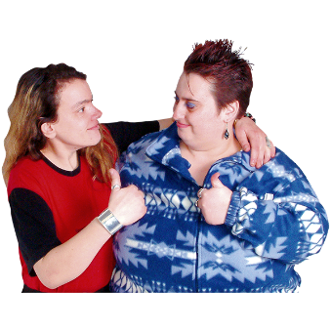 | Thank you for telling us what you think.  What you tell us is important.

Copyright images © Photosymbols. Prepared by Disability Equality Scotland

