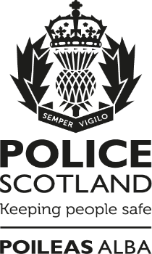

Police Scotland
Gaelic Plan Survey

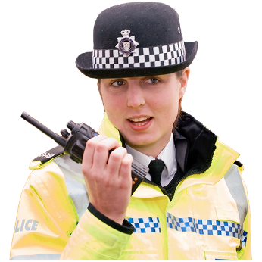

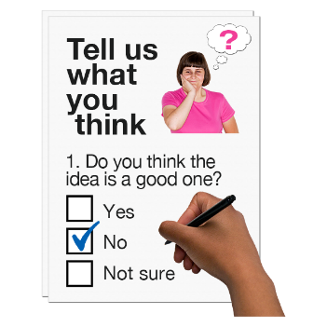

Copyright images © Photosymbols. Prepared by Disability Equality Scotland 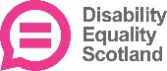

What is this survey for?
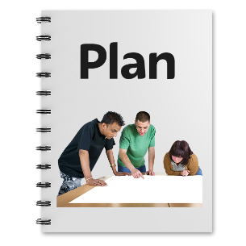 | This survey is about Police Scotland's Gaelic Language Plan 2021-26.
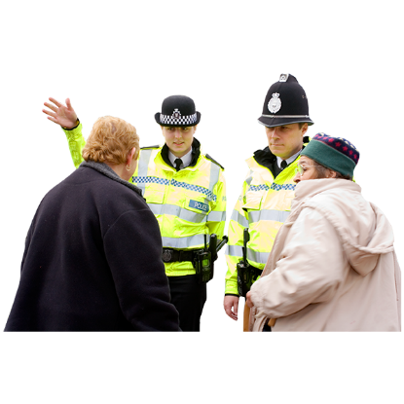 | We want to know what you think about police officers using Gaelic when we communicate with people.
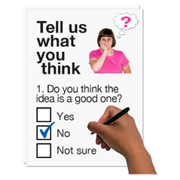 | This survey will help us listen, understand and respond to what you think.
This survey is not about reporting crime.
There are ways to contact Police Scotland.
Find out more online at:
https://www.scotland.police.uk/contact-us/
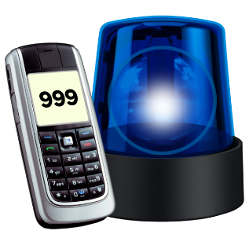 | If you need help from the Police in an emergency call 999.
How will we use your personal information?
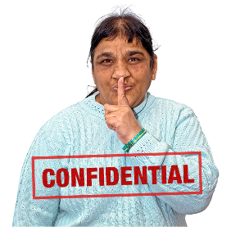 | Your replies are confidential.  This means your information will be kept private.
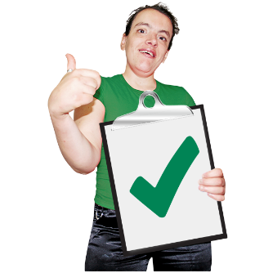 | If you fill out the survey you agree to Police Scotland using your data for their reports.  No-one will know it is your information.
How do I take part in the survey?
You can fill out this survey on your computer, then save it and email it to:
consultations@scotland.pnn.police.uk
 | or print a copy, write in your answers then scan it and email it to: consultations@scotland.pnn.police.uk
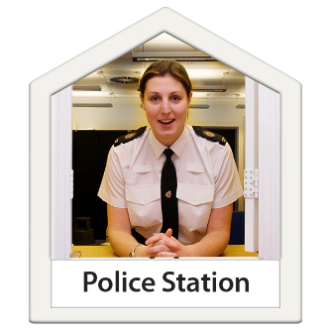 | If you cannot use the internet to send an email, please go to the public counter of your local police station.  Take this survey with you if you can.
Ask the staff to send an email with your phone number to: consultations@scotland.pnn.police.uk
Our team will call you before 10 days have passed.

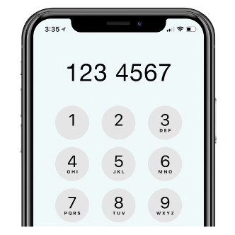  101 | If you do not live close to a police station, please phone 101 and choose Option 4.  Tell them you are phoning about the Gaelic Plan survey.
 | Ask them to email: consultations@scotland.pnn.police.uk with a phone number our team can reach you on.
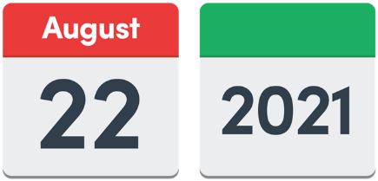 | Send us your survey before 22 August 2021.
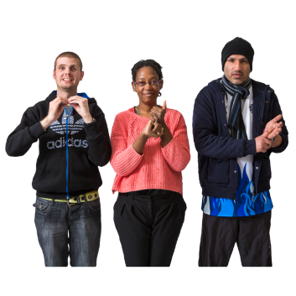 | A British Sign Language version of the survey will be available online at: https://consult.scotland.police.uk
If you have questions or if you want to do the survey over the phone please phone the Insight Team on: 07717 188 184

or email: consultations@scotland.pnn.police.uk

The survey has 5 parts.

Click on the box of the answer you agree with and a tick will appear. ☐

If you change your mind you can click on it again to untick it.

If you are filling out a paper copy, tick the box of the answer you agree with, and if you have more to say write your answer in the ‘Write your answer here’ spaces.

Miss out a question if you do not know the answer.

You do not have to answer a question if you do not want to.

Part 1. Police Scotland want to use more Gaelic when we communicate with people.

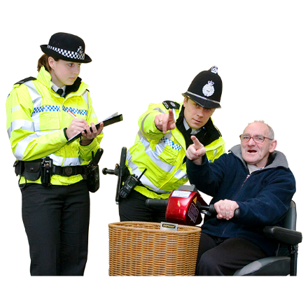 | - How could we use more Gaelic when we communicate with people?  Write it here:
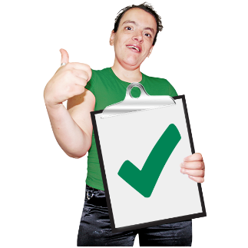 | 2. If our officers and staff used Gaelic when they communicate with people would this be a good thing for the Gaelic language and for people who use Gaelic?
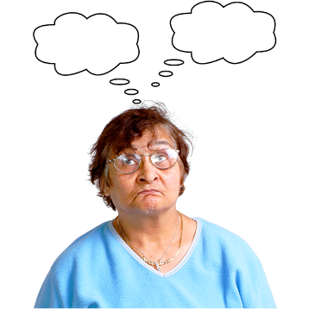 | Yes | ☐
 | I am not sure | ☐
 | No | ☐
- Tell us why you think this.
Write it here:

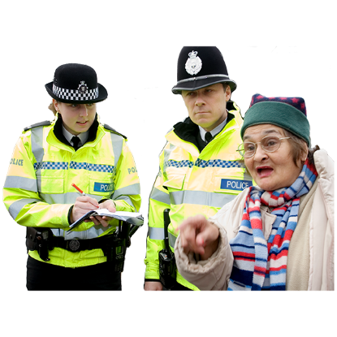 | 4. If you think we should communicate in Gaelic as well as English tell us why.  Write it here:
Part 2. Police Scotland will buy goods and services which promote and use Gaelic.

Goods and services are things staff need to do their job. An example is using Gaelic on our new cars and vans.

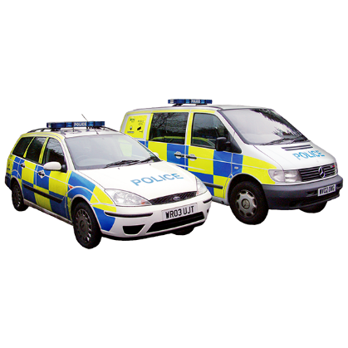 | 5. If Police Scotland buy goods and services that promote and use Gaelic is this a good thing?
 | Yes | ☐
 | I am not sure | ☐
 | No | ☐
6. Tell us why you think this. Write it here:

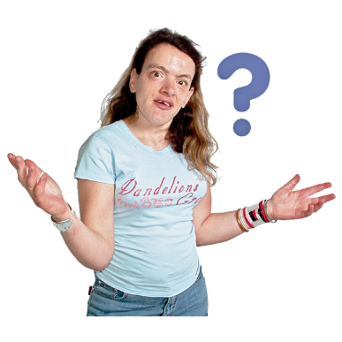 | 7. Are there any other ways we could support the use of Gaelic in Scotland?  Write it here:
Part 3. Police Scotland will use Gaelic and English when we give the public information online and in the papers.

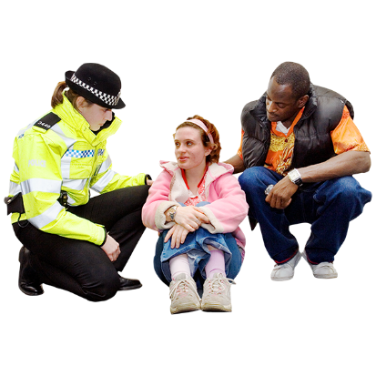 | 8. A campaign is when we tell people about part of our work.  What should any new campaigns about safety and wellbeing be about?  Write it here:
Part 4. Police Scotland will have a group of officers and staff to make the Gaelic Language Plan 2021-2026 and to decide what work should be done.

9. What could the group do to make the Gaelic Language Plan work well?

Write it here:

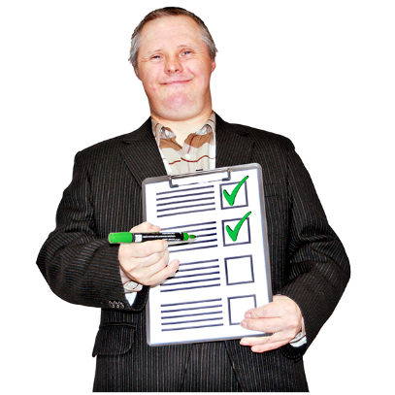 | 10. Have we missed anything in the first Gaelic Language Plan?  Write it here:
Part 5. And finally…
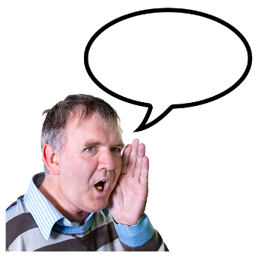 | 11. Is there anything else you want to tell us?  Write it here:
About you.

We ask these questions to make sure we get lots of different types of people answering the survey.

You do not have to answer any of these questions if you do not want to.

 | 10. Are you answering this survey:
 | - as an individual (go to question 12. | ☐
 | - or as an organisation (go to question 11)  11. Tell us the name of the organisation.  If you are answering for an organisation you are now finished the survey.  Thank you. | ☐
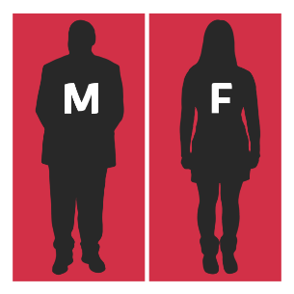 | 12. Do you think of yourself as:
 | Female | ☐
 | Male | ☐
 | Non-binary (I don’t see myself as only male or only female) | ☐
 | In another way. | ☐
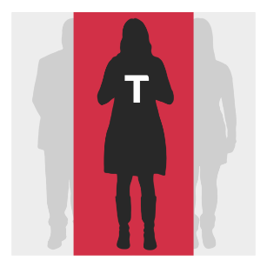 | 13. Do you think of yourself as trans or that you have a transgender history?  Transgender means you see yourself differently from your birth sex (male or female).
 | Yes | ☐
 | No | ☐
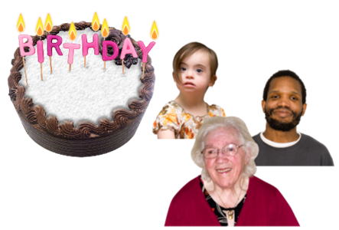 | 14. How old are you? Write it here:
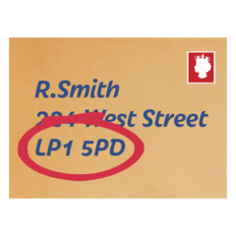 | - What is your postcode? Write it here:
We use postcodes for our reports.
We do not use them to find out who you are or where you live.
Your information is kept private.
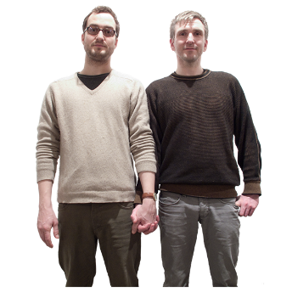 | 16. Sexual orientation means what kinds of people you love or have sexual or romantic feelings about.  Do you think of yourself as:
 | Heterosexual or straight | ☐
 | Bisexual | ☐
 | Gay | ☐
 | Lesbian | ☐
 | Any other sexual orientation. | ☐
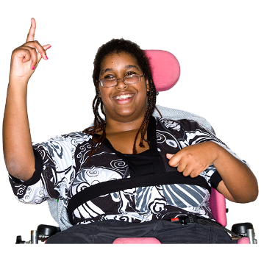 | 17. Do you consider yourself to have a disability, long-term illness or health condition?  Long term means it has lasted for over a year.  Yes ☐ go to question 18.  No ☐ go to question 19.
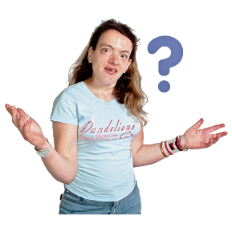 | 18. Does this disability or health condition affect you in any of these ways?
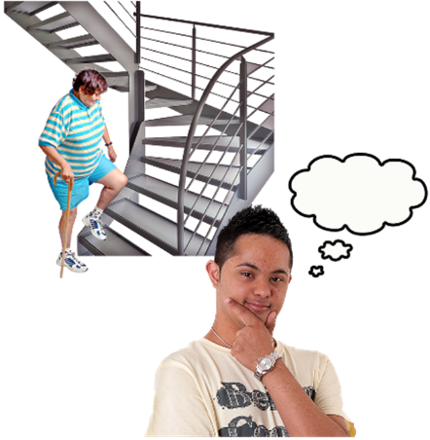  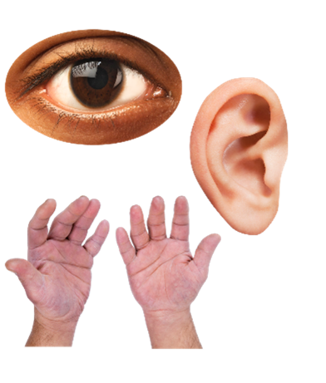 | Vision – how I see | ☐
 | Hearing | ☐
 | How I use my hands – for example if it is difficult to lift things or use a keyboard | ☐
 | Mobility – for example walking or climbing stairs | ☐
 | Learning or concentrating | ☐
 | Remembering things | ☐
 | Mental health | ☐
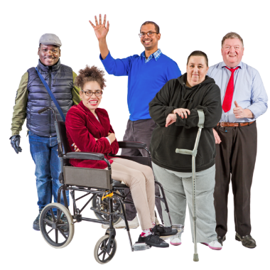 | I get out of breath or tired easily | ☐
 | How I behave around people | ☐
 | In another way. Please tell us what: | ☐
In last year’s survey disabled people told us they wanted to say how their disability affected them. We will use this information to make our service better.
19. What is your ethnicity?
Ethnicity is the word we use to describe our background.
People from an ethnic group might have the same language, culture or religion.
What best describes you?
If you tick ‘other’ please tell us what your ethnicity is.

 | White
 | Scottish | ☐
 | Other British | ☐
 | Irish | ☐
 | Gypsy or Traveller | ☐
 | Polish | ☐
 | Any other white ethnic group | ☐
 | Mixed or multiple ethnic group
 | Any mixed or multiple ethnic group | ☐
 | Asian, Asian Scottish or Asian British
 | Bangladeshi, Bangladeshi Scottish, Bangladeshi British | ☐
 | Chinese, Chinese Scottish, Chinese British | ☐
 | Indian, Indian Scottish, Indian British | ☐
 | Pakistani, Pakistani Scottish, Pakistani British | ☐
 | Any other Asian | ☐
 | African
 | African, African Scottish, African British | ☐
 | Any other African | ☐
 | Caribbean or Black
 | Black, Black Scottish, Black British | ☐
 | Caribbean, Caribbean Scottish, Caribbean British | ☐
 | Any other Caribbean or Black | ☐
 | Other ethnic group
 | Arab, Arab Scottish, Arab British | ☐
 | Any other ethnic group. Write your answer here: | ☐
 | 20. What religion do you belong to?
 | No religion | ☐
 | Church of Scotland | ☐
 | Roman Catholic | ☐
 | Other Christian | ☐
 | Buddhist | ☐
 | Hindu | ☐
 | Jewish | ☐
 | Muslim | ☐
 | Sikh | ☐
 | Any other religion. ☐ Write your answer here:
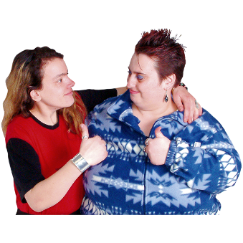 | Thank you for telling us what you think.  What you tell us is important.

Copyright images © Photosymbols. Prepared by Disability Equality Scotland

