Police Scotland
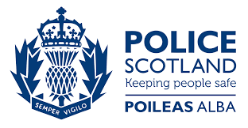

Equality Engagement Questionnaire
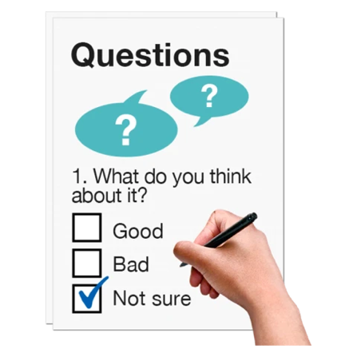

Easy Read

Copyright images © Photosymbols. Prepared by Disability Equality Scotland

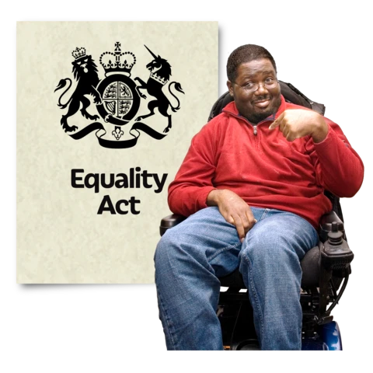 | Police Scotland is writing a new set of Equality Outcomes.  We do this every 4 years because of the Equalities Act 2010.
 | This is a survey to find out what you think.
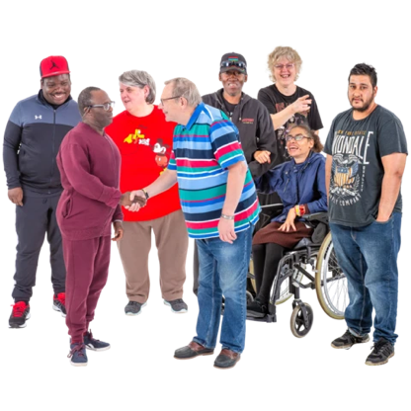 | We want to hear opinions from lots of different protected groups.
Protected groups means people who are part of these groups:
- age
- disability
- gender reassignment
- marriage and civil partnership
- pregnancy and maternity
- race
- religion or belief
- sex
- sexual orientation
How will this survey help?
This survey will help us write the new Equality Outcomes for 2021 – 2025.
This survey is not about reporting crime.
There are ways to contact Police Scotland. Find out more online. Go to:
https://www.scotland.police.uk/contact-us/
Click on the box of the answer you agree with and a tick will appear. ☐

If you change your mind you can click on it again to untick it.

If you are filling out a paper copy, tick the box of the answer you agree with.

If you have more to say, write your answer in the ‘Type your answer here’ spaces.

If you don’t know the answer to a question, miss it out.

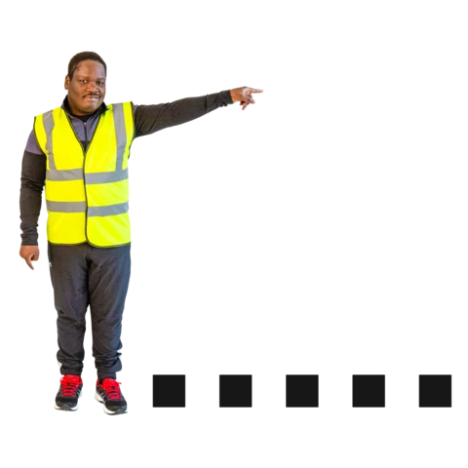 | The Survey  Questions about you
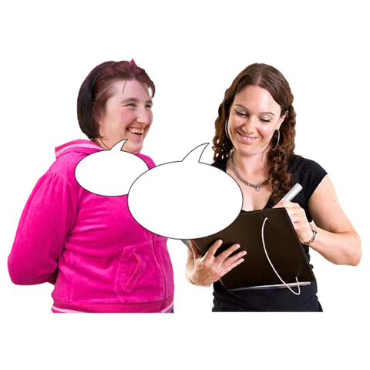 | 1. Are you answering as yourself or are you answering for an organisation?
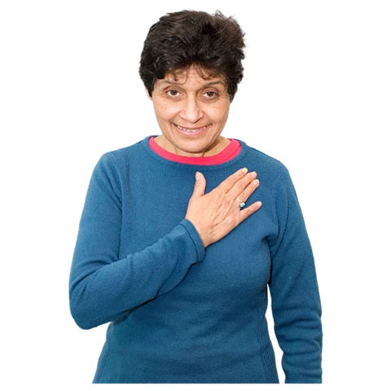 | I am answering as myself. | ☐
 | I am answering for someone else. | ☐
 | I am answering for an organisation. | ☐
 | I am answering as someone who works for Police Scotland. | ☐
If you ticked ‘I am answering for an organisation’ please answer question 2 below.
If you are not answering for an organisation please miss out question 2.
 | 2. Which of these protected groups does your organisation work with?
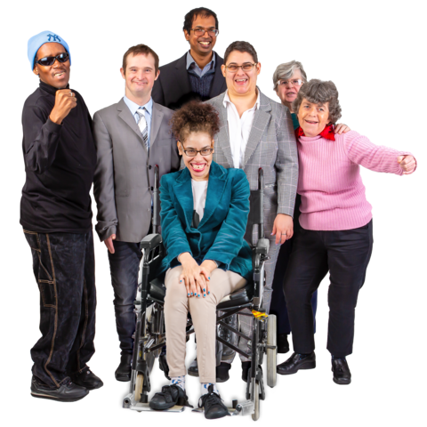 | Age | ☐
 | Disability | ☐
 | Gender reassignment | ☐
 | Marriage and civil partnership | ☐
 | Pregnancy and maternity | ☐
 | Race | ☐
 | Religion or belief | ☐
 | Sex | ☐
 | Sexual orientation | ☐
 | All of these groups | ☐
 | None of these groups | ☐
If you work for Police Scotland please answer question 3 below.
If you don’t work for Police Scotland please miss out question 3.
 | 3. What is your job at Police Scotland?
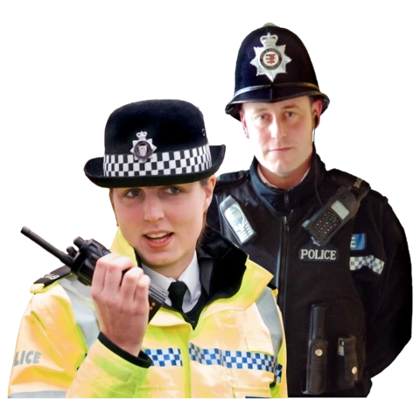 | Police Officer | ☐
 | Police Staff | ☐
 | Special Constable | ☐
 | I don’t want to say | ☐
If you ticked ‘Police Officer’ please answer question 4 below.
If you didn’t tick ‘Police Officer’, please miss out question 4.
 | 4. Which rank do you hold at the moment?
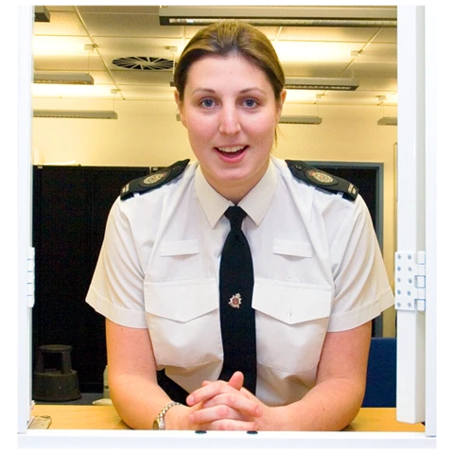 | Constable | ☐
 | Sergeant | ☐
 | Inspector | ☐
 | Chief Inspector | ☐
 | Superintendent | ☐
 | Chief Superintendent | ☐
 | Executive | ☐
If you work for Police Scotland please answer question 5 below.
If you don’t work for Police Scotland please miss out question 5.
 | 5. How many years have you worked for Police Scotland?
 | Less than 1 year | ☐
 | 2 to 3 years | ☐
 | 4 to 5 years | ☐
 | 6 to 8 years | ☐
 | 9 to 10 years | ☐
 | 11 to 15 years | ☐
 | 16 to 20 years | ☐
 | 21 to 25 years | ☐
 | 26 to 30 years | ☐
 | More than 30 years | ☐
 | I don’t want to say | ☐
 | Questions about how accessible Police Scotland is
6. What do you think about this next sentence?
Police Scotland is accessible.
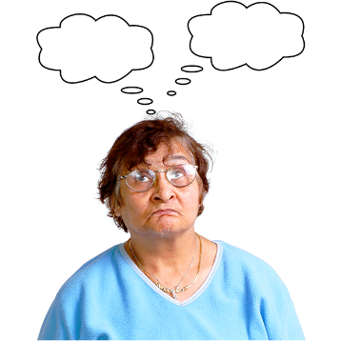 | I really agree | ☐
 | I agree | ☐
 | I don’t agree or disagree | ☐
 | I disagree | ☐
 | I really disagree | ☐
 | I don’t know | ☐
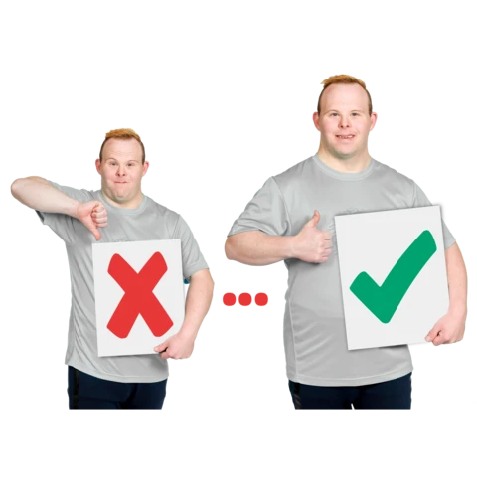 | 7. Please tell us what Police Scotland can do to be more accessible?
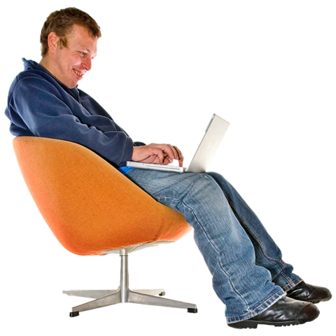 | Type your answer here.
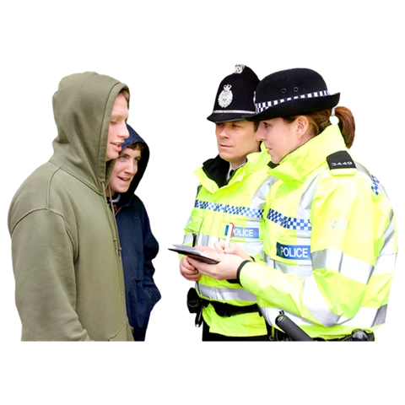 | Questions about how well Police Scotland respond to crimes and other incidents
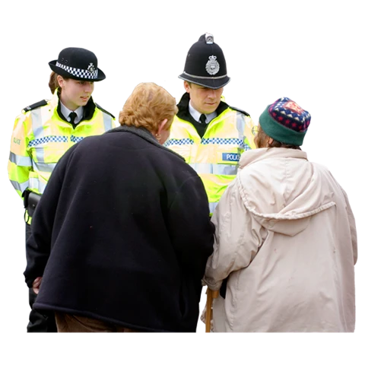 | 8. How confident do you feel about telling Police Scotland about a crime or something that’s happened?
 | I feel very confident | ☐
 | I feel quite confident | ☐
 | I have mixed feelings | ☐
 | I don’t feel confident | ☐
 | I really don’t feel confident at all | ☐
 | I don’t know | ☐
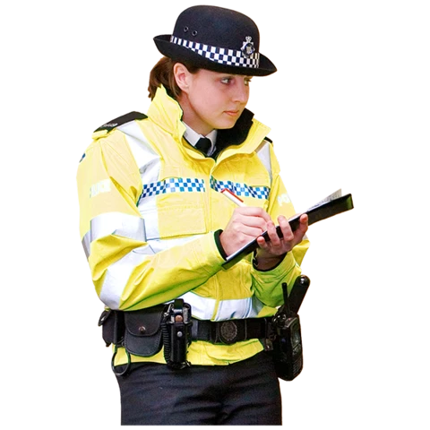 | 9. How confident do you feel that Police Scotland will respond well to a crime or something that’s happened?
 | I feel very confident | ☐
 | I feel quite confident | ☐
 | I have mixed feelings | ☐
 | I don’t feel confident | ☐
 | I really don’t feel confident at all | ☐
 | I don’t know | ☐
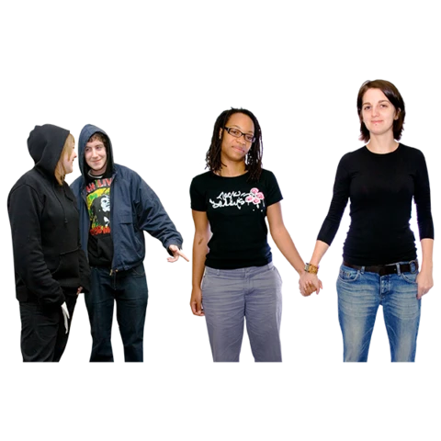 | Hate Crime is when someone commits a crime because they hate or are prejudiced against the victim because the victim is part of a group.  There are 5 groups protected in Scotland. These are:  - disability  - race  - religion  - sexual orientation  - transgender identity
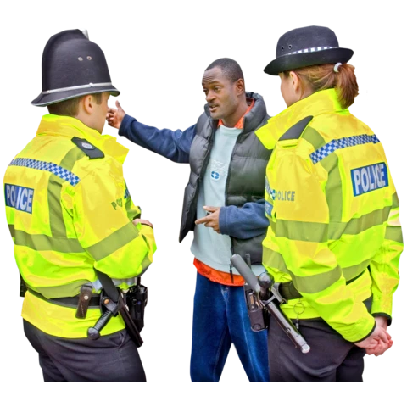 | 10. How confident are you that Police Scotland will respond in the right way to hate crimes?
 | I feel very confident | ☐
 | I feel quite confident | ☐
 | I have mixed feelings | ☐
 | I don’t feel confident | ☐
 | I really don’t feel confident at all | ☐
 | I don’t know | ☐
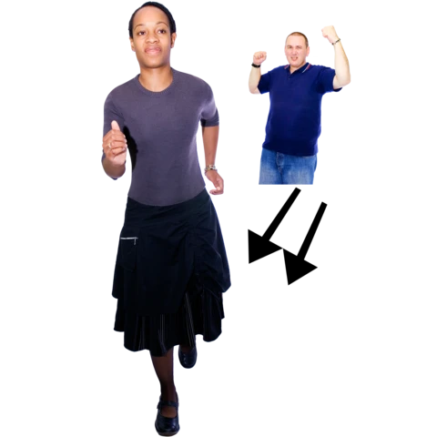 | 11. This question is about violence against women and girls.  How confident are you that Police Scotland will respond to these crimes or other incidents in the right way?
 | I feel very confident | ☐
 | I feel quite confident | ☐
 | I have mixed feelings | ☐
 | I don’t feel confident | ☐
 | I really don’t feel confident at all | ☐
 | I don’t know | ☐
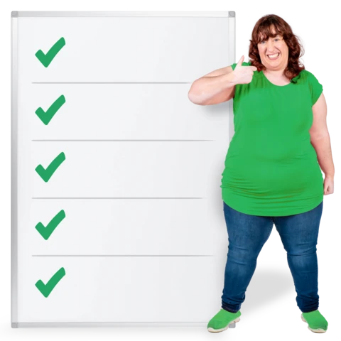 | 12. Please think about the way Police Scotland responds to crimes or things that have happened.  What are we doing well?
 | Type your answer here.
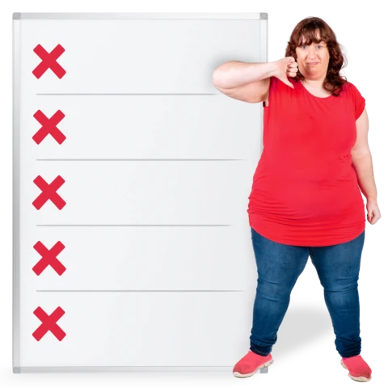 | 13. Please think about the way Police Scotland responds to crimes or things that have happened.  What can we do better?
 | Type your answer here.
 | Questions about the COVID-19 pandemic
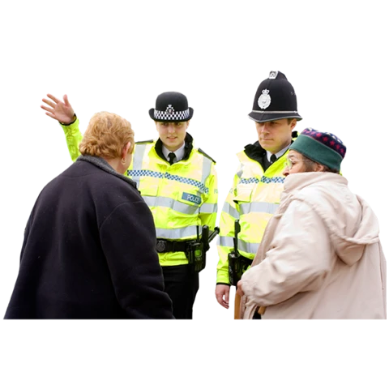 | 14. What do you think about this next sentence?  The coronavirus has changed the way I’m in contact with Police Scotland.
 | I really agree | ☐
 | I agree | ☐
 | I don’t agree or disagree | ☐
 | I disagree | ☐
 | I really disagree | ☐
 | I don’t know | ☐
 | 15. Please tell us how the coronavirus has changed the way you’re in contact with Police Scotland.
 | Type your answer here.
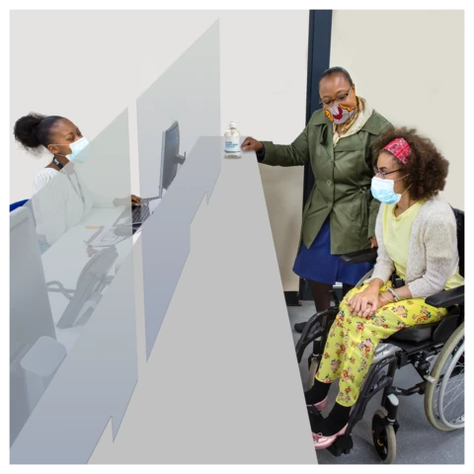 | Because of the coronavirus, Police Scotland had to stop meeting people face-to-face as much as before.  16. How has this changed the way you talk with the police?
 | Type your answer here.
 | Questions about working for Police Scotland
 | If you work for Police Scotland, please miss this question 17.
 | 17A. What would make you want to work for Police Scotland?
 | Type your answer here.
 | 17B. What would make you not want to work for Police Scotland?
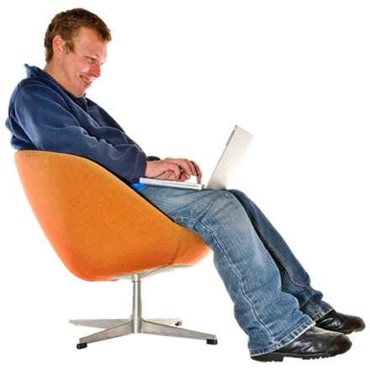 | Type your answer here.
 | If you work for Police Scotland, please answer questions 18 and 19.
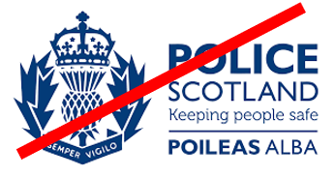 | If you don’t work for Police Scotland, please miss out questions 18 and 19.
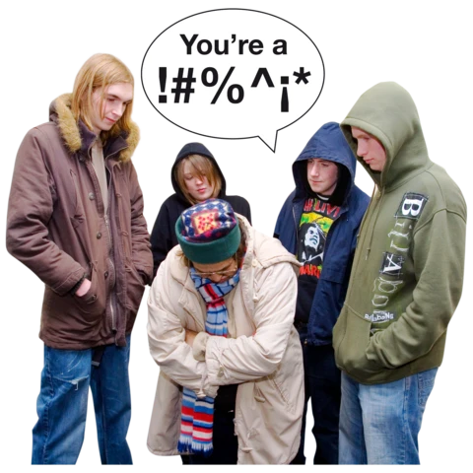 | 18. What do you think about this next sentence?  I have seen hate crime while I’ve been working.
 | I really agree | ☐
 | I agree | ☐
 | I don’t agree or disagree | ☐
 | I disagree | ☐
 | I really disagree | ☐
 | I don’t know | ☐
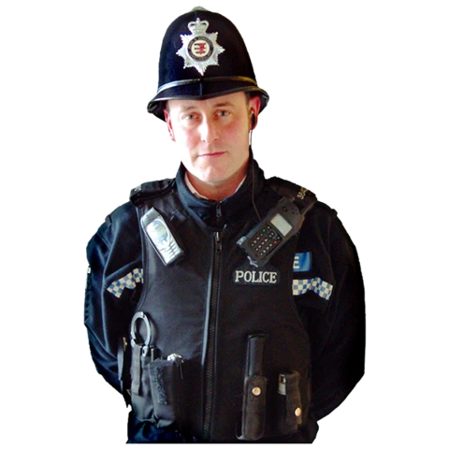 | 19. How can Police Scotland do a better job of supporting officers and staff who have seen hate crime or been the victim of hate crime while they work?
 | Type your answer here.
 | Questions about you
 | If you are answering for an organisation, please miss out questions 20 to 26. You have finished, thank you.
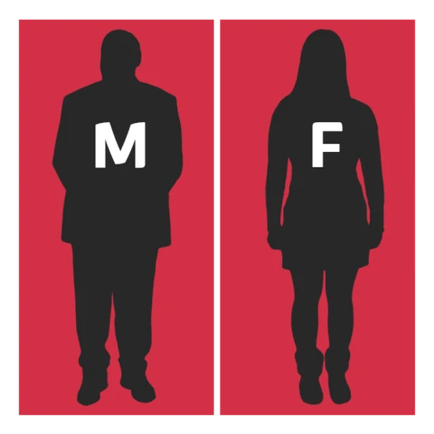 | 20. Do you think of yourself as:
 | Male | ☐
 | Female | ☐
 | Non-binary or Gender neutral  (I don’t see myself as only male or only female) | ☐
 | In another way  (please type here:  ……………………. | ☐
 | I don’t want to say | ☐
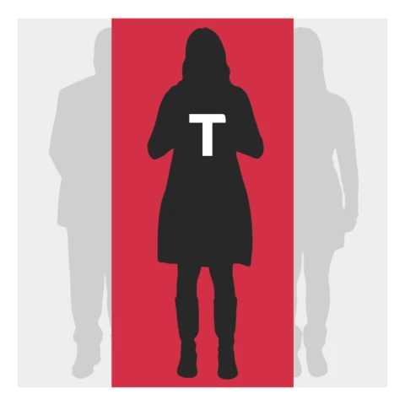 | 21. Do you think of yourself as transgender or that you have a transgender history?  Transgender means you see yourself differently from your birth sex (male or female).
 | Yes | ☐
 | No | ☐
 | I don’t want to say | ☐
 | 22. How old are you?
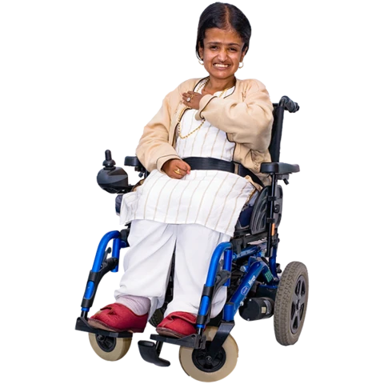 | 10 to 15 years old | ☐
 | 16 to 19 years old | ☐
 | 20 to 29 years old | ☐
 | 30 to 39 years old | ☐
 | 40 to 49 years old | ☐
 | 50 to 59 years old | ☐
 | 60 to 69 years old | ☐
 | 70 years old or older than 70 | ☐
 | I don’t want to say | ☐
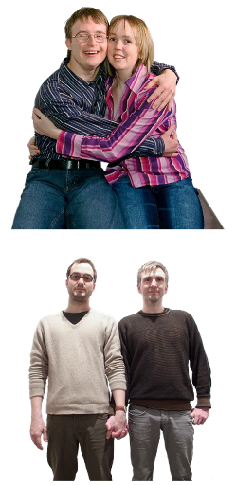 | 23. Sexual orientation means what kinds of people you love or have sexual or romantic feelings about.  Do you think of yourself as:
 | Heterosexual or straight | ☐
 | Gay | ☐
 | Lesbian | ☐
 | Bisexual | ☐
 | Another sexual orientation | ☐
 | I don’t want to say | ☐
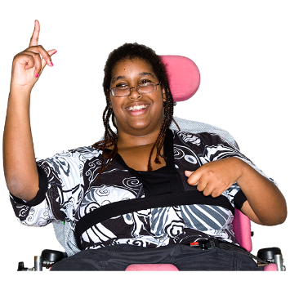 | 24. Do you have a disability?
 | Yes | ☐
 | No | ☐
 | I don’t want to say | ☐
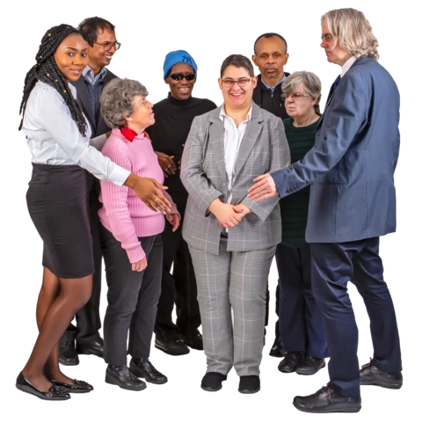 | 25. What is your ethnicity?  Ethnicity is the word we use to describe our background.  People from an ethnic group might have the same language, culture or religion.  What best describes you?
 | White
 | Scottish | ☐
 | Other British | ☐
 | Irish | ☐
 | Gypsy or Traveller | ☐
 | Polish | ☐
 | Another white ethnic group | ☐
 | Mixed or several ethnic groups
 | Mixed ethnic group or several ethnic groups | ☐
 | Asian, Asian Scottish or Asian British
 | Pakistani, Pakistani Scottish or Pakistani British | ☐
 | Indian, Indian Scottish or Indian British | ☐
 | Bangladeshi, Bangladeshi Scottish or Bangladeshi British | ☐
 | Chinese, Chinese Scottish or Chinese British | ☐
 | Another Asian group | ☐
 | African
 | African, African Scottish or African British | ☐
 | Another African group | ☐
 | Caribbean or Black
 | Caribbean, Caribbean Scottish or Caribbean British | ☐
 | Black, Black Scottish or Black British | ☐
 | Other ethnic group
 | Arab, Arab Scottish or Arab British | ☐
 | Another ethnic group | ☐
 | I don’t want to say | ☐
 | 26. What religion do you belong to?
 | No religion | ☐
 | Church of Scotland | ☐
 | Roman Catholic | ☐
 | Other Christian | ☐
 | Buddhist | ☐
 | Hindu | ☐
 | Jewish | ☐
 | Muslim | ☐
 | Sikh | ☐
 | Another religion | ☐
 | I don’t want to say | ☐
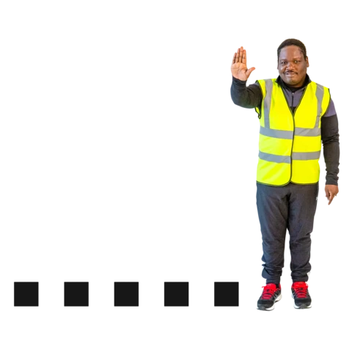 | This is the end of the survey.  Thank you.

