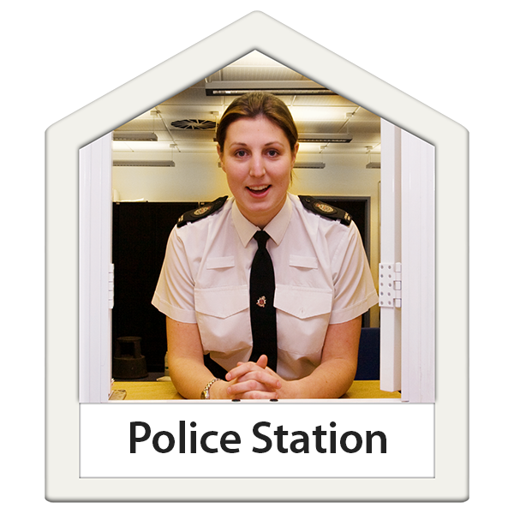

Our National Conversation

Tell us what you think about our plans for police stations

Easy Read

What is this survey about?
A survey is a way for us to find out what you think about our plans for our estate - the buildings we own.

Our Estate Strategy was published in 2019.

A strategy is a big plan.

Questions we are often asked

Why are you getting rid of some police stations?

This is part of the work in our Estate Strategy.

The work was approved in 2019 by the Scottish Police Authority.

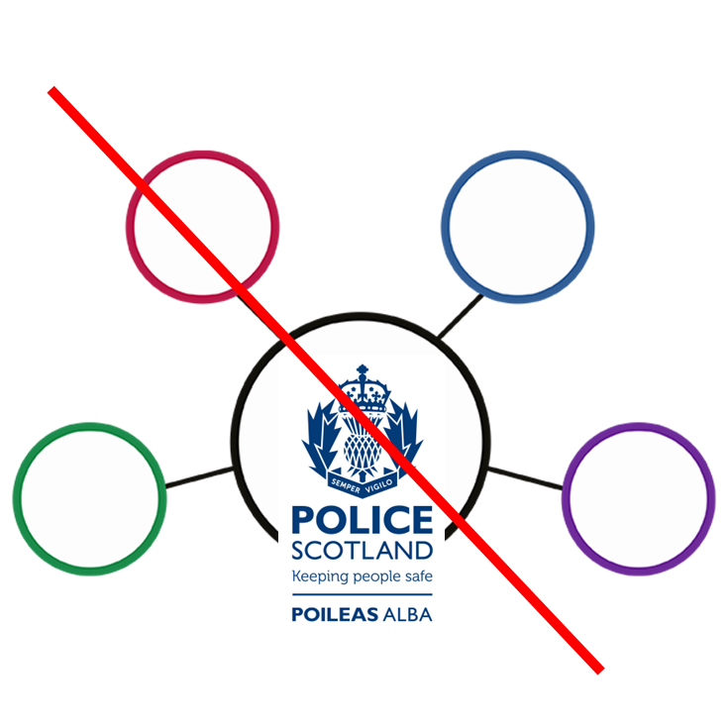 | Do you want all services to be in a central place?  We do not want all services to be in one place.  We must make sure our staff work in the areas where they are needed most.  Police work has changed a lot over the years but our buildings have stayed the same.
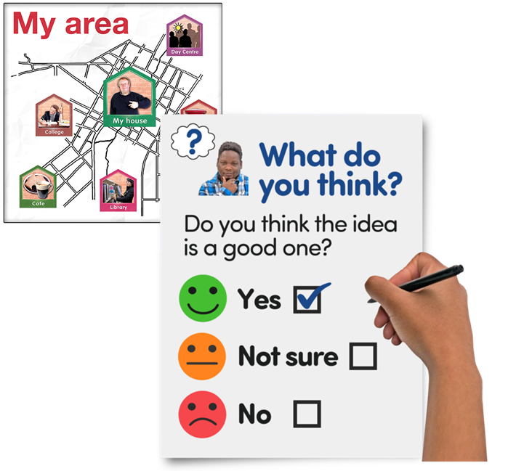 | How have you decided which police stations to get rid of and which to keep?  A list of the buildings we plan to get rid of are in our local area consultation.  A review was done by the police officers in charge of each local police area.  A review is when something is looked at to see if it is working well and what needs to change.
We understand that local communities will be worried about changes involving police buildings.

We will keep asking the public about our plans.

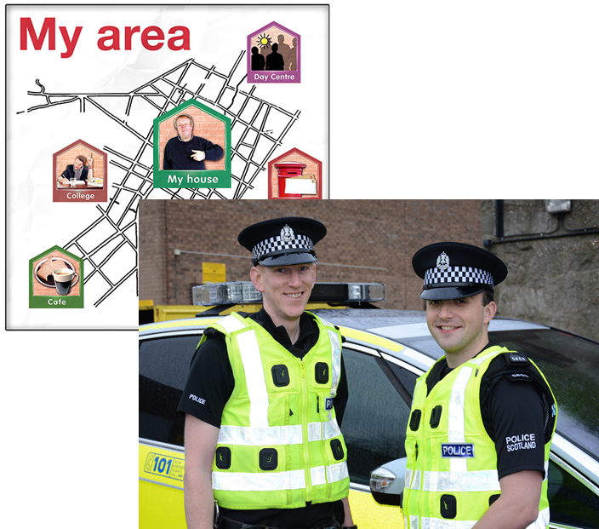 | Are you getting rid of properties to save money?  We must give local communities what they need and make sure our staff work in the right places.
We are making hard choices to deliver police services that work well using the money we have.

Most of the stations we are getting rid of do not work well for police services now and are expensive to run.

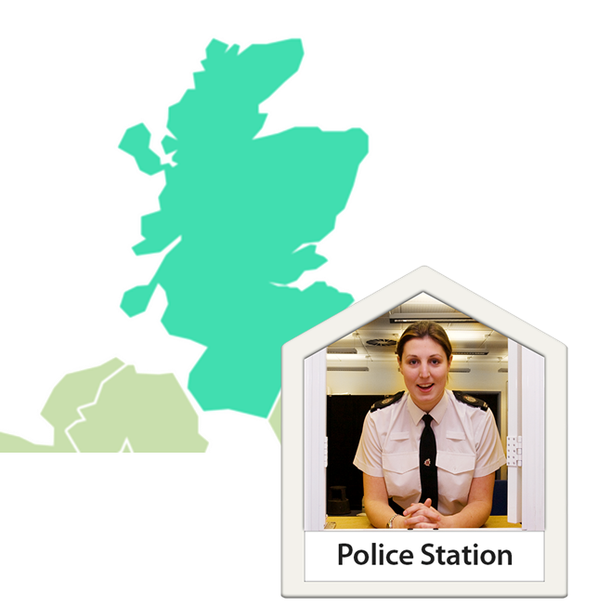  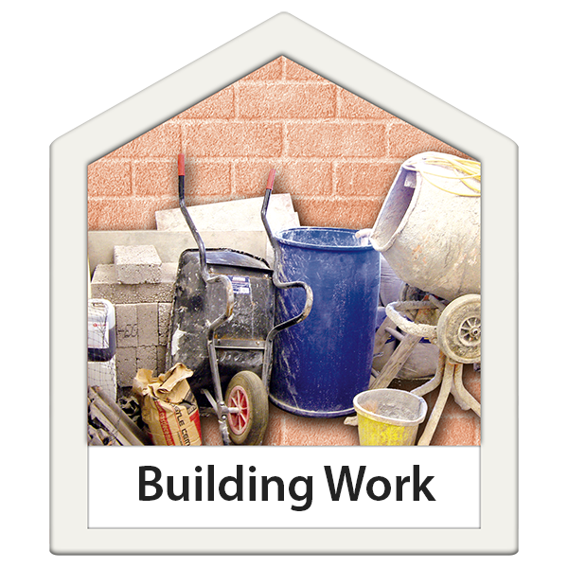 | How many police buildings are there across Scotland?  Police Scotland has 309 sites with 329 buildings.  306 buildings are working police stations.  Many operational stations:  - need repairs  - are not open to the public  - are not used very much by the public  - do not have many officers or staff based in them
How many staff will be affected by the closure plans?

Around 2 thousand 5 hundred staff will be affected.
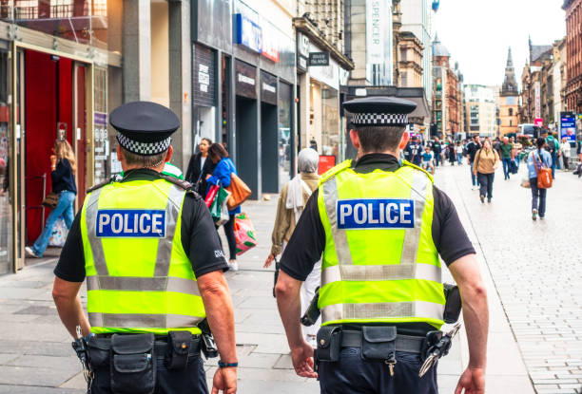  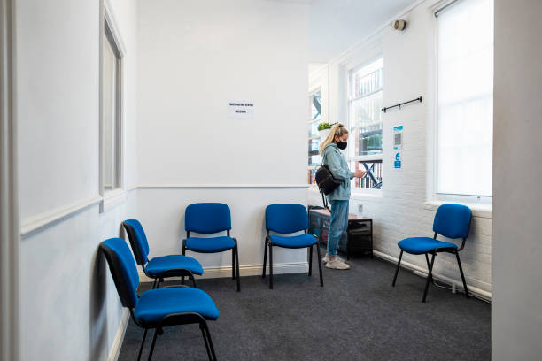 | How have you decided what buildings to get rid of?  Many of our buildings do not work well for police services now.  Each Police area has looked at:  - how many people used their local police station  - where police officers and staff need to be to give the best service
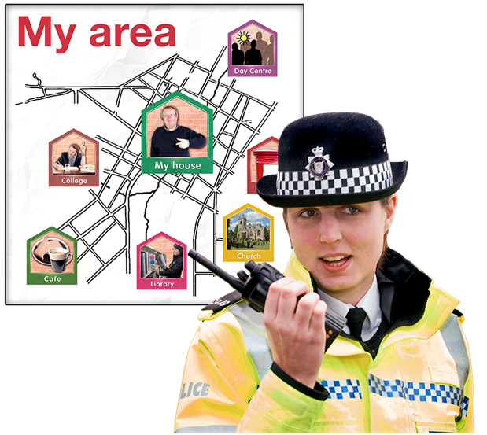  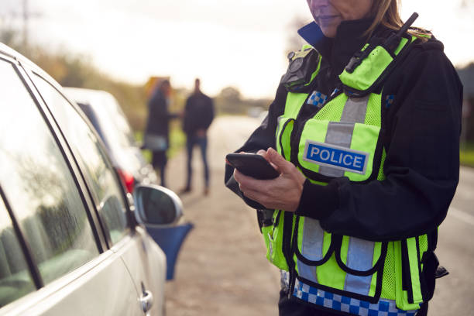  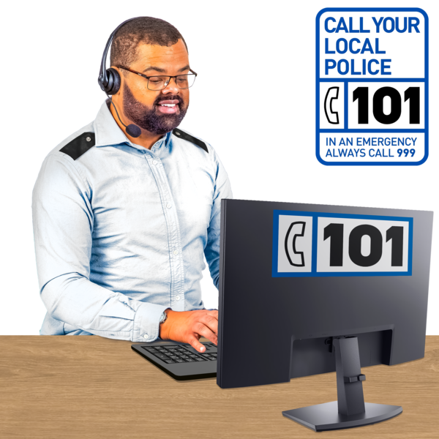 | What affect will getting rid of police stations have on local communities?  Most people contact the Police by telephone rather than by visiting a police station.  We have already introduced technology that supports our officers to stay in local areas.  This means they do not have to return to police stations as often, to do paperwork.  Technology is machines, equipment and information that use scientific knowledge.
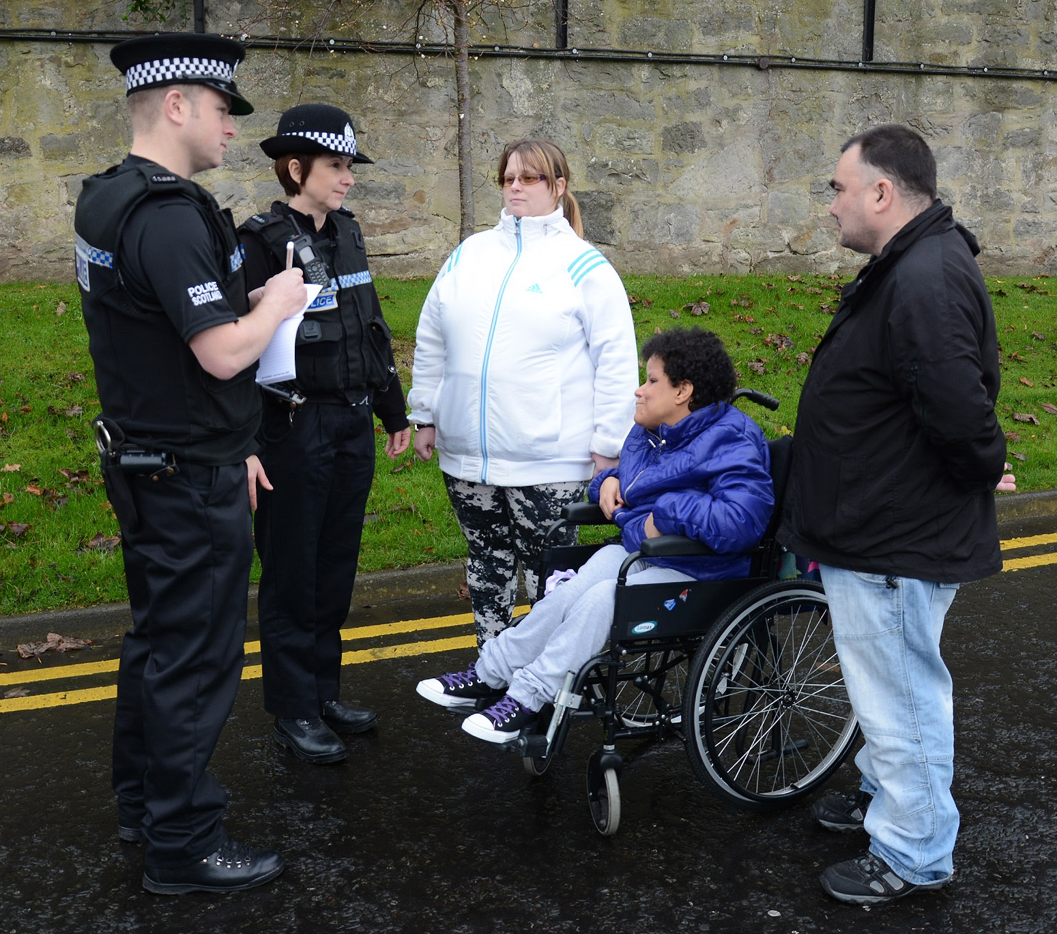 | Are you leaving local communities?  No - we are committed to maintaining a presence within our local communities, through police officers being able to patrol and respond to community needs.

How will we use your personal information?
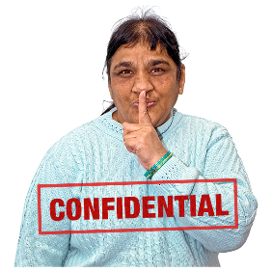 | When you send the survey back to us we save it separately from your email.  Your replies are confidential.  This means your information will be kept private.
If you fill out the survey you agree to Police Scotland using your data for their reports.

No-one will know it is your information in any reports.

How do I fill in the survey?
You can fill out this survey:

- on your computer, then save it and email it to:
insightengagement@scotland.police.uk

- or print a copy, write in your answers then:
  - scan it and email it to:

insightengagement@scotland.police.uk

  - or post it to:

Kevin Ditcham, Insight and Engagement Police Scotland
4 West Bell Street (Annexe)
Dundee DD1 1AD

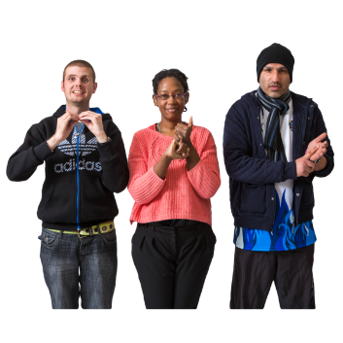 | Information about the survey is available in British Sign Language.
If you have questions or you want to do the survey over the phone please contact the Insight Team:

- by phoning 07467 118 010

- or email: insightengagement@scotland.police.uk
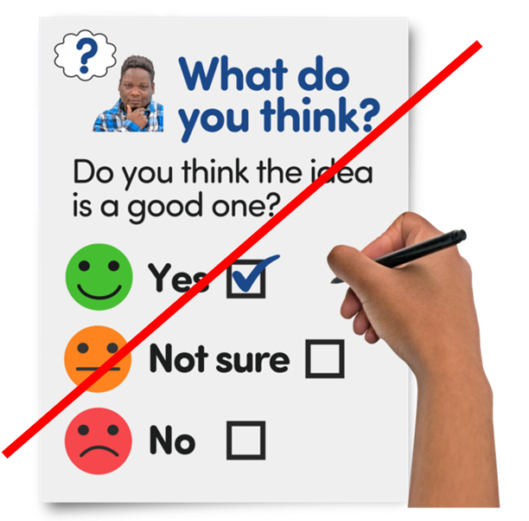  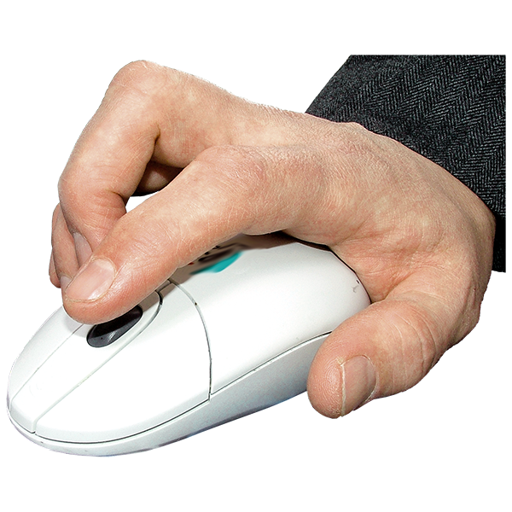 | There are 31 questions in the survey.  Each question is in bold black writing.  Click on the box of the answer you agree with and a tick will appear. ☐  If you change your mind you can click on it again to untick it.  If you are filling out a paper copy, tick the box of the answer you agree with.  If you have more to say write your answer in the ‘Write your answer here’ spaces.  If you are typing, the space will get bigger as you type.  You do not have to answer a question if you do not want to.

Questions
 | - Who are you filling in the survey for?
 | I am answering for myself |  | ☐
 | I am representing a local community group, community council or residents’ association |  | ☐
 | I am representing an educational organisation like a school or college |  | ☐
 | I am representing a local council |  | ☐
 | I am a local Councillor |  | ☐
 | I am representing a voluntary organisation |  | ☐
 | Other – please tell us what: |  | ☐
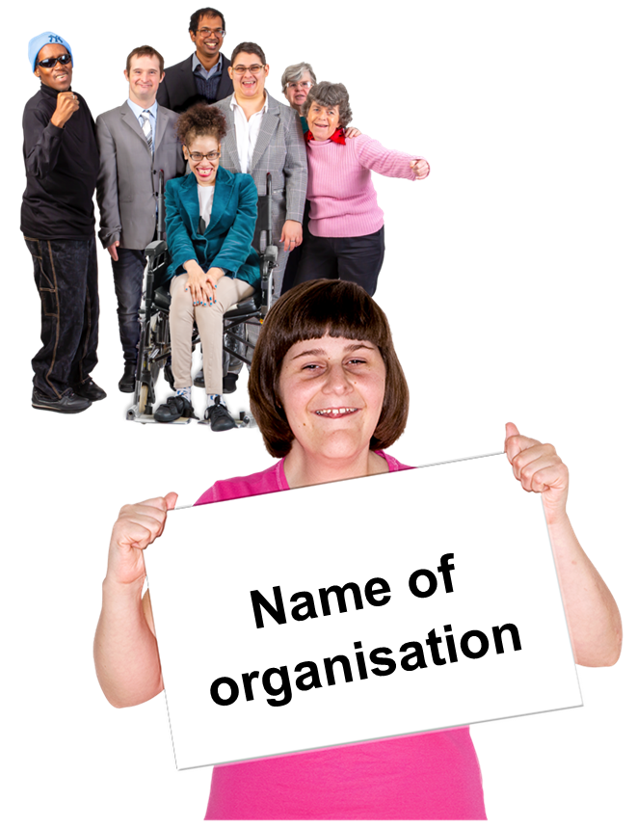 | If you are representing an organisation please tell us its name.  Type it here:
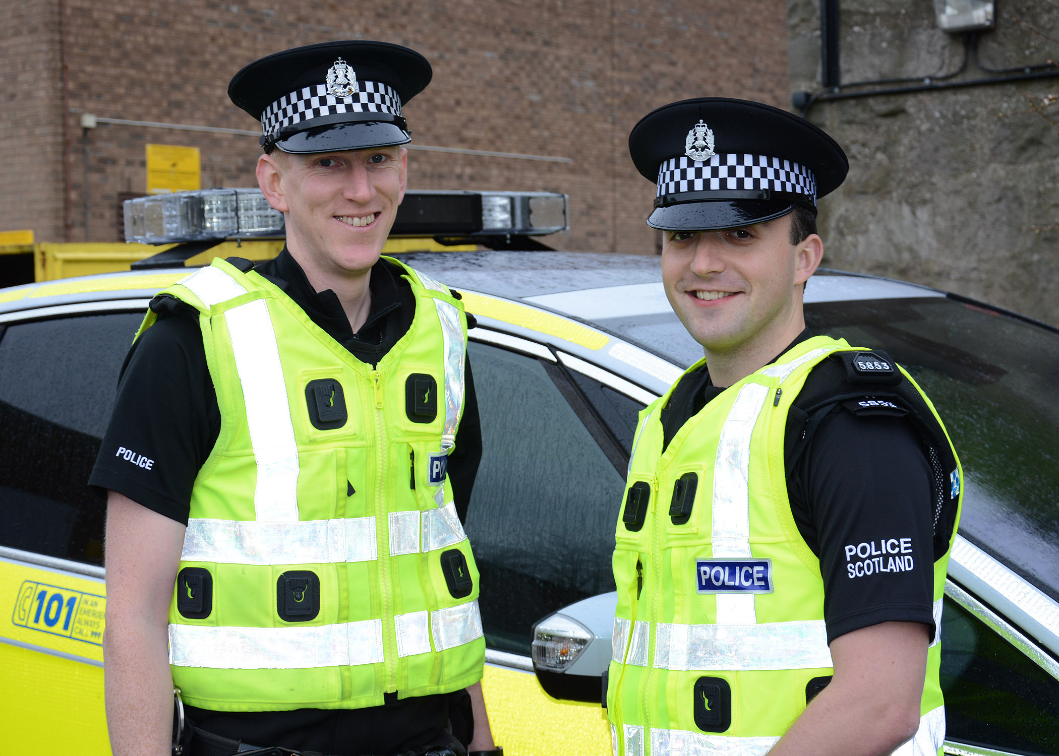 | - Do you work for Police Scotland?
 | Yes |  | ☐
 | No |  | ☐
 | I do not want to say |  | ☐
 | Do you agree or disagree that our plans in the Estates Strategy are what you expect from Police Scotland in these ways?:
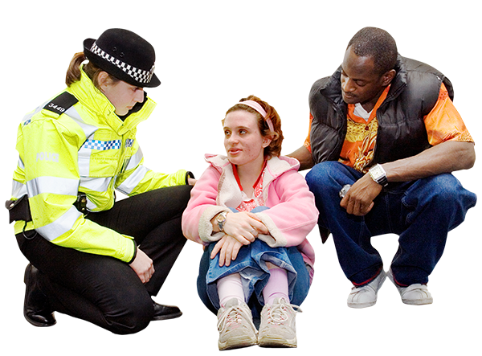 | - It is easier to get help from the police when you need it in your community
 | I agree |  | ☐
 | ? I am not sure |  | ☐
 | I do not agree |  | ☐
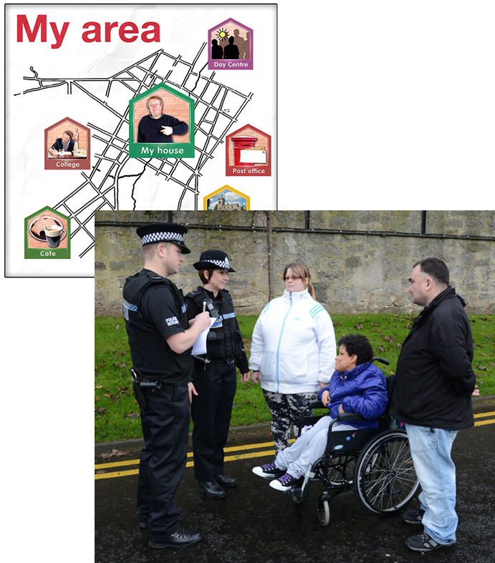 | - Police officers work well in local communities
 | I agree |  | ☐
 | ? I am not sure |  | ☐
 | I do not agree |  | ☐
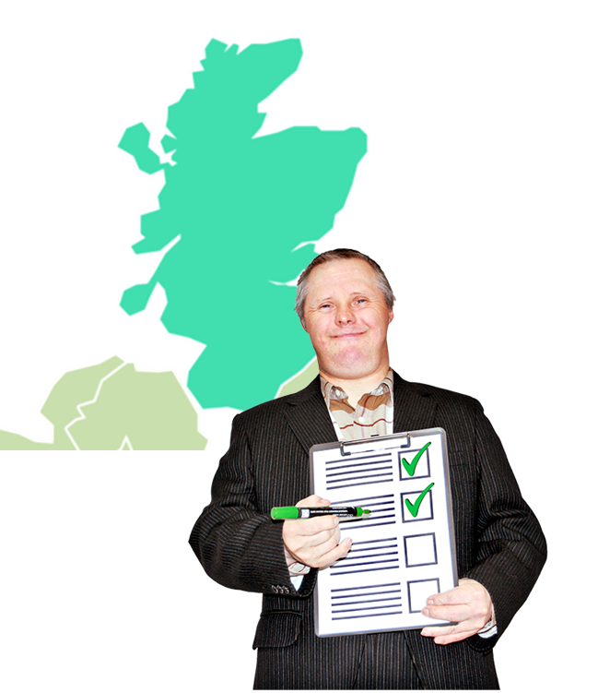 | - Police Scotland services are the same in all parts of the country
 | I agree |  | ☐
 | ? I am not sure |  | ☐
 | I do not agree |  | ☐
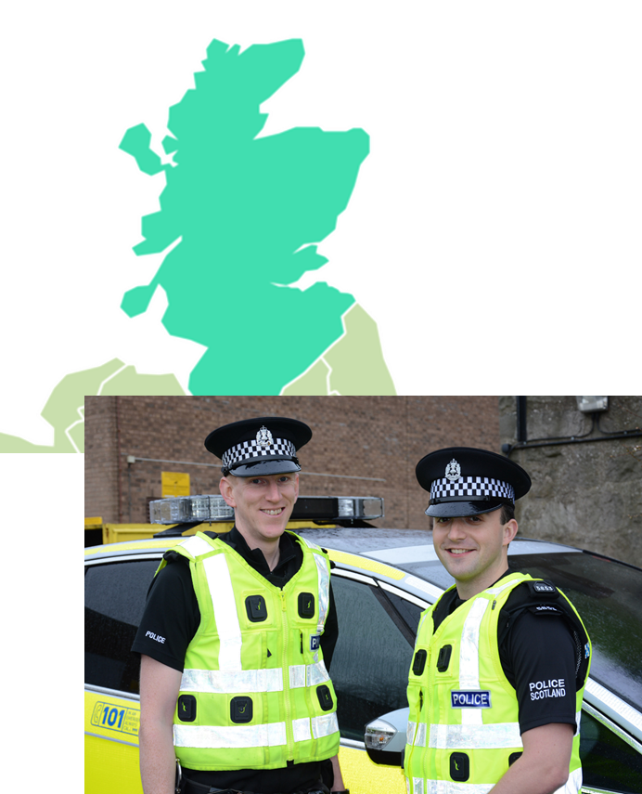 | - Police Scotland officers and staff have the same chance to progress their career wherever they work in Scotland
 | I agree |  | ☐
 | ? I am not sure |  | ☐
 | I do not agree |  | ☐
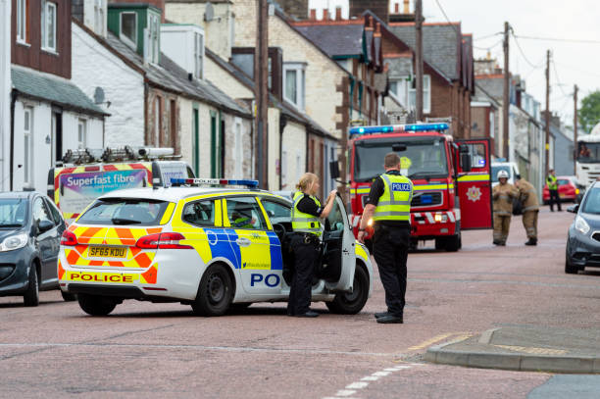 | - Police Scotland is quicker at responding to calls and has better ways of using information and communication technology
 | I agree |  | ☐
 | ? I am not sure |  | ☐
 | I do not agree |  | ☐
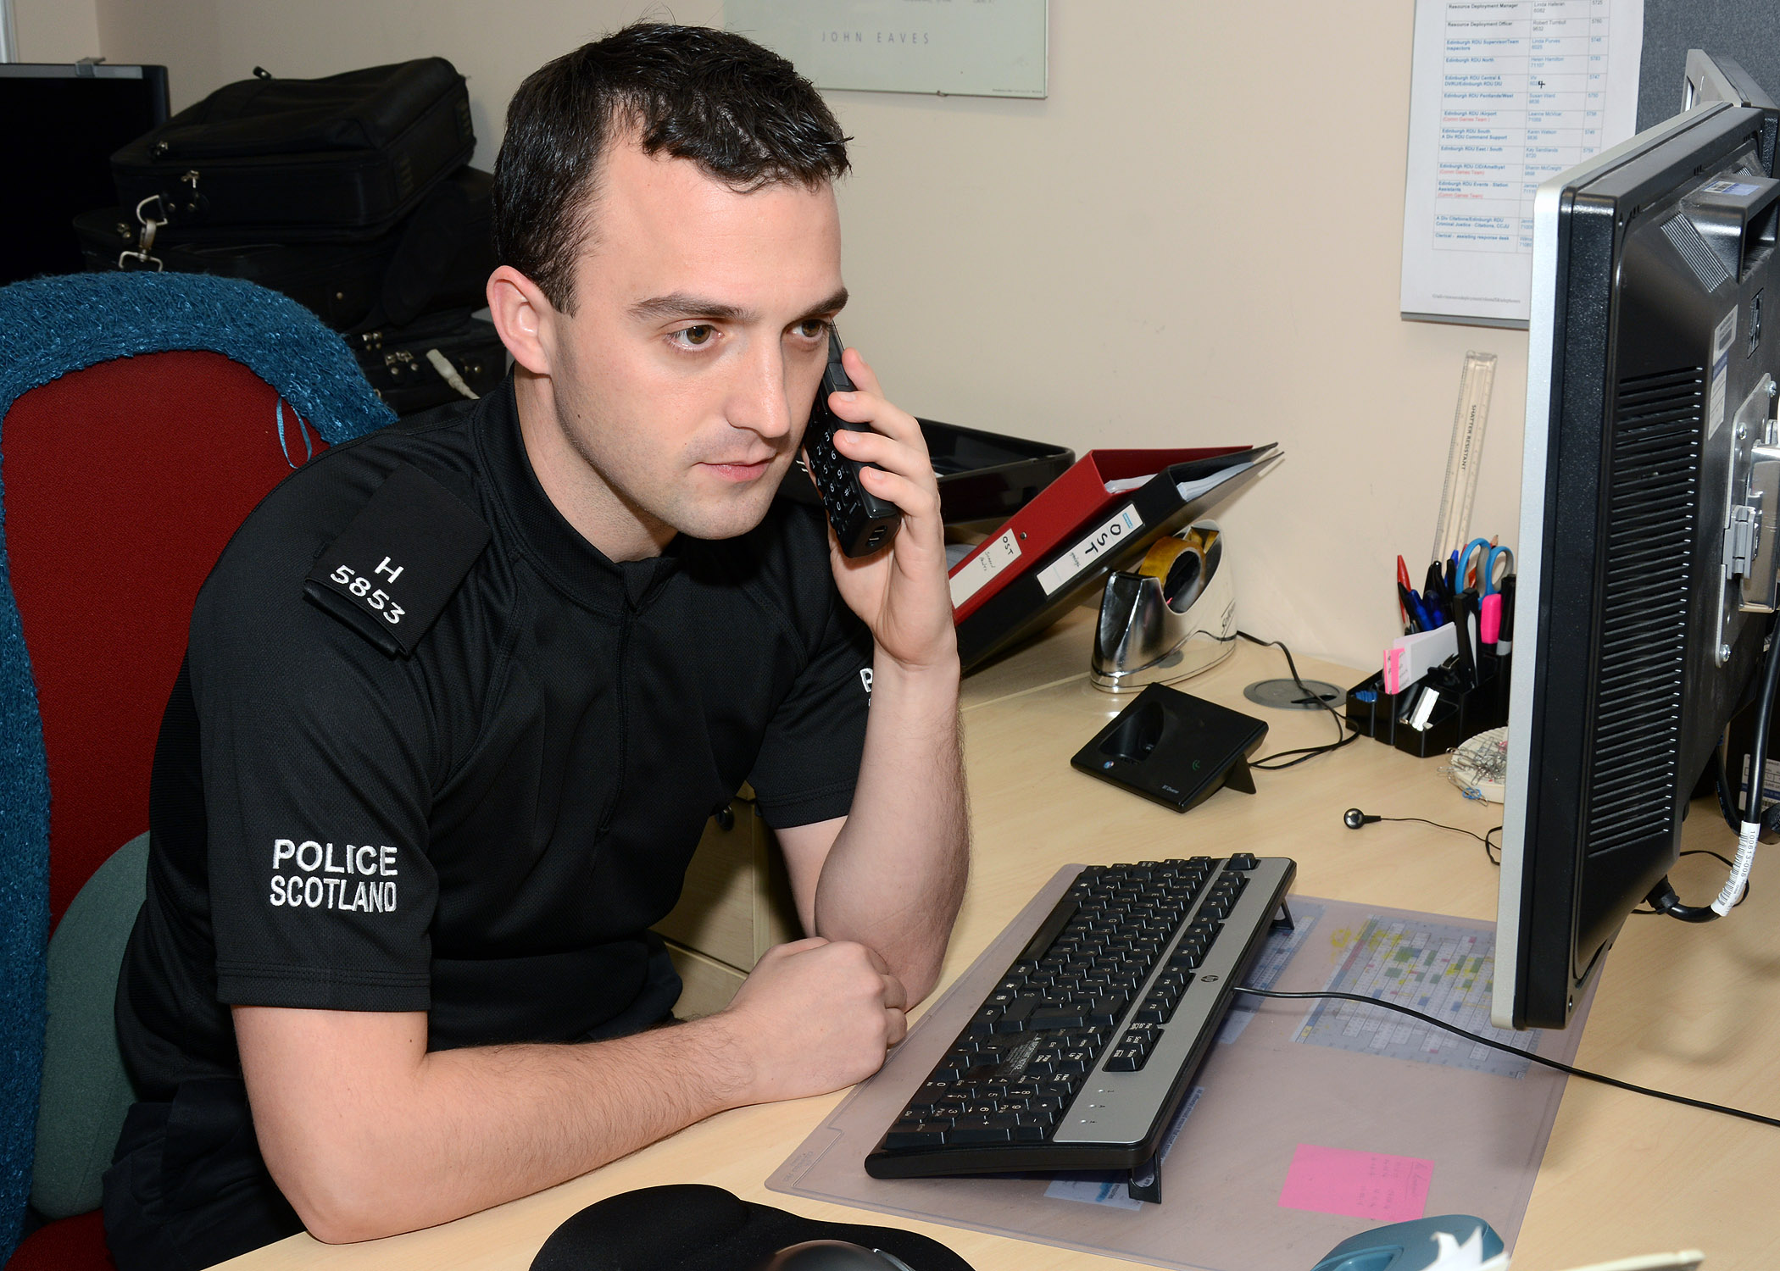 | - Police Scotland is dealing with the growing amount of online crime
 | I agree |  | ☐
 | ? I am not sure |  | ☐
 | I do not agree |  | ☐
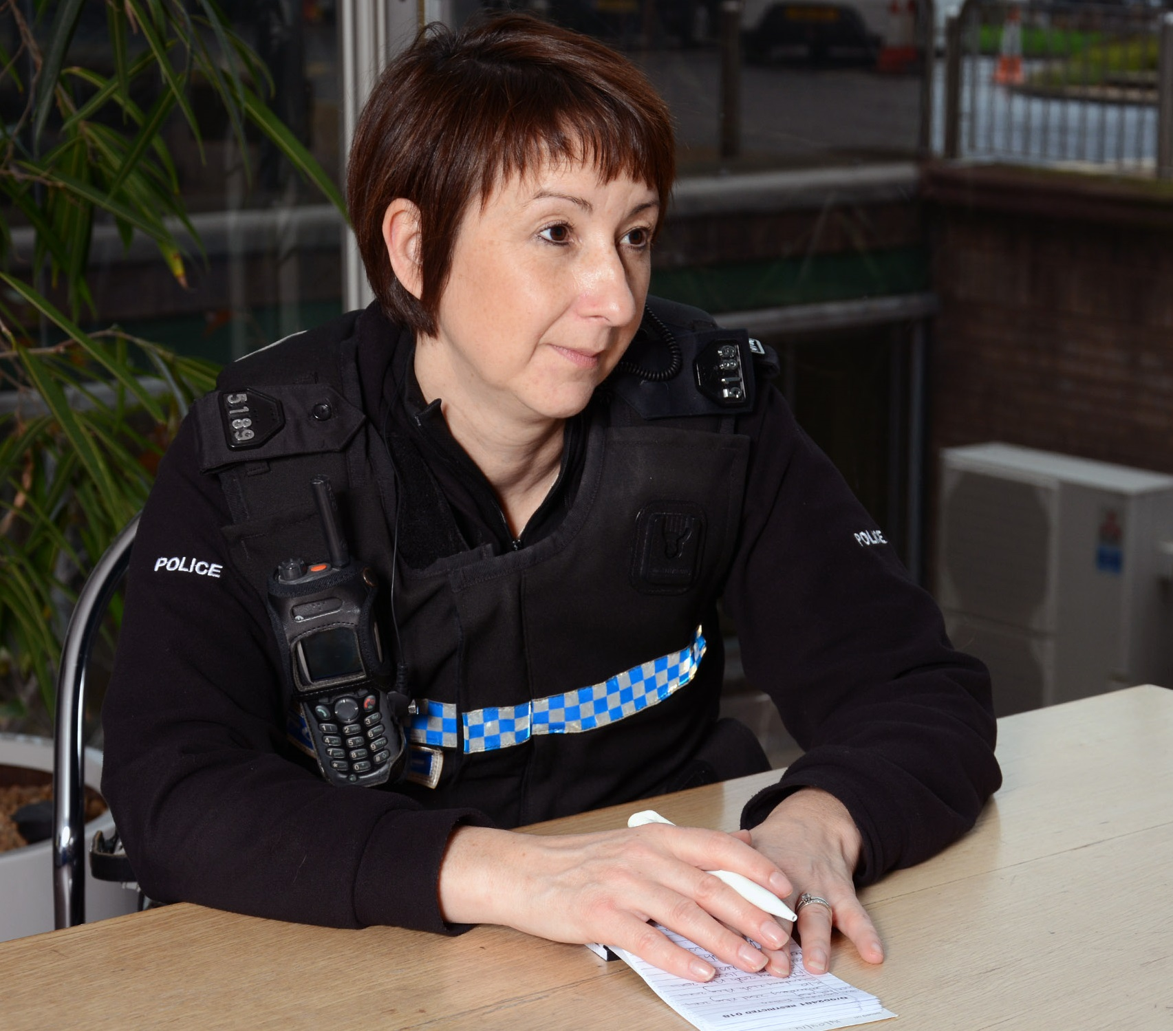 | - Police Scotland supports people in custody into ways to recover from addictions to alcohol or drugs
 | I agree |  | ☐
 | ? I am not sure |  | ☐
 | I do not agree |  | ☐
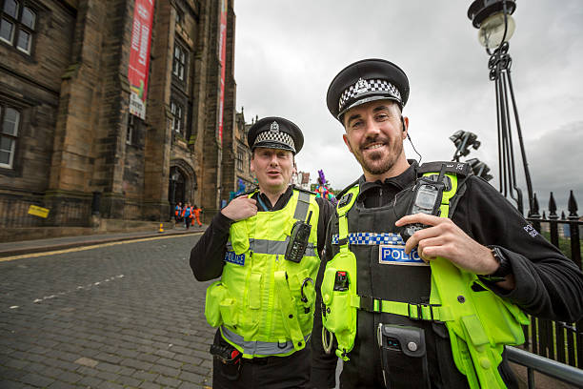 | - Police Scotland looks after the wellbeing of its officers and staff
 | I agree |  | ☐
 | ? I am not sure |  | ☐
 | I do not agree |  | ☐
 | - Police Scotland has a better quality of services and less paperwork
 | I agree |  | ☐
 | ? I am not sure |  | ☐
 | I do not agree |  | ☐
- Police Scotland makes sure services work well and more money goes to frontline policing

Frontline policing means the police officers in communities that:

- respond to calls for service

- do community policing

- work in specialist departments keeping people safe

 | I agree |  | ☐
 | ? I am not sure |  | ☐
 | I do not agree |  | ☐
- Is there anything else you want to tell us about your answers?

Type or write it here:

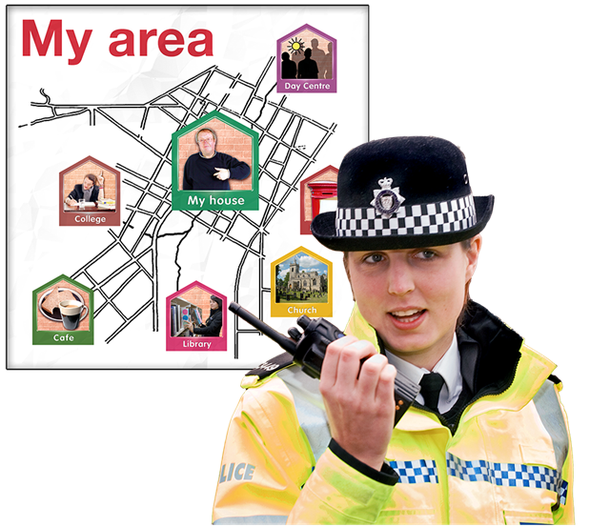 | How important is it for police to work in the ways below?
 | - Making sure that police officers can be mobile in communities using digital devices to connect with policing systems
 | It is important |  | ☐
 | ? I am not sure |  | ☐
 | It is not important |  | ☐
- Making sure the public, communities and partners:

- know about our work – for example by looking at our website

- can tell us what they think about our work

 | It is important |  | ☐
 | ? I am not sure |  | ☐
 | It is not important |  | ☐
 | - Working with other community services through co-location so it is easier for the public to get services
 | It is important |  | ☐
 | ? I am not sure |  | ☐
 | It is not important |  | ☐
- Is there anything else you want to tell us about your answers?

Type or write it here:

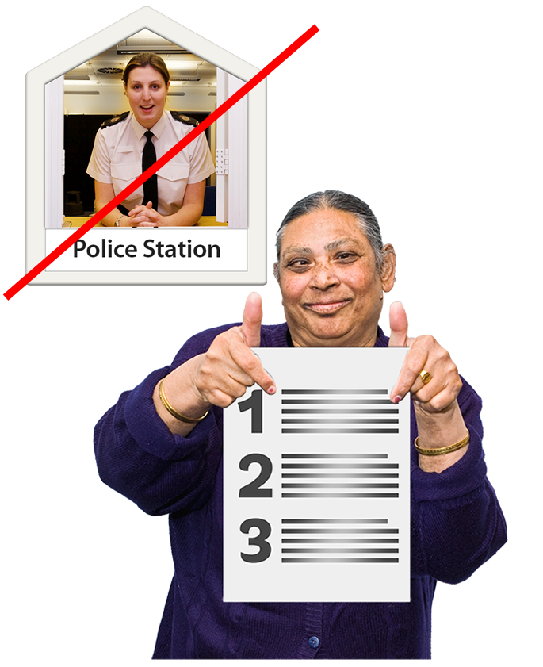 | - Do you want to tell us what you think about the closure of a particular building?  The list of stations that we plan to close is online in our Local Estates consultation.  Scroll down to the bottom of the page to see the North, East and West lists of stations.  Which station would you like to tell us about?  Write or type your answer here:
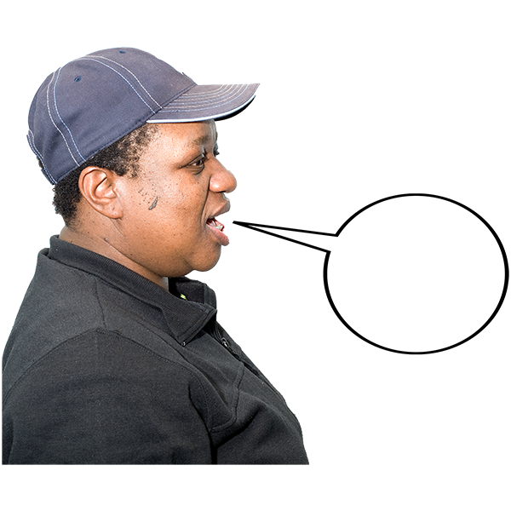 | - What would you like Police Scotland to know about this building when we make decisions about its future?
Write or type your answer here:

 | - Do you think that this building should be closed?
 | Yes it should be closed | ☐
 | No it should not be closed | ☐
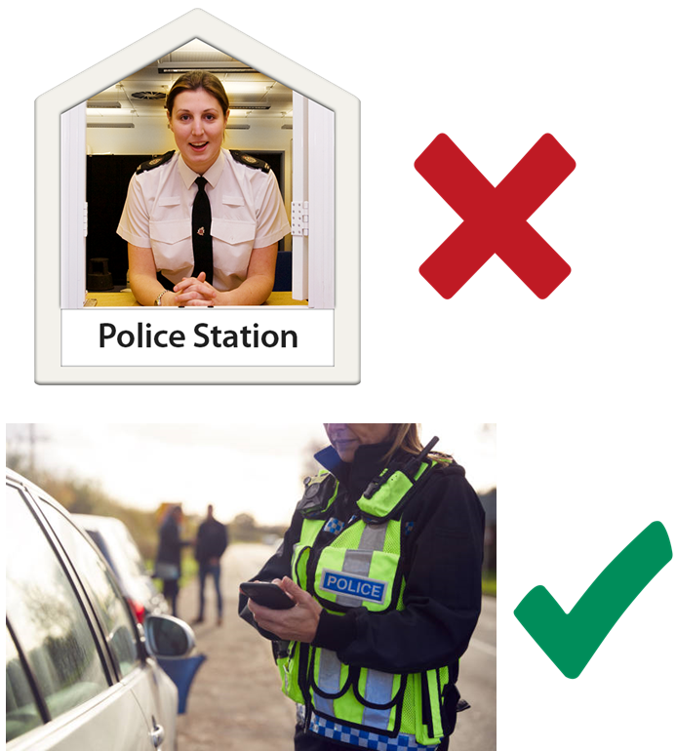 | - What do you think about Police Scotland planning to use less buildings so it is a more modern and better policing service?
Type or write your answer here:

 | - Is there anything else you want to tell us about Police Scotland's estate changes?
Type or write your answer here:

Your questions and feedback
We want to make sure we are as open and honest as possible about our planned estate changes.

- What questions do you have for us?

We will use questions that people have to make sure we are putting the right information online and in the news.

Type or write your questions here:

- Is there anything else you want to tell us about our buildings and how we use them?

Type your answer here:

About you
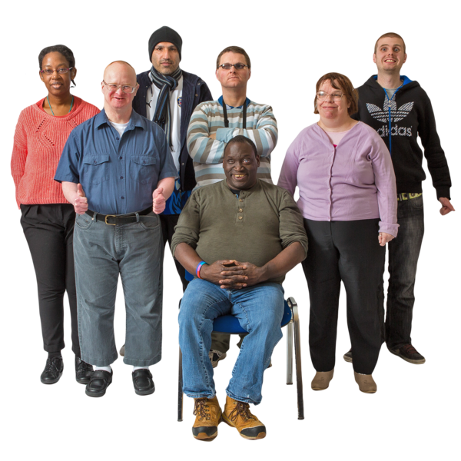 | Why are you asking me these questions?  These questions help us understand the views and experiences of everyone in Scotland's diverse communities.  Any personal information you give us will be kept safe and is confidential.  You can answer all, some or none of these questions.
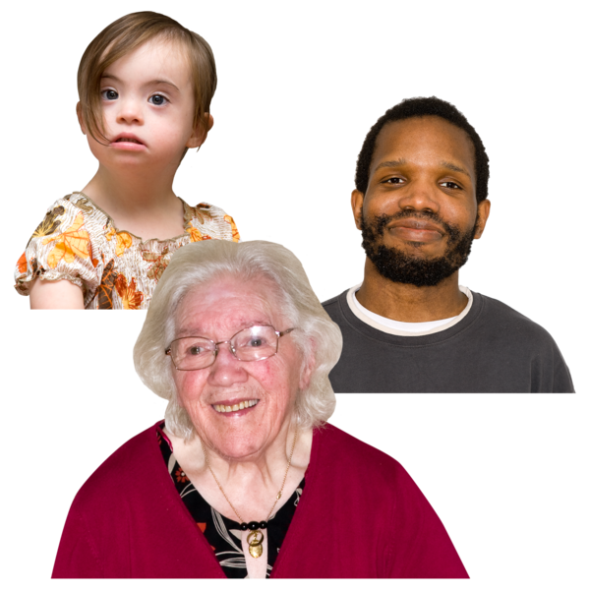 | - What is your age?  Type it here:
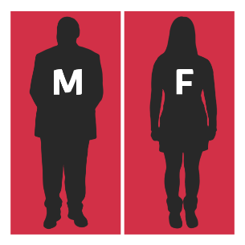 | - Do you think of yourself as:
 | Female |  | ☐
 | Male |  | ☐
 | Non-binary or gender neutral – this means I do not see myself as only male or only female |  | ☐
 | In another way. Write or type your answer here: |  | ☐
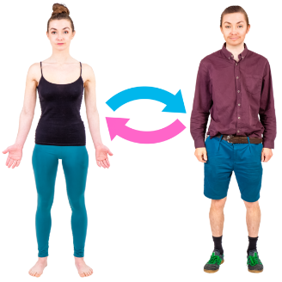  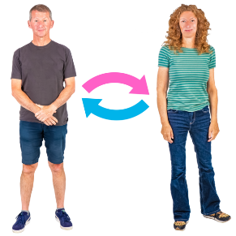 | - Do you consider yourself to be a trans person or to have a trans history?  Trans means you do not identify as the sex on your birth certificate.
 | Yes |  | ☐
 | No |  | ☐
28. What is your ethnicity?

Ethnicity is the word we use to describe our background.

People from an ethnic group might have the same language, culture or religion.

 | White
 | Scottish | ☐
 | Other British | ☐
 | Irish | ☐
 | Gypsy or Traveller | ☐
 | Polish | ☐
 | Roma | ☐
 | Showman/Showwoman | ☐
 | Any other white ethnic group. Write or type your answer here: | ☐
 | Mixed or multiple ethnic group
 | Any mixed or multiple ethnic group. Write your answer here: | ☐
 | Asian, Asian Scottish or Asian British
 | Bangladeshi, Bangladeshi Scottish, Bangladeshi British | ☐
 | Chinese, Chinese Scottish, Chinese British | ☐
 | Indian, Indian Scottish, Indian British | ☐
 | Pakistani, Pakistani Scottish, Pakistani British | ☐
 | Any other Asian. Write or type your answer here: | ☐
 | African
 | African, African Scottish, African British | ☐
 | Any other African. Write or type your answer here: | ☐
 | Caribbean or Black
 | Caribbean, Caribbean Scottish or Caribbean British | ☐
 | Black, Black Scottish or Black British | ☐
 | Any other Caribbean or Black | ☐
 | Other ethnic group
 | Arab, Arab Scottish or Arab British | ☐
 | If your ethnic group is not shown, please write it here:
29. Do you consider yourself to have a disability, long-term illness or health condition?

Long term means it has lasted for over a year.

 | Yes – go to question 30 | ☐
 | No – go to question 31 | ☐
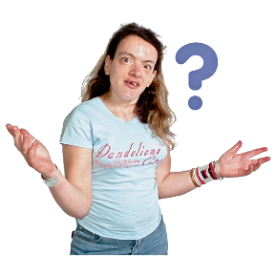 | 30. Does this disability or health condition affect you in any of these ways?
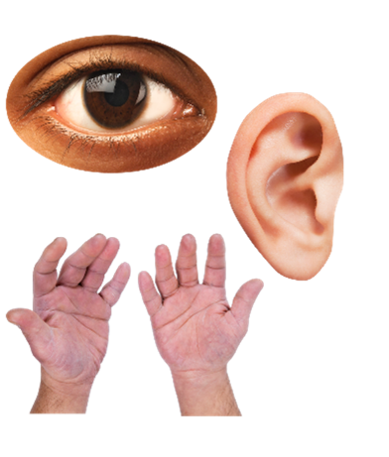  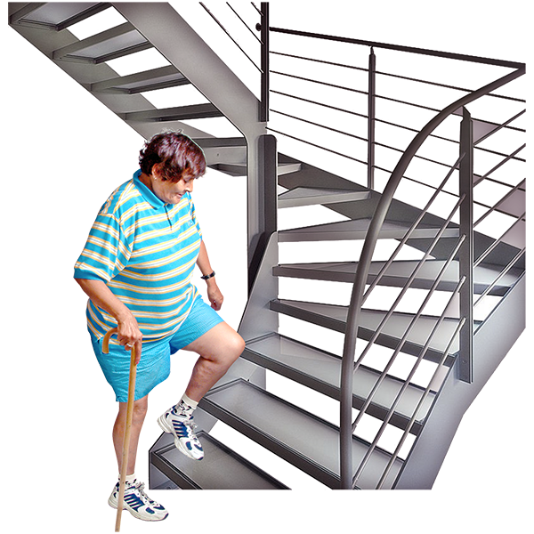 | Vision – how I see | ☐
 | Hearing | ☐
 | How I use my hands – for example if it is difficult for me to lift things or use a keyboard | ☐
 | Mobility – for example walking or climbing stairs | ☐
 | Appearance – for example a mark, scar or condition which makes me look different | ☐
 | Learning, understanding or concentrating | ☐
 | Remembering things | ☐
 | Mental health | ☐
 | I get out of breath or tired easily | ☐
 | How I behave around other people | ☐
 | None of these | ☐
 | In another way.  Please tell us what: | ☐
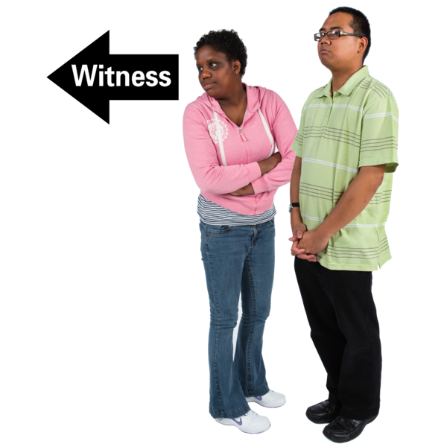  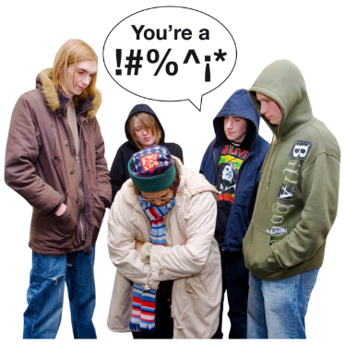 | 31. In the last 12 months have any of these things happened to you?
 | I have been a victim of crime | ☐
 | I have seen a crime | ☐
 | I have been a victim of crime and I have seen a crime | ☐
 | I have not been a victim and I have not seen a crime | ☐
Thank you for telling us what you think.

What you tell us is important.

