Policing Plan 2020
Keeping Scotland Safe

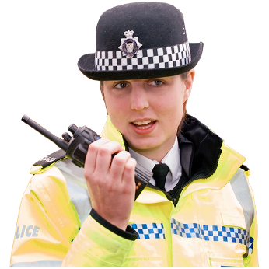

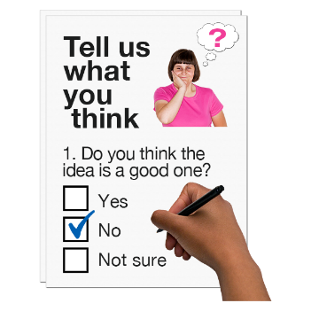

Copyright images © Photosymbols. Prepared by Disability Equality Scotland

Police Scotland has a new plan for policing in Scotland.
It is very important that we support the people of Scotland to stay safe.
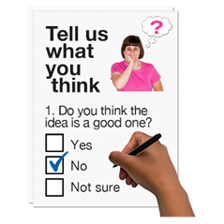 | We want to know what you think about our plans.
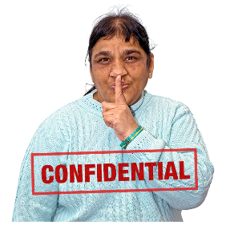 | How will we use your personal information?  Your responses are confidential.  This means your information will be kept private.  If you fill out the survey you agree to Police Scotland using your data for their reports.  No-one will know it is your information.
How do I take part in the survey?
You can fill out the survey on your computer, then save it and email it to:
StrategicPlanningDevelopment@scotland.pnn.police.uk
Or you can print a copy of the survey, fill in the answers and post it to:

Scottish Police Authority and Police Scotland
c/o Strategy and Planning Team
Room 808 Culzean Building
Scottish Police College
Kincardine
FK10 4BE
Fife

 | Or scan your printed copy and email it to: StrategicPlanningDevelopment@scotland.pnn.police.uk
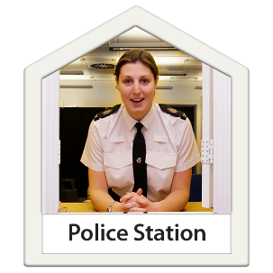 | You can also hand it in at the front counter of a police station.
 | It should take about 20 minutes to fill in the survey.
 | Send us your survey before Monday 2 March 2020.
If you have questions call:
01786 893 060

or email: StrategicPlanningDevelopment@scotland.pnn.police.uk

 | There are 5 sections in the survey.
Click on the box of the answer you agree with and a tick will appear. ☐

If you change your mind you can click on it again to untick it.

If you are filling out a paper copy, tick the box of the answer you agree with, and if you have more to say write your answer in the ‘Write your answer here’ spaces.

Section 1: Keeping people safe.

A lot of crime now happens online.
Police Scotland will work with other organisations and work with new technology.

We will work with community planning partnerships.
These let police and local public services work together to use money and staff in the best way.

We will:
- Keep people safe in the real world and online.
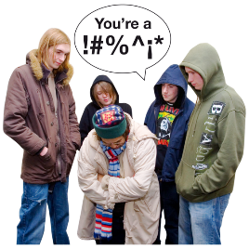 | - Have services that work together to keep people safe.  - Work on prevention – stopping crime from happening.
Do you think these plans are right?
Yes ☐ No ☐
Not sure ☐
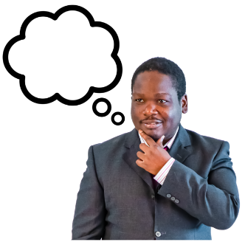 | Is there anything else you would like to tell us about Section 1? Write your answer here:
Cybercrime is when technology is used to commit crime, or when crime happens online.

Police Scotland will find different ways to stop cybercrime.
 | Is there anything else you would like to tell us about cybercrime? Write your answer here:
To report a cybercrime dial 101.
If it is an emergency call 999.

To report it online visit: https://www.scotland.police.uk/contact-us/ and choose ‘report cybercrime’

Section 2:
Communities are at the centre of policing.

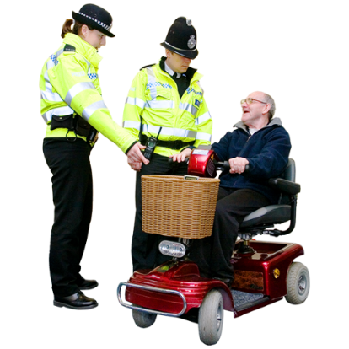 | The role of policing is to keep people safe wherever they live.  Police Scotland must meet the needs of all people and all communities as they change and grow.  This includes helping people to stay safe online.
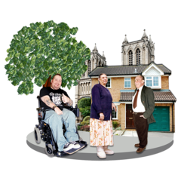 | We will:  - Understand our local areas.  - Give local areas services that meet their needs.  - Support our local area with knowledge from local and national experts. An expert is someone who knows a lot about a subject.  - Support communities when they change and grow.
Do you think these plans are right?

Yes ☐ No ☐

Not sure ☐

 | Is there anything else you would like to tell us about Section 2? Write your answer here:
Section 3: How we involve you.

Policing happens with consent.
This means people agree to policing.

New technology means we can communicate with people in different ways.

We must make sure we have the right balance between giving people privacy and making sure they are protected.

The Police might not always be the best people to respond.

We will work with others to agree when Police Scotland will get involved.

We will:
- Make sure there is a balance between privacy and protection.

- Protect the public with services that are accessible and work well.

- Work with local groups, public services, private organisations and voluntary organisations to support our communities.

Do you think these plans are right?

Yes ☐ No ☐

Not sure ☐

 | Is there anything else you would like to tell us about Section 3? Write your answer here:

Section 4: Supporting our people.

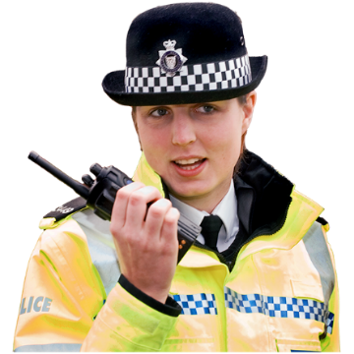 | Police Scotland think looking after its officers and staff is important.  We must give our officers and staff the skills, knowledge and technology they need.
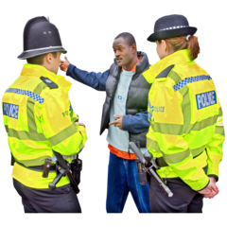 | We will:  - Look after our officers and staff. Make sure they are protected and they have the right equipment.  - Support our staff to be confident and to give us new ideas.  - Support our staff to feel part of Police Scotland and to stand up for what it believes in.
Do you think these plans are right?

Yes ☐ No ☐

Not sure ☐

 | Is there anything else you would like to tell us about Section 4? Write your answer here:
Section 5: Policing in the future.

Policing must always change and develop as the world changes.

Police Scotland will work with new ideas and work in partnership with other organisations.

We will use our money, staff and resources in the best way and give the best value for money.

We will:

We will:

- Use new ways of working to give people the best service.

- Work in ways that are good for the environment.

- Use new technology and give the best value for money.
Do you think these plans are right?

Yes ☐ No ☐

Not sure ☐

 | Is there anything else you would like to tell us about Section 5? Write your answer here:

About you
We ask these questions so that we can understand how representative the respondents are of the general population.

You do not have to answer any question that makes you feel uncomfortable.

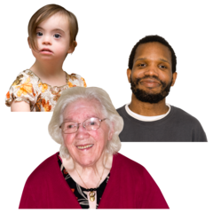 | 1. How old are you? Write it here:
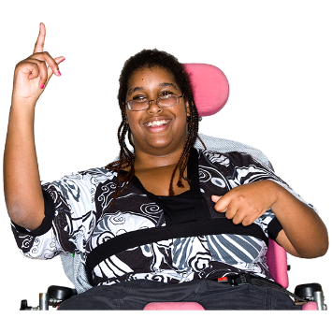 | 2. Do you consider yourself to have a disability, long-term illness or health condition?  Yes ☐ No ☐
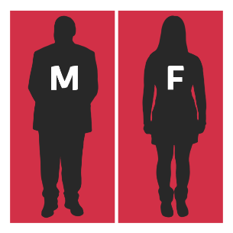 | 3. Do you think of yourself as:
 | Female |  |  | ☐
 | Male |  |  | ☐
 | Non-binary (I don’t see myself as only male or only female) |  |  | ☐
 | Transgender |  |  | ☐
 | In another way |  |  | ☐
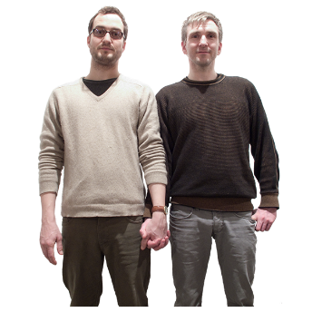 | 4. Sexual orientation means what kinds of people you love or have sexual or romantic feelings about. Do you think of yourself as:
 | Heterosexual or straight |  |  | ☐
 | Bisexual |  |  | ☐
 | Gay |  |  | ☐
 | Lesbian |  |  | ☐
 | Any other sexual orientation |  |  | ☐
5. What is your ethnicity?
Ethnicity is the word we use to describe our background.
People from an ethnic group might have the same language, culture or religion.
What best describes you?
If you tick ‘other’ please tell us what your ethnicity is.
 | White British |  |  | ☐
 | White Scottish |  |  | ☐
 | White English |  |  | ☐
 | White Welsh |  |  | ☐
 | White Irish |  |  | ☐
 | White Northern Irish |  |  | ☐
 | White Polish |  |  | ☐
 | Gypsy or Traveller |  |  | ☐
 | Bangladeshi, Bangladeshi Scottish, Bangladeshi British |  |  | ☐
 | Chinese, Chinese Scottish, Chinese British |  |  | ☐
 | Indian, Indian Scottish, Indian British |  |  | ☐
 | Pakistani, Pakistani Scottish, Pakistani British |  |  | ☐
 | African, African Scottish, African British |  |  | ☐
 | Black, Black Scottish, Black British |  |  | ☐
 | Caribbean, Caribbean Scottish, Caribbean British |  |  | ☐
 | Arab, Arab Scottish, Arab British |  |  | ☐
 | Mixed Ethnic group |  |  | ☐
 | Other. Write your answer here: |  |  | ☐
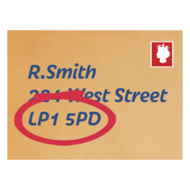 | 6. What is your postcode? Write it here:
 | 7. What religion do you belong to?
 | No religion |  | ☐
 | Church of Scotland |  | ☐
 | Roman Catholic |  | ☐
 | Other Christian |  | ☐
 | Buddhist |  | ☐
 | Hindu |  | ☐
 | Jewish |  | ☐
 | Muslim |  | ☐
 | Sikh |  | ☐
 | Other. Please say below:
 | 8. Are you answering this survey:
 | as an individual |  | ☐
 | as an organisation.  Tell us the name of the organisation: |  | ☐
9. Would you like Police Scotland to get in touch with you in the future so you can tell us what you think about our plans?
If you agree we will only keep your details to do this.
This does not mean you have to take part.
 | By email | ☐
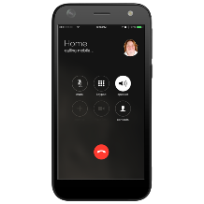 | By phone | ☐
 | In another way. Tell us how:
 | Give us your contact details if you want to:
 | Name:
 | Telephone number:
 | Email:
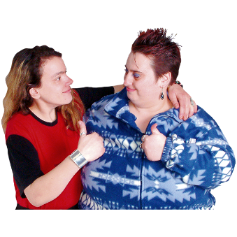 | Thank you for telling us what you think.  What you tell us is important.

Copyright images © Photosymbols. Prepared by Disability Equality Scotland

